**Supplemental Materials for ‘Synthesizing data from pretest-posttest-control-group designs in mediation meta-analysis’**

Table of Contents

S1 Mathematical Derivations 3

S1.1 Derivations for Equations Used to Construct Correlation Matrices 3

S1.1.1 Point-biserial Correlations 3

S1.1.2 Converting from Paired-sample t Values to Bivariate Correlations 4

S1.1.3 Converting from Confidence Intervals to Bivariate Correlations 4

S1.1.4 Converting from Regression Coefficients to Bivariate Correlations 5

S1.2 Data-generating Mechanisms 5

S1.2.1 Change-score Group Variances 5

S1.2.2 Posttest Means of $M$ and $Y$ in the Treatment Group 5

S1.2.3 Combined Variances of Change Scores of $M$ and $Y$ 5

S1.2.4 Generating Pretest Data of $Y$ 6

S2 Additional Results 6

S2.1 Study 1 6

S2.1.1 Indirect Effect 6

S2.1.2 Direct Effect 11

S2.1.3 Moderating Effect 15

S2.1.4 Coefficients of the a Path and the b Path 19

S2.2 Study 2 28

S2.2.1 Indirect Effect 28

S2.2.2 Direct Effect 32

S2.2.3 Moderating Effect 36

S2.2.4 Coefficients of the a path and the b path 39

S2.3 Positive Definite Rates in Study 1 & 2 48

S3 The Relationship between Parameters in PSMMA and CSMMA 50

S3.1 Parameters in PSMMA with Nonzero Counterparts in CSMMA 50

S3.2 Asynchrony in Taking a Value of Zero 53

S4 Simulations on MMA with Missing Correlations 55

S4.1 Manipulated Factors and Fixed Parameters 55

S4.2 Simulation Results 56

S4.2.1 Convergence Rates in Studies 3 and 4 56

S4.2.2 Study 3 57

S4.2.3 Study 4 60

# S1 Mathematical Derivations

## S1.1 Derivations for Equations Used to Construct Correlation Matrices

### S1.1.1 Point-biserial Correlations

In this section, we do not consider the justification for degree of freedom for simplicity.

Considering Equation 1 and 2, $$r_{pb,cs/ps}=\frac{{\hat{μ}}_{T}-{\hat{μ}}_{C}}{\sqrt{\frac{N_{T}({\hat{σ}}_{T}^{2}+{\left({\hat{μ}}_{T}-\frac{N_{T}{\hat{μ}}_{T}+N_{C}{\hat{μ}}_{C}}{N_{T}+N_{C}}\right)}^{2})+N_{C}({\hat{σ}}_{C}^{2}+{\left({\hat{μ}}_{C}-\frac{N_{T}{\hat{μ}}_{T}+N_{C}{\hat{μ}}_{C}}{N_{T}+N_{C}}\right)}^{2})}{N_{T}+N_{C}}}}\sqrt{\frac{N_{T}N_{C}}{{\left(N_{T}+N_{C}\right)}^{2}}},$$

Equation 3 can be obtained with the following algebraic transformations:

1. Expanding the denominator:
$$r_{pb,cs/ps}=\frac{{\hat{μ}}_{T}-{\hat{μ}}_{C}}{\sqrt{\frac{N_{T}{\hat{σ}}_{T}^{2}+N_{C}{\hat{σ}}_{C}^{2}+N_{T}{\hat{μ}}_{T}^{2}+N_{C}{\hat{μ}}_{C}^{2}-{\frac{{(N}_{T}{\hat{μ}}_{T}+N_{C}{\hat{μ}}_{C})}{N_{T}+N_{C}}}^{2}}{N_{T}+N_{C}}\frac{{\left(N_{T}+N_{C}\right)}^{2}}{N_{T}N_{C}}}};$$

2. Simplifying the denominator:
$$r_{pb,cs/ps}=\frac{{\hat{μ}}_{T}-{\hat{μ}}_{C}}{\sqrt{\frac{\left(N_{T}+N_{C}\right)(N_{T}{\hat{σ}}_{T}^{2}+N_{C}{\hat{σ}}_{C}^{2}+N_{T}{\hat{μ}}_{T}^{2}+N_{C}{\hat{μ}}_{C}^{2})-{\left(N_{T}{\hat{μ}}_{T}+N_{C}{\hat{μ}}_{C}\right)}^{2}}{N_{T}N_{C}}}};$$

3. Expanding the simplified equation:
$$r_{pb,cs/ps}=\frac{{\hat{μ}}_{T}-{\hat{μ}}_{C}}{\sqrt{\frac{N_{T}^{2}{\hat{σ}}_{T}^{2}+{N_{T}N}_{C}{\hat{σ}}_{T}^{2}+N_{C}^{2}{\hat{σ}}_{C}^{2}+{N_{T}N}_{C}{\hat{σ}}_{C}^{2}+{N_{T}N}_{C}{\hat{μ}}_{T}^{2}+{N_{T}N}_{C}{\hat{μ}}_{C}^{2}-2N_{T}N_{C}{\hat{μ}}_{T}{\hat{μ}}_{C}}{N_{T}N_{C}}}};$$

$$r_{pb,cs/ps}=\frac{{\hat{μ}}_{T}-{\hat{μ}}_{C}}{\sqrt{\frac{N_{T}{\hat{σ}}_{T}^{2}(N_{T}+N_{C})+N_{C}{\hat{σ}}_{C}^{2}(N_{T}+N_{C})}{N_{T}N_{C}}+{\hat{μ}}_{T}^{2}+{\hat{μ}}_{C}^{2}-2{\hat{μ}}_{T}{\hat{μ}}_{C}}};$$

4. Obtaining Equation 3 in the main text

$$r_{pb,cs/ps}=\frac{{\hat{μ}}_{T}-{\hat{μ}}_{C}}{\sqrt{{\left({\hat{μ}}_{T}-{\hat{μ}}_{C}\right)}^{2}+(N_{T}{\hat{σ}}_{T}^{2}+N_{C}{\hat{σ}}_{C}^{2})\frac{N_{T}+N_{C}}{N_{T}N_{C}}}}.$$

### S1.1.2 Converting from Paired-sample t Values to Bivariate Correlations

Equation 4 in the main text can be obtained by multiplying the *t* value and dividing the SD in both sides of the regular *t*-test equation $t=\frac{{\hat{μ}}_{cs}}{\frac{{\hat{σ}}_{cs}}{√N}}$.

### S1.1.3 Converting from Confidence Intervals to Bivariate Correlations

The upper or lower bound of the confidence interval of change scores can be computed using $CI_{upper/lower}={\hat{μ}}_{cs}±t_{crit}\frac{{\hat{σ}}_{pl, cs}}{\sqrt{N}}$. Therefore, half of the confidence interval can be obtained: $\frac{CI_{upper}-CI_{lower}}{2}=\frac{{\hat{μ}}_{cs}+t_{crit}\frac{{\hat{σ}}_{pl, cs}}{\sqrt{N}}-{\hat{μ}}_{cs}+t_{crit}\frac{{\hat{σ}}_{pl, cs}}{\sqrt{N}}}{2}=t_{crit}\frac{{\hat{σ}}_{pl, cs}}{\sqrt{N}}$. Then Equation 5 in the main text can be obtained by dividing $t_{crit}$ and multiplying $\sqrt{N}$ in both sides.

### S1.1.4 Converting from Regression Coefficients to Bivariate Correlations

The standardized $a$ and $c$ coefficients are in nature bivariate correlations between $X$ and $M$ and between $X$ and $Y$, respectively. The correlation between $M$ and $Y$, on the other hand, can be converted from the regression coefficient $b$ using the equation in the main text, which comes from $b_{s}=\frac{r_{MY}-r_{XM}r_{XY}}{1-r_{XM}^{2}}$, the regular equation for converting between regression coefficients and Pearson’s correlations.

## S1.2 Data-generating Mechanisms

### S1.2.1 Change-score Group Variances

$$var(M_{cs})=cov(M_{2}-M_{1},M_{2}-M_{1})$$

$$=var(M_{1})-2×cov(M_{2},M_{1})+var(M_{2})$$

$$var(Y_{cs})=cov(Y_{2}-Y_{1},Y_{2}-Y_{1})$$

$$=var(Y_{1})-2×cov(Y_{2},Y_{1})+var(Y_{2})$$

### S1.2.2 Posttest Means of $M$ and $Y$ in the Treatment Group

For each individual study, considering that the pretest both groups and posttest of the control group were fixed at 0, posttest meansin the treatment group would be the mean difference of change scores $MD_{k}={\hat{μ}}_{T,cs}-{\hat{μ}}_{C,cs}$, which applies to both $M$ and $Y$. Considering $d_{cs}=\frac{MD_{k}}{\sqrt{\frac{σ_{T,cs}^{2}+σ_{C,cs}^{2}}{2}}}$ and $d_{cs}=\frac{2r}{\sqrt{1-r^{2}}}$, we can obtain ${MD}_{k}^{M}=\frac{2r_{XM,k}}{\sqrt{1-r_{XM,k}^{2}}} ×\sqrt{\frac{σ_{M_{cs,T}}^{2}+σ_{M_{cs,C}}^{2}}{2}}$, and ${MD}_{k}^{Y}=\frac{2r_{XY,k}}{\sqrt{1-r_{XY,k}^{2}}}×\sqrt{\frac{σ_{M_{cs,T}}^{2}+σ_{M_{cs,C}}^{2}}{2}}$.

### S1.2.3 Combined Variances of Change Scores of $M$ and $Y$

Given the fixed pretest and posttest means and variances, $D_{T}=D_{C}=\frac{{MD}_{k}^{M/Y}}{2}$ in the population when $π=0.5$. Therefore, $σ_{cb,cs}^{2}=\frac{σ_{C,cs}^{2}+σ_{T,cs}^{2}}{2}+\frac{{\left({MD}_{k}\right)}^{2}}{4}$, which applies to both $M$ and $Y$.

### S1.2.4 Generating Pretest Data of $Y$

We generated pretest data of $Y$ based on change scores of $Y$ using:

$$\begin{aligned}Y_{1,T/C}=i_{Y_{1,T/C}}+b_{Y_{cs,1,T/C}}Y_{cs,T/C}+e_{Y_{1,T/C}}, \end{aligned}$$

where $b_{Y_{cs,1,T/C}}$ is the unstandardized regression coefficient when regressing $Y_{cs,T/C}$ on $Y_{1,T/C}$, and the subscript $T/C$ represent the treatment group OR the control group.

Considering the correlation between pretest and posttest in each group is set as $ρ_{12}$:

$$cor\left(Y_{1,T/C},Y_{2,T/C}\right)=ρ_{12},$$

the correlation between pretest and change-score in each group can be computed using

$$cor(Y_{1,T/C},Y_{cs,T/C})=\frac{cov(Y_{1,T/C},Y_{2,T/C})-{cov(Y_{1,T/C},Y}_{1,T/C})}{σ_{Y_{1,T/C}}σ_{Y_{cs,T/C}}}= \frac{ρ_{12}σ_{Y_{1,T/C}}σ_{Y_{2,T/C}}-σ_{Y_{1,T/C}}^{2}}{σ_{Y_{1,T/C}}σ_{Y_{cs,T/C}}}.$$

Next, the unstandardized regression coefficient ($b_{Y_{cs,1,T/C}}$) can be obtained:

$$b_{Y_{cs,1,T/C}}=cor(Y_{1,T/C},Y_{cs,T/C})×(\frac{σ_{Y_{1,T/C}}}{σ_{Y_{cs,T/C}}})=\frac{ρ_{12}σ_{Y_{1,T/C}}σ_{Y_{2,T/C}}-σ_{Y_{1,T/C}}^{2}}{σ_{Y_{cs,T/C}}^{2}}.$$

# S2 Additional Results

Here, complete results regarding the indirect, direct, moderating effects are shown, including bias, CR, type I error rates, and statistical power. In all figures, “PostVar” represents the posttest variance in the treatment group.

## S2.1 Study 1

### S2.1.1 Indirect Effect

**Bias.** As shown in Figure S1, bias of CSMMA and PSMMA remained acceptable.

**Figure S1.**

*Bias of the Indirect Effect under All Conditions in Study 1*

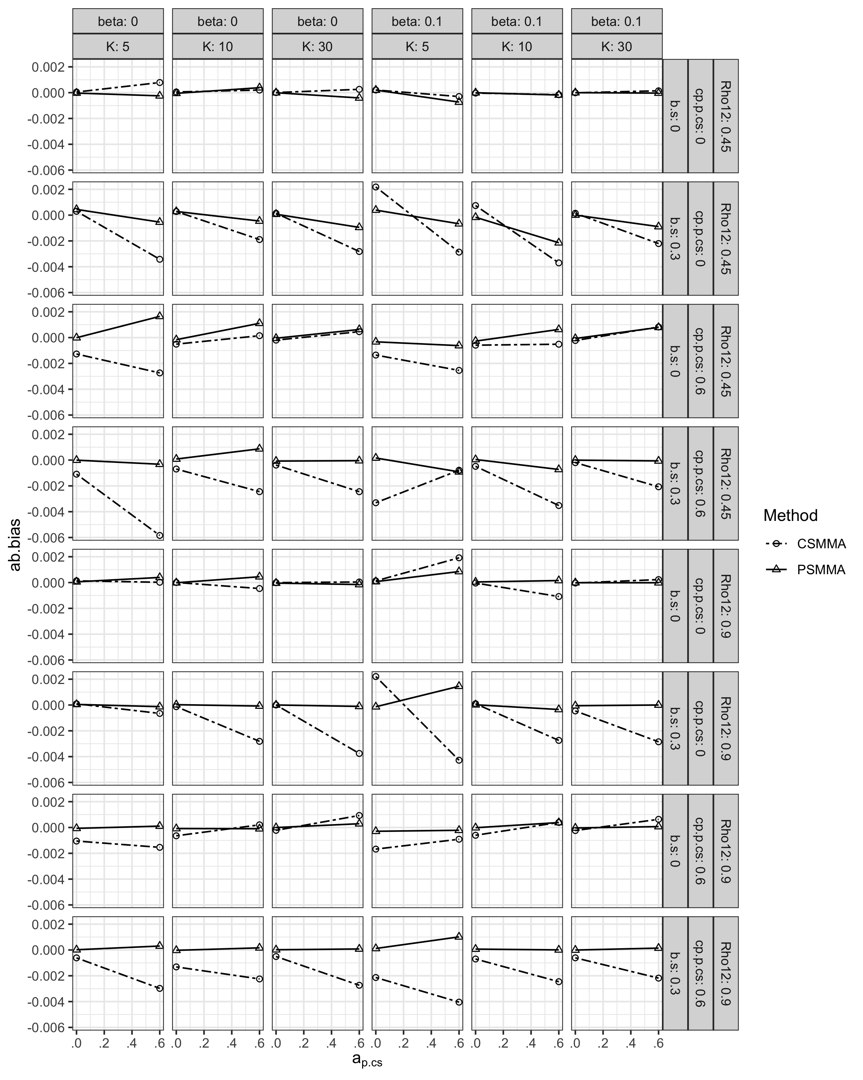

**CR.** The CR of both approaches remained above 0.95 (Figure S2).

**Figure S2.**

*Coverage Rates of the Indirect Effect under All Conditions in Study 1*

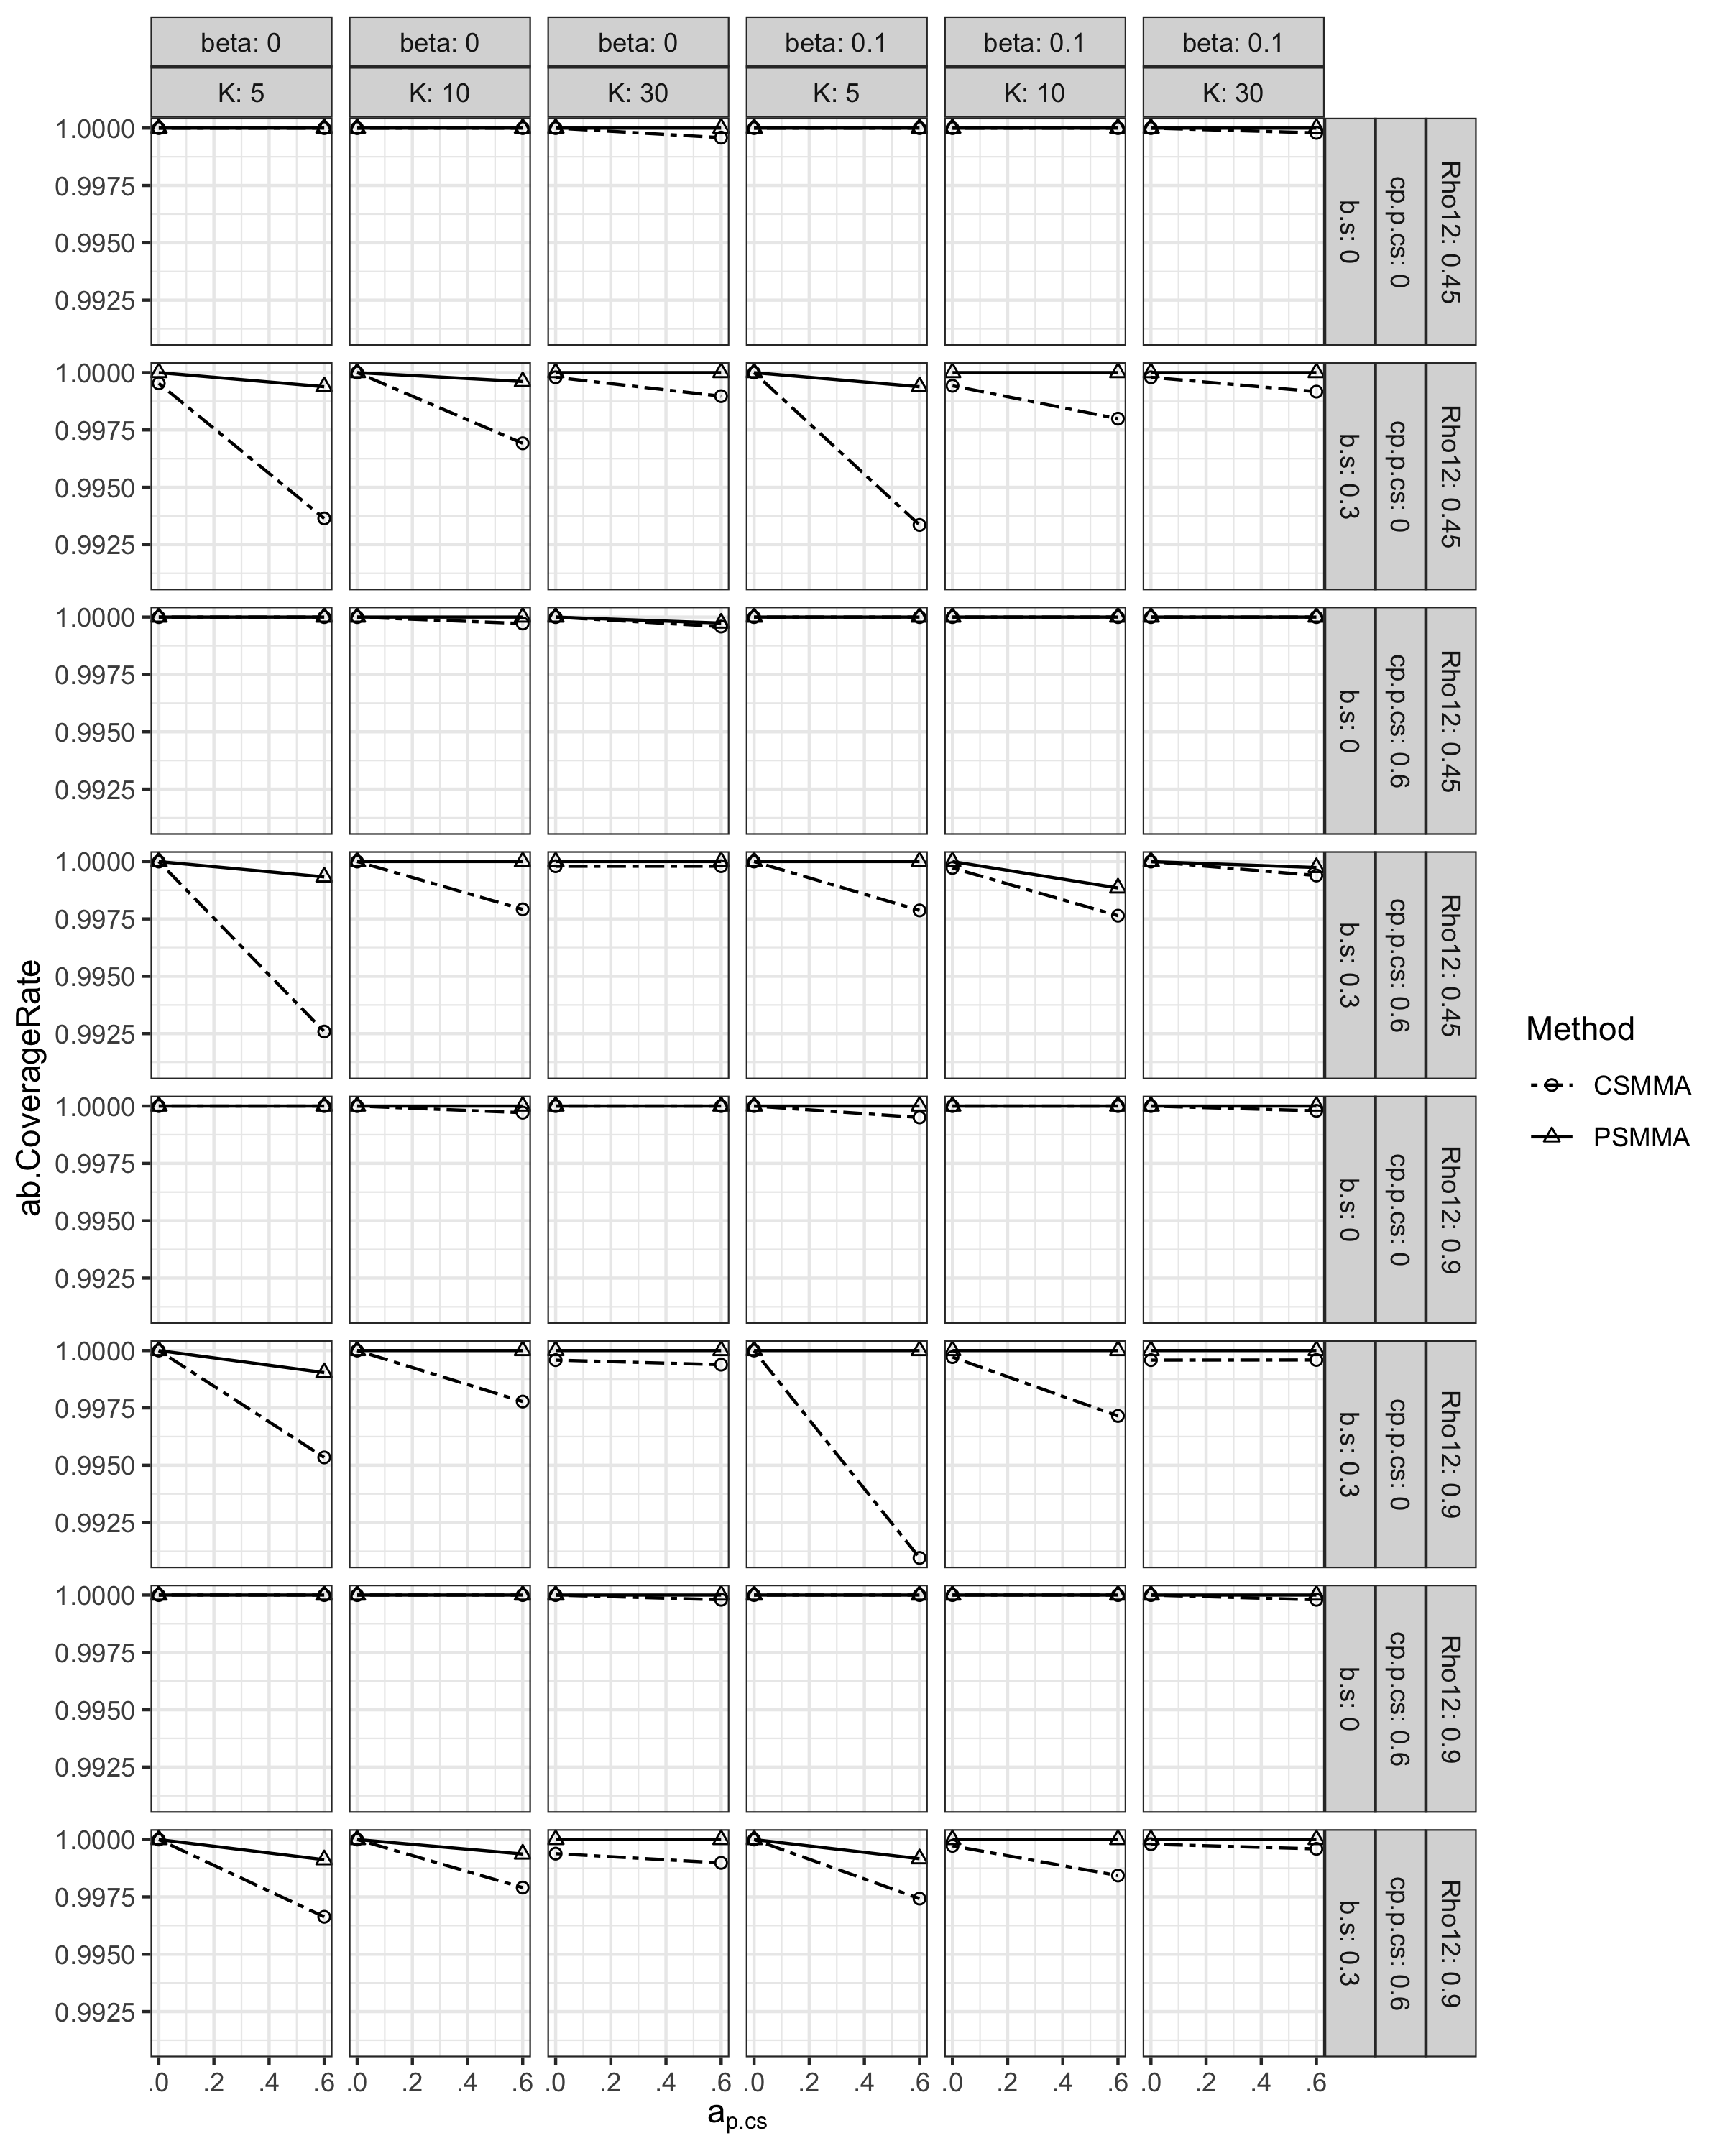

**Type I error Rates.** The type I error rates of CSMMA and PSMMA remained below 0.07 (Figure S3).

**Figure S3.**

*Type I Error Rates of the Indirect Effect under All Conditions in Study 1*

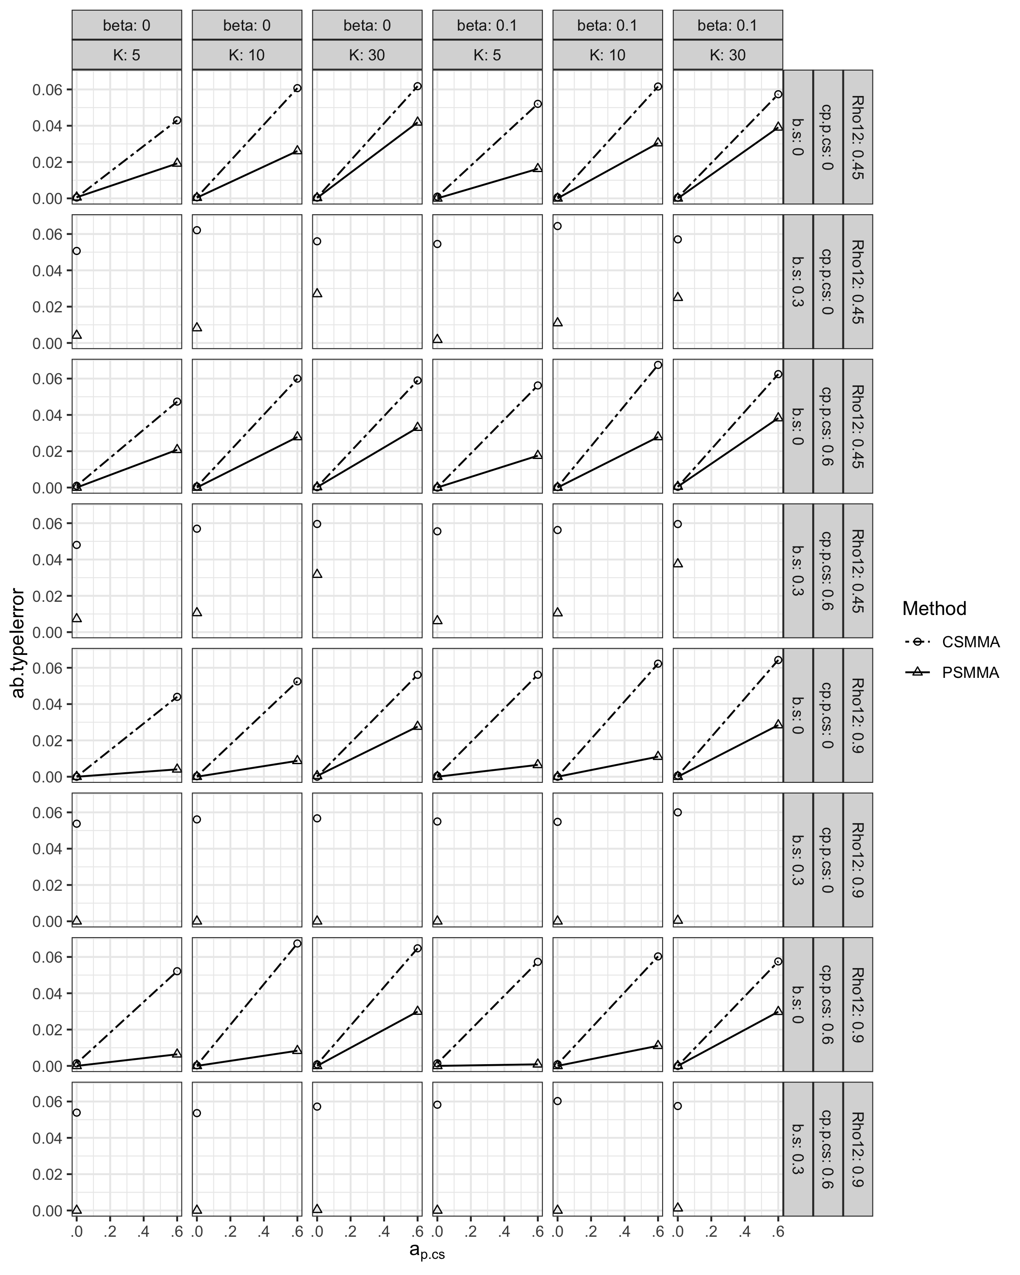

**Statistical Power.** The pattern of statistical power of CSMMA and PSMMA was demonstrated in the main text. The magnitude of the moderating effect $β_{c_{s,cs}^{'}}$ and $c_{s,cs}^{'}$ had no apparent effect on statistical power when estimating the indirect effect (Figure. S4).

**Figure S4.**

*Statistical Power of the Indirect Effect under All Conditions in Study 1*

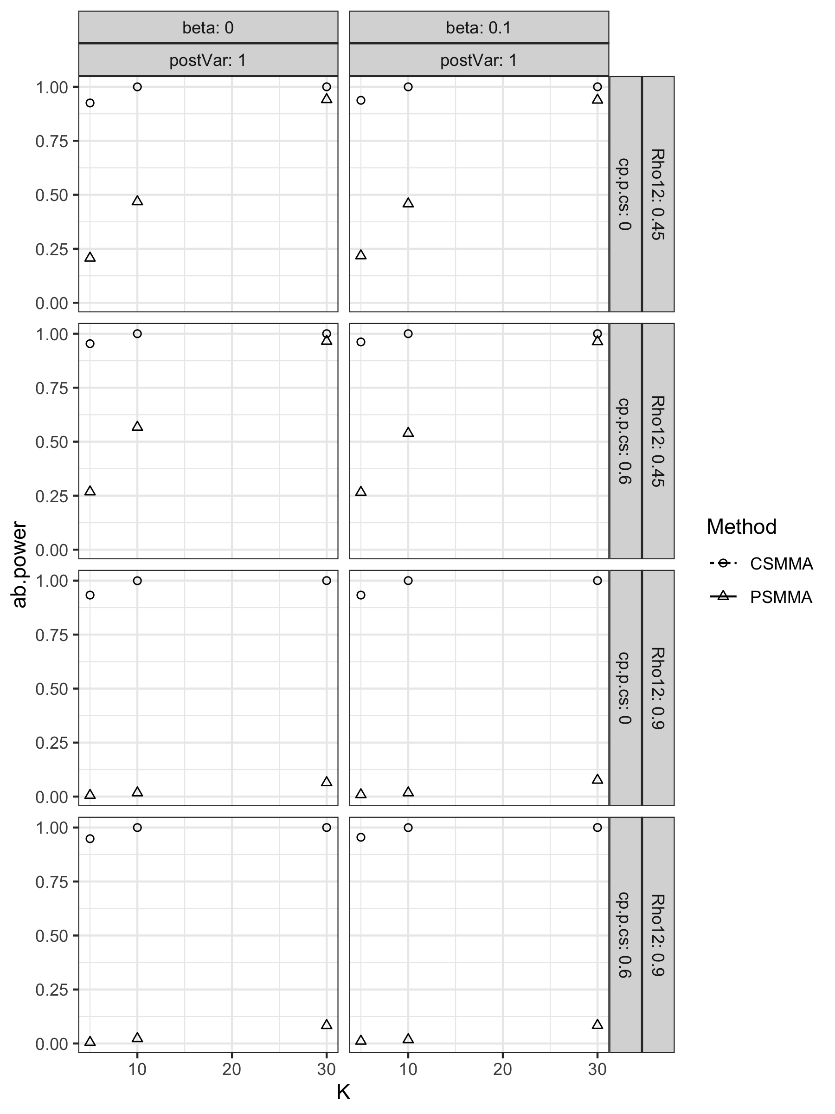

### S2.1.2 Direct Effect

**Bias.** As shown in Figure S5, both approaches had small bias.

**Figure S5.**

*Bias of the Direct Effect under All Conditions in Study 1*

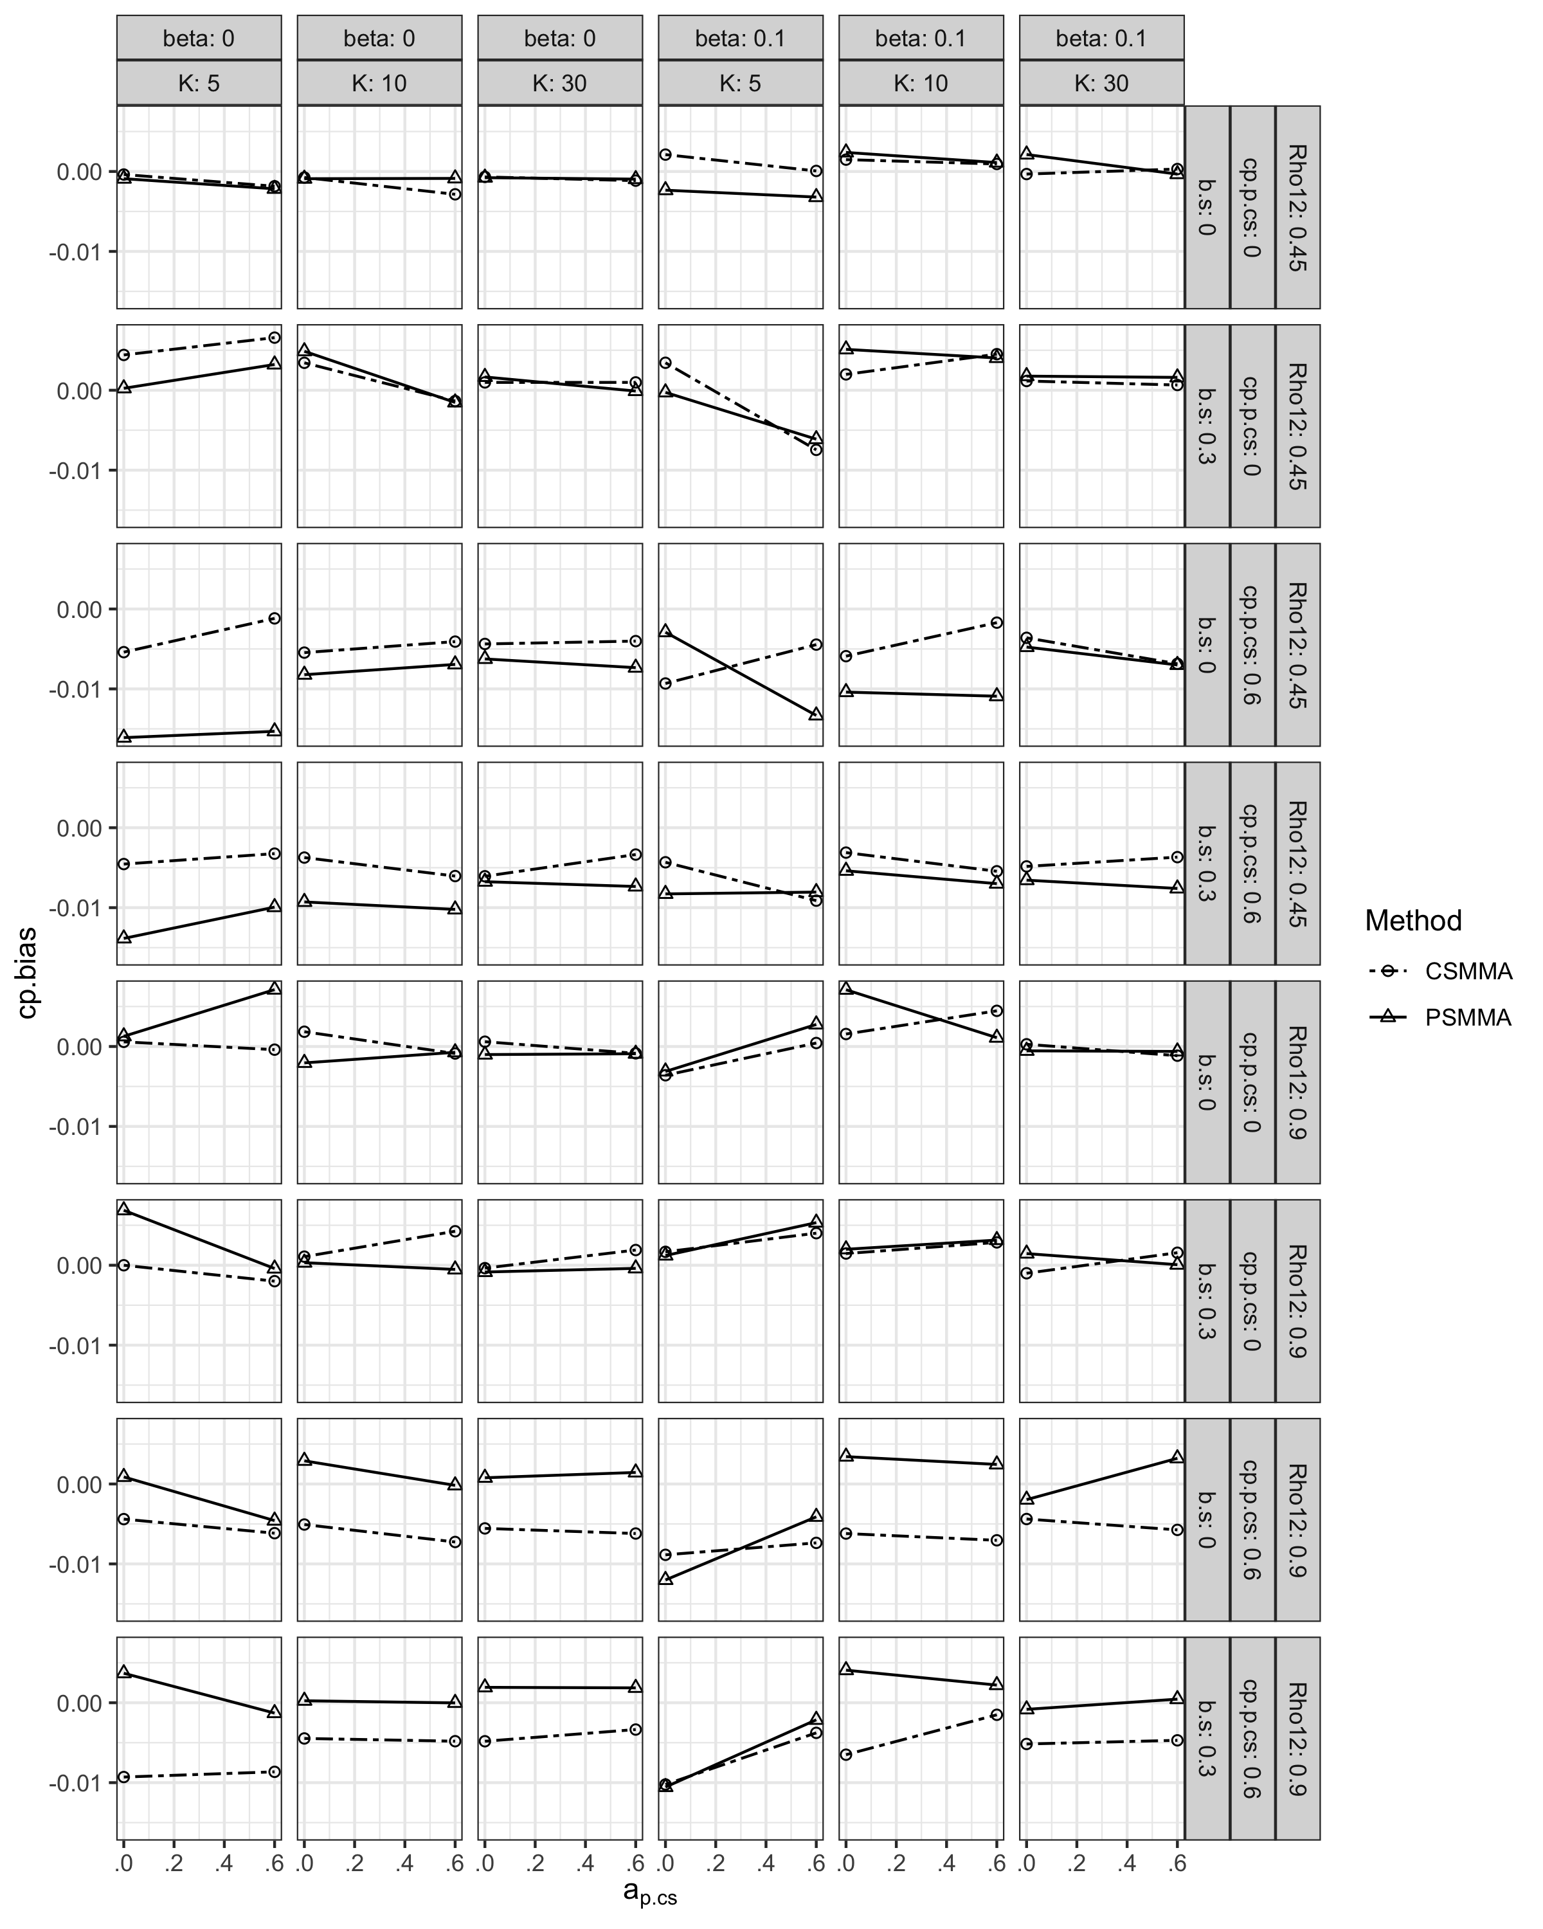

**CR.** The CR of both CSMMA and PSMMA remained above 0.85 (Figure S6).

**Figure S6.**

*Coverage Rates of the Direct Effect under all Conditions in Study 1*

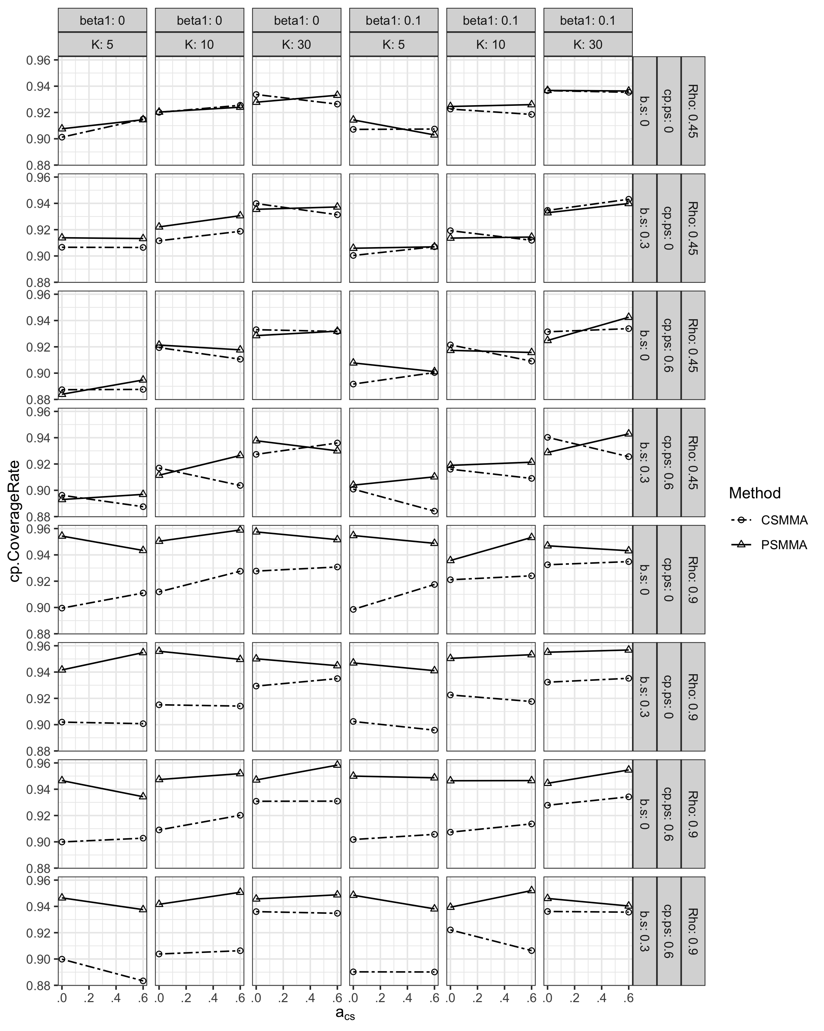

**Type I Error Rates.** The type I error rates of both approaches remained below 0.1 (Figure S7).

**Figure S7.**

*Type I Error Rates of the Direct Effect under All Conditions in Study 1*

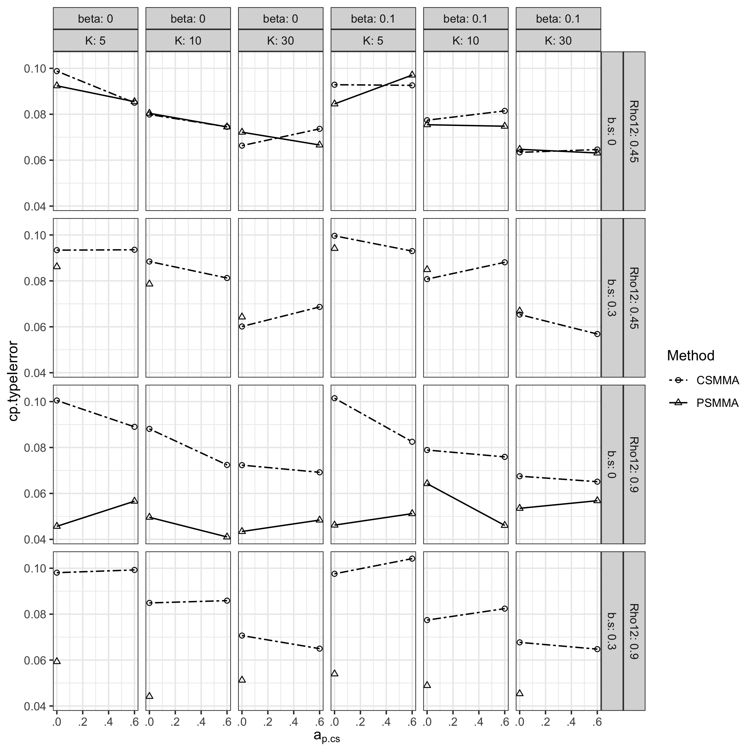

**Statistical Power.** The pattern of power of CSMMA and PSMMA was demonstrated in the main text. The size of $β_{c_{s,cs}^{'}}$ and $c_{s,cs}^{'}$ had no apparent effect on power (Figure S8).

**Figure S8.**

*Statistical Power of the Direct Effect under All Conditions in Study 1*

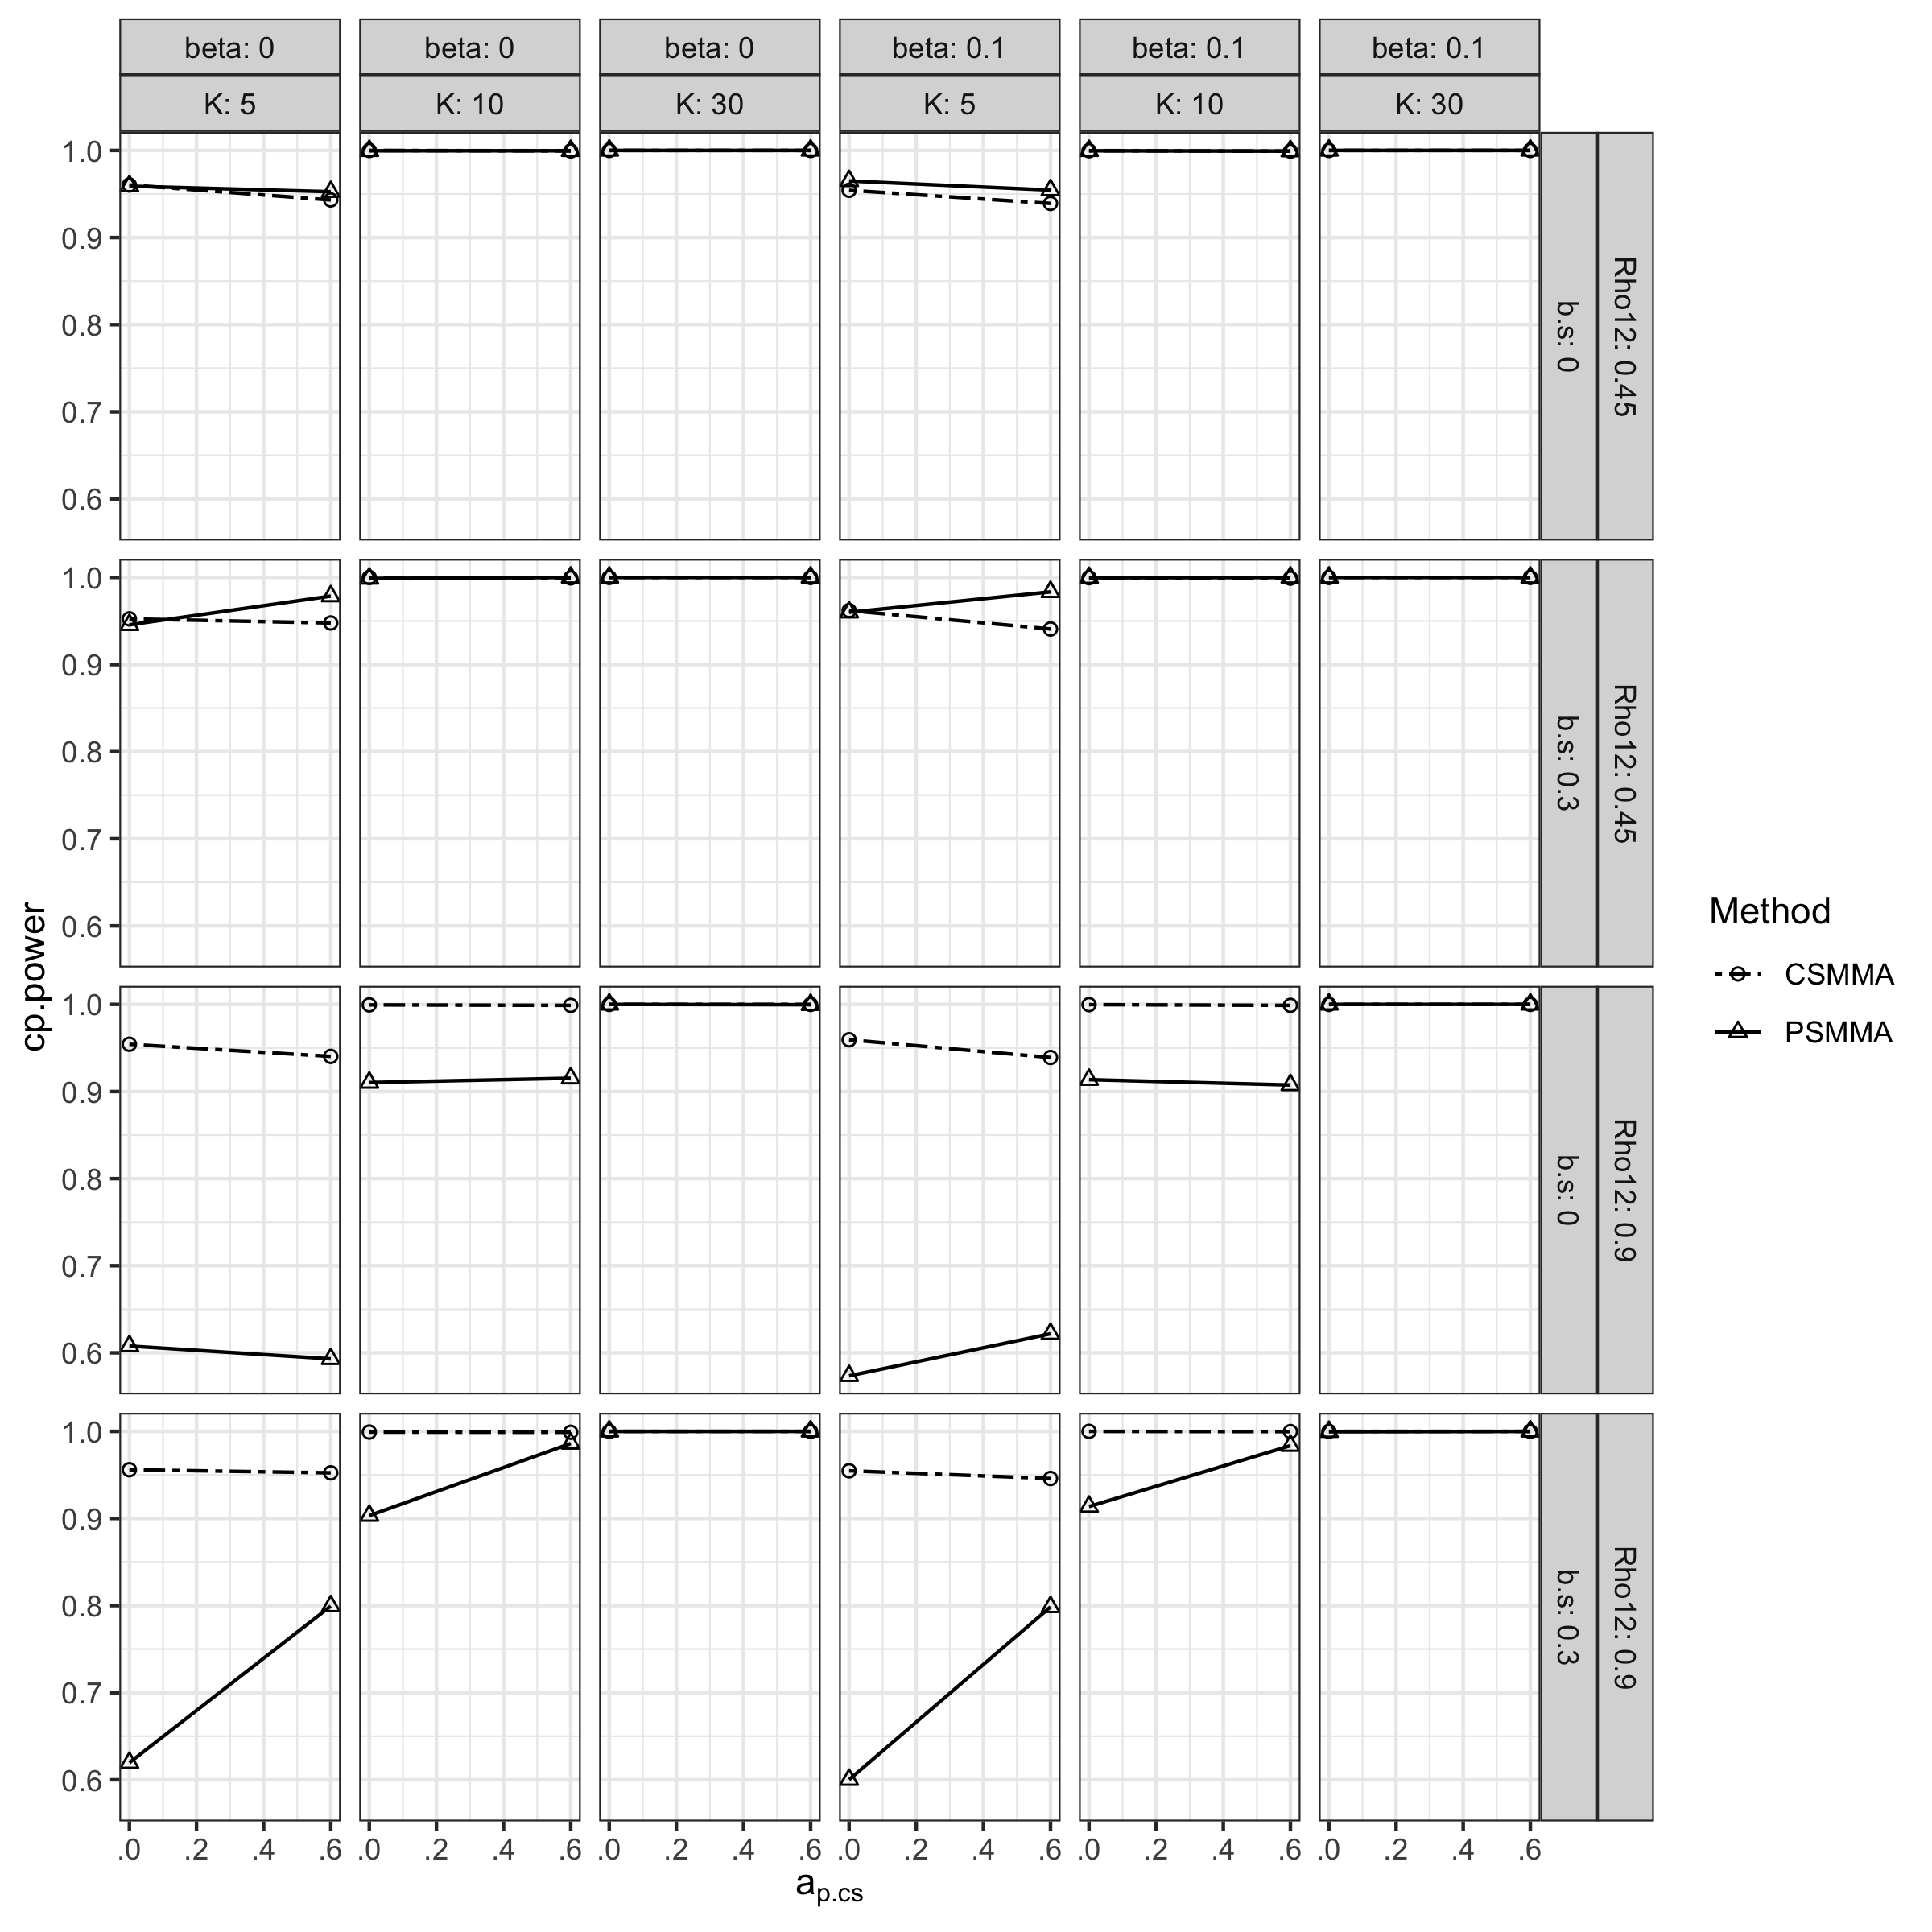

### S2.1.3 Moderating Effect

**Bias.** As shown in Figure S9, the bias of both CSMMA and PSMMA were small.

**Figure S9.**

*Bias of the Moderating Effect under All Conditions in Study 1*

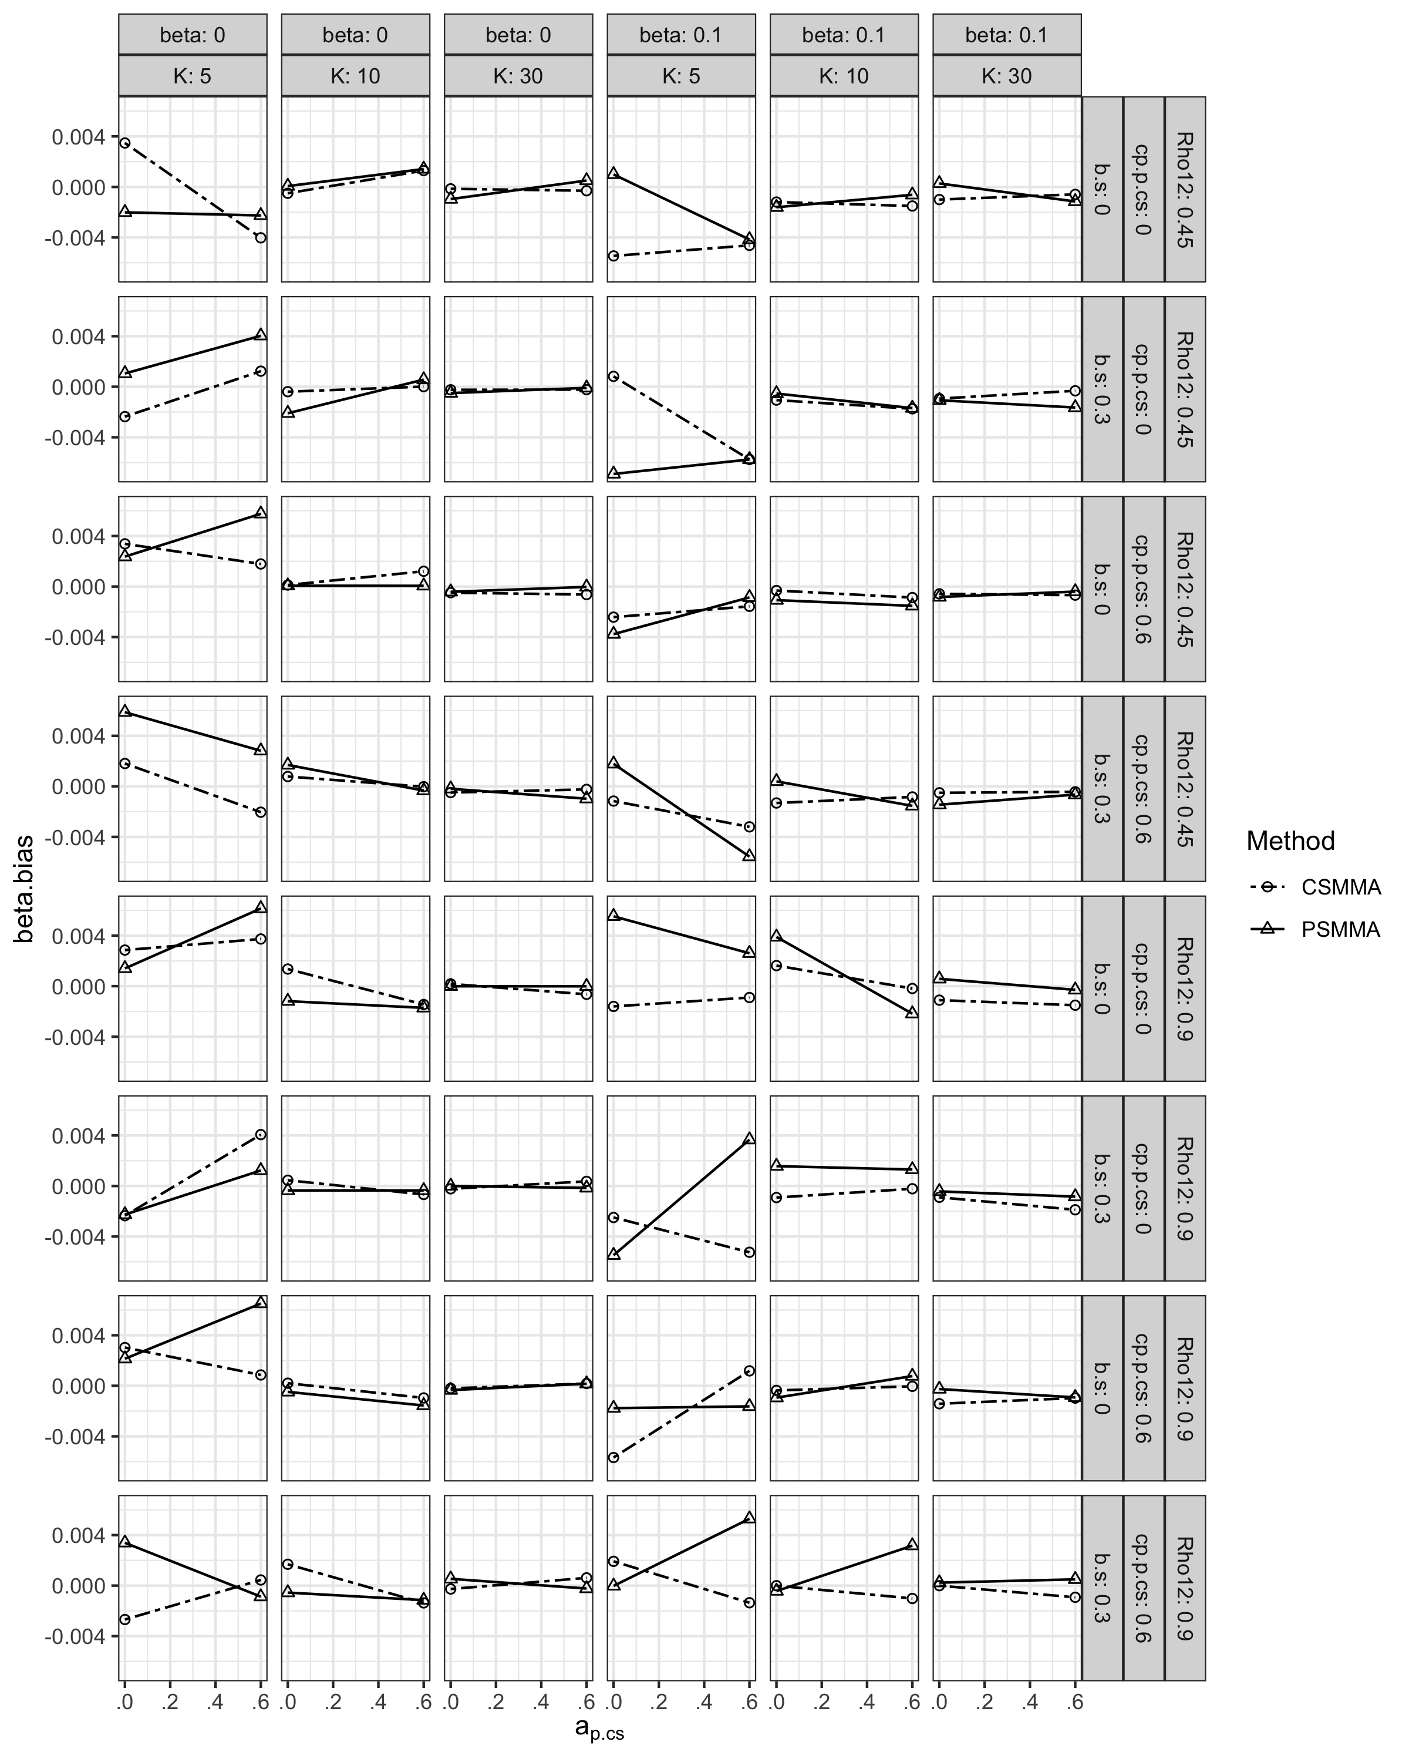

**CR.** The CR of both CSMMA and PSMMA remained above 0.85 (Figure S10).

**Figure S10.**

*Coverage Rates of the Moderating Effect under All Conditions in Study 1*

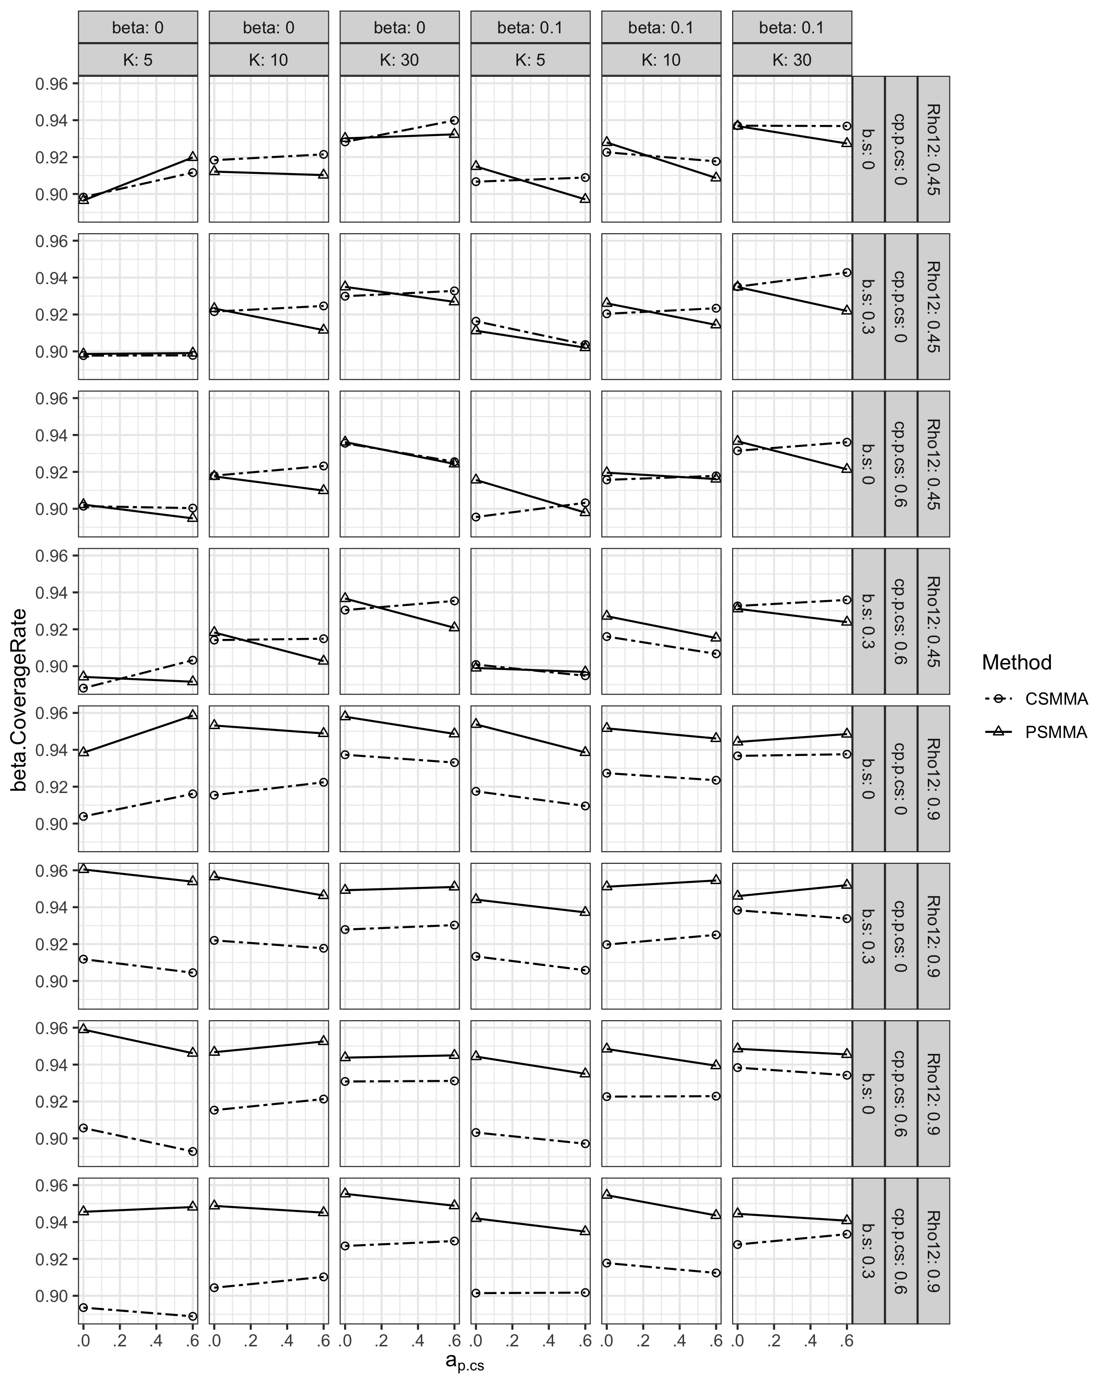

**Type I Error Rates.** The pattern of type I error rates was demonstrated in the main text. The magnitude of $a_{s,cs}$, $b_{s,cs}$ and $c_{s,cs}^{'}$ had no apparent effect (Figure S11).

**Figure S11.**

*Type I Error Rates of the Moderating Effect under All Conditions in Study 1*

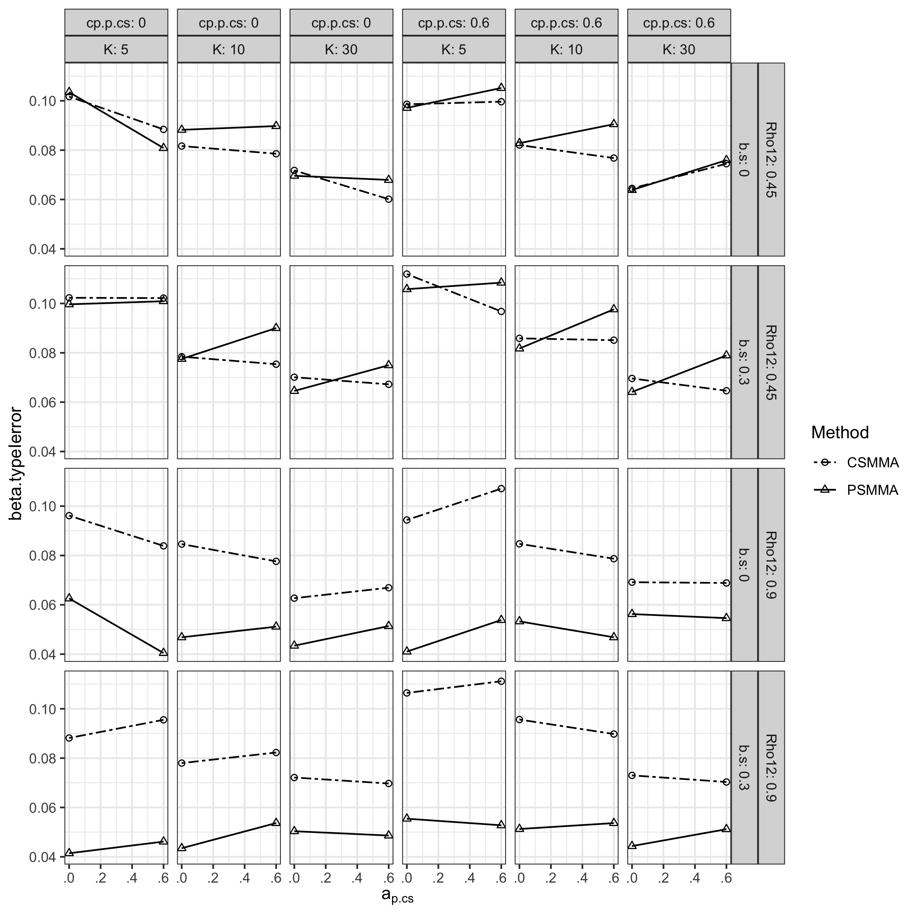

**Statistical Power.** The patter of statistical power regarding the moderating effect was demonstrated in the main text. The magnitude of $a_{s,cs}$, $b_{s,cs}$ and $c_{s,cs}^{'}$ had no apparent effect on statistical power regarding the moderating effect (Figure S12).

**Figure S12.**

*Statistical Power of the Moderating Effect under All Conditions in Study 1*

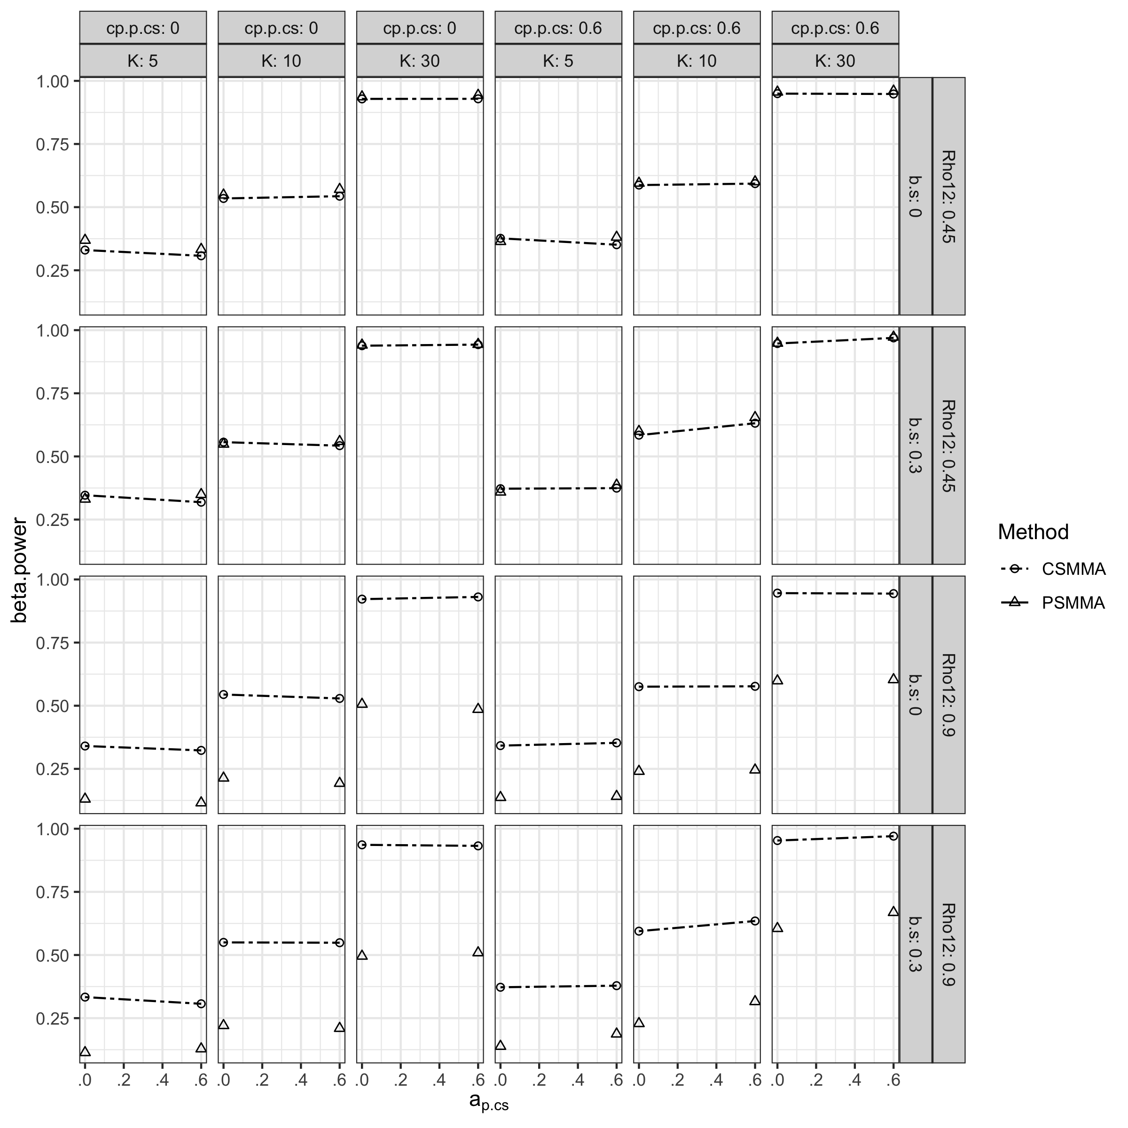

### S2.1.4 Coefficients of the a Path and the b Path

As shown in Figure S13-15, the bias, CR and type I error rates of $a$ path estimates of CSMMA and PSMMA both remained favorable under all conditions. The statistical power when estimating the $a$ path (Figure S16), on the other hand, decreased with a larger $ρ_{12}$, due to small true posttest score coefficient on the $a$ path.

**Figure S13.**

*bias of the a Path under All Conditions in Study 1*

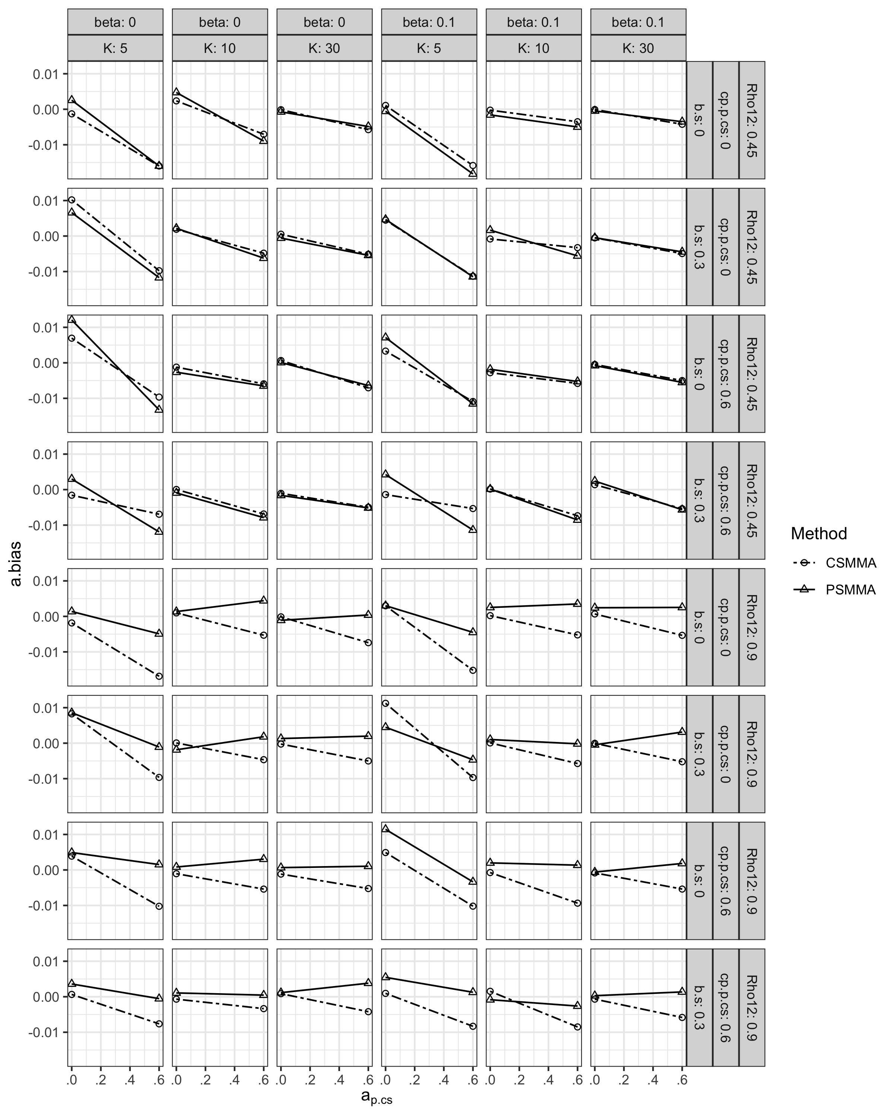

**Figure S14.**

*Coverage Rates of the a Path under All Conditions in Study 1*

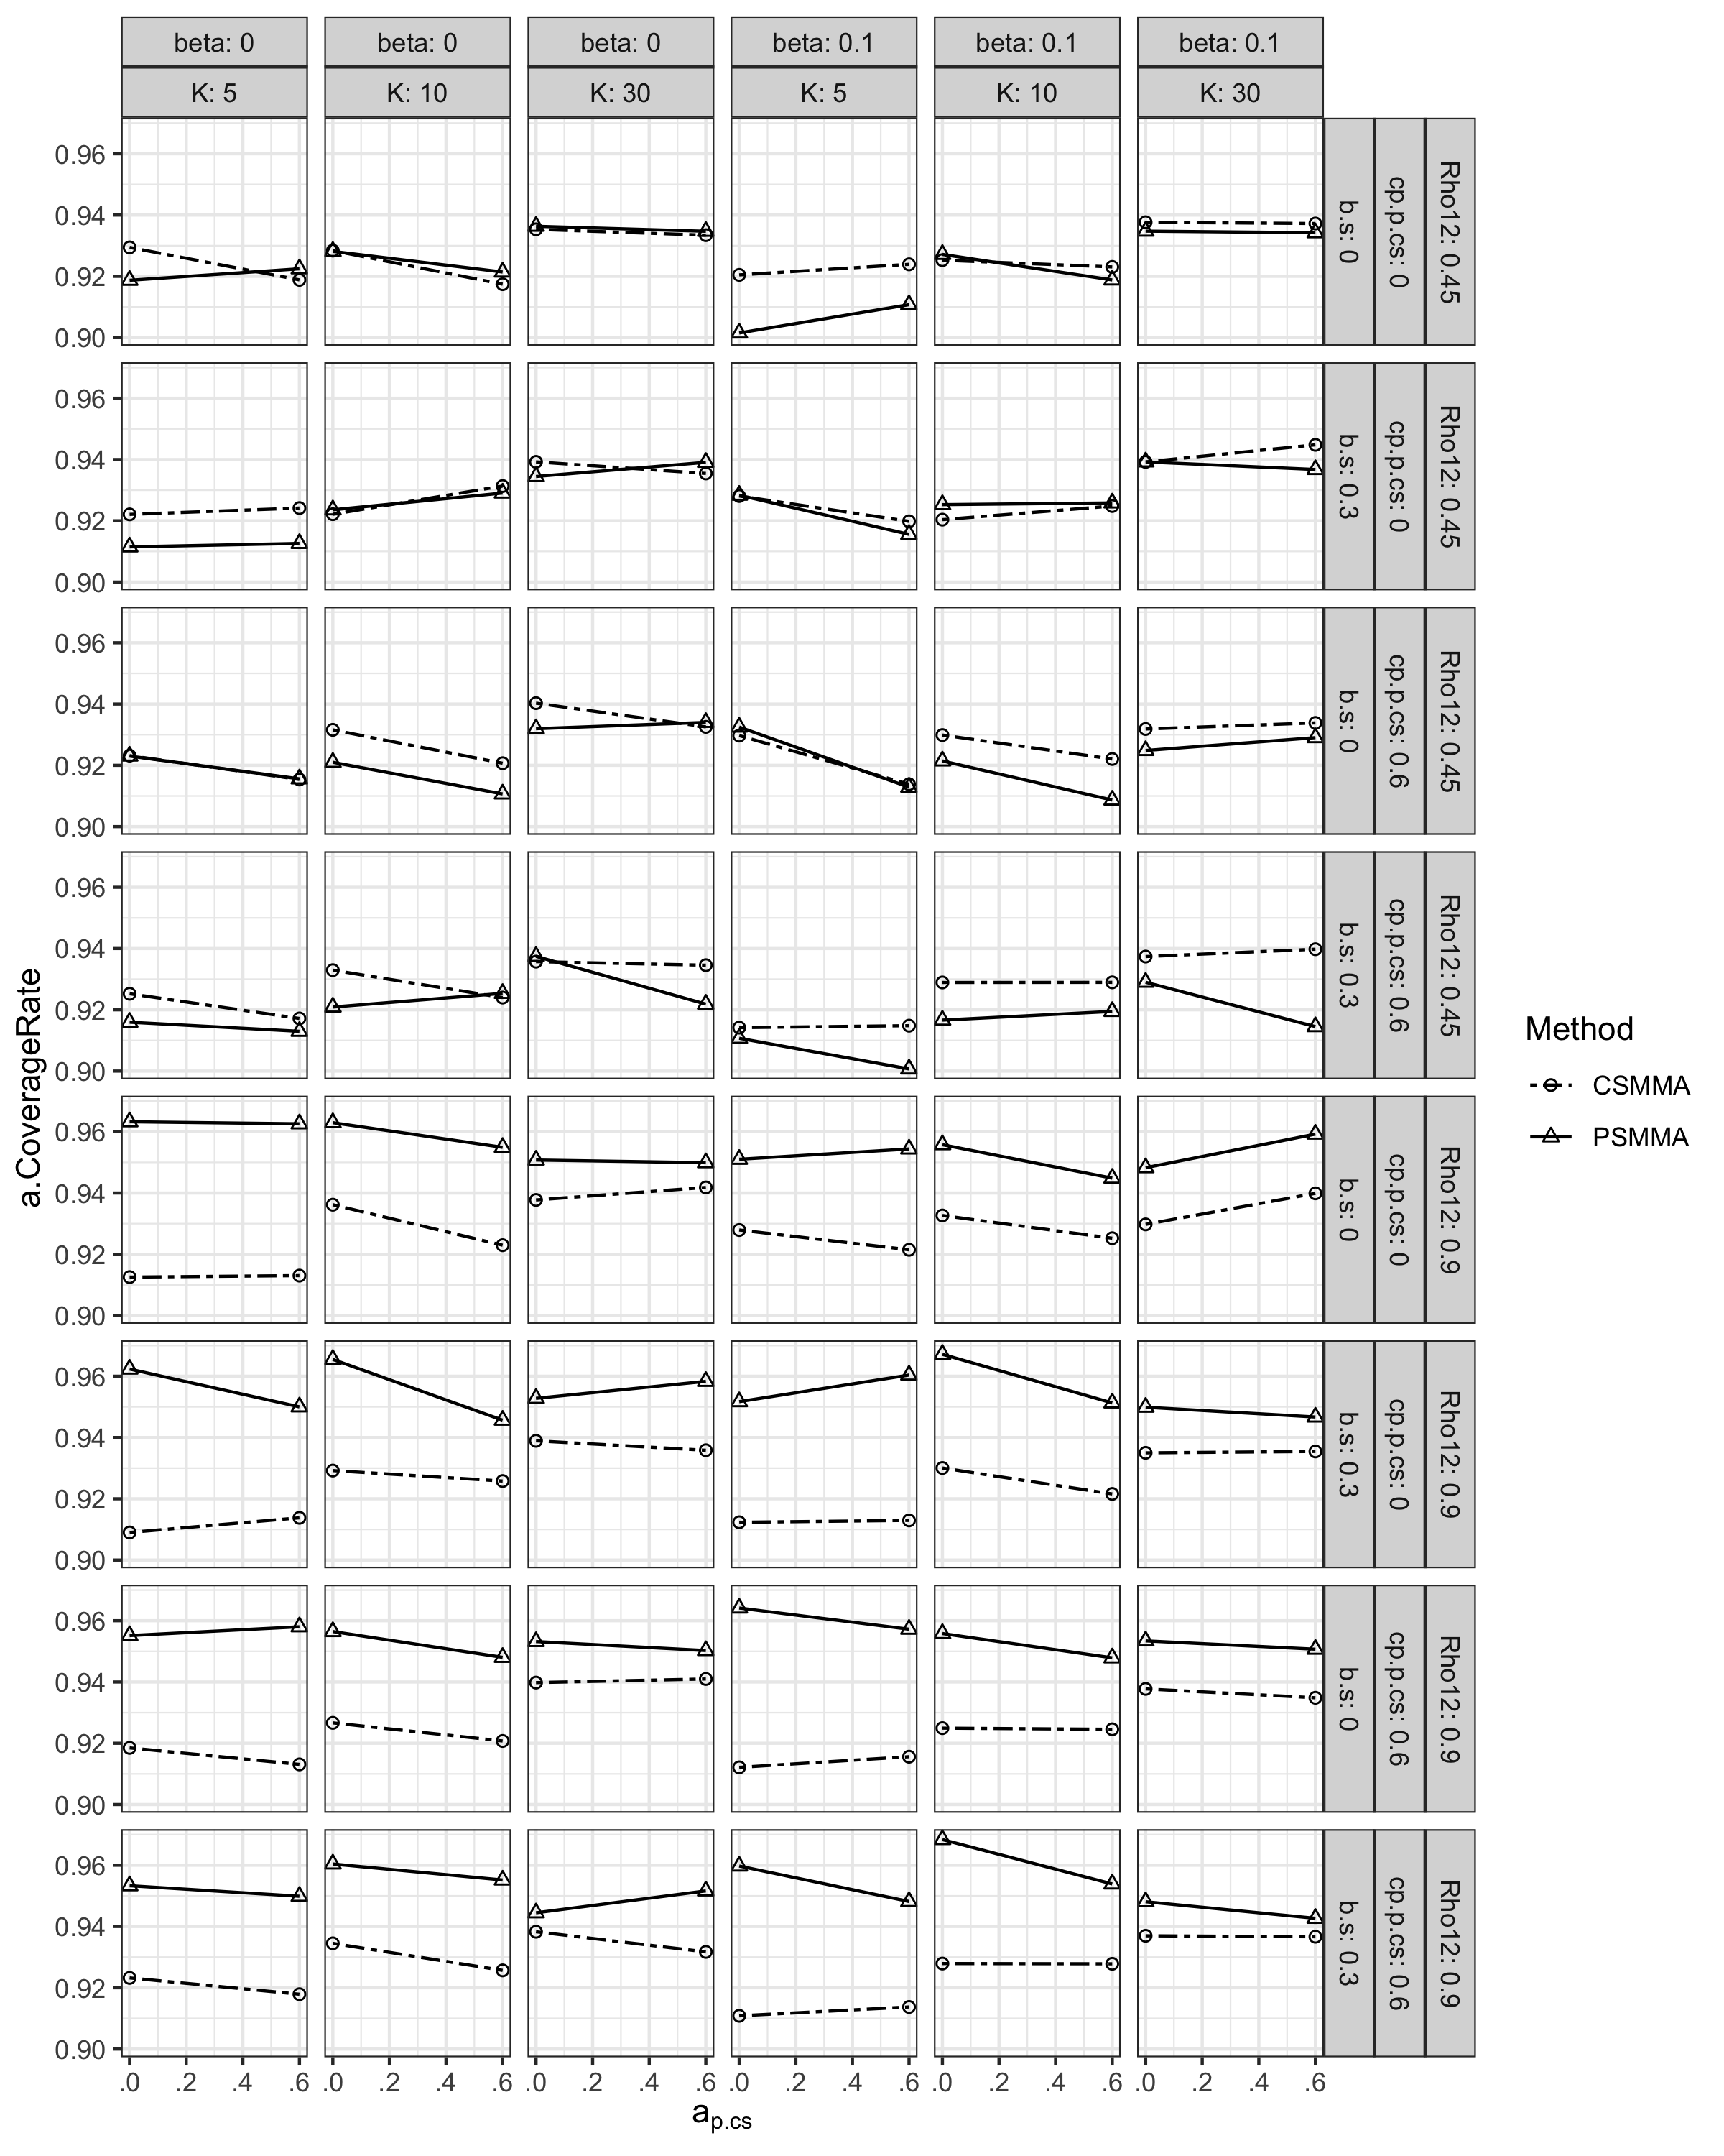

**Figure S15.**

*Type I Error Rates of the a Path under All Conditions in Study 1*

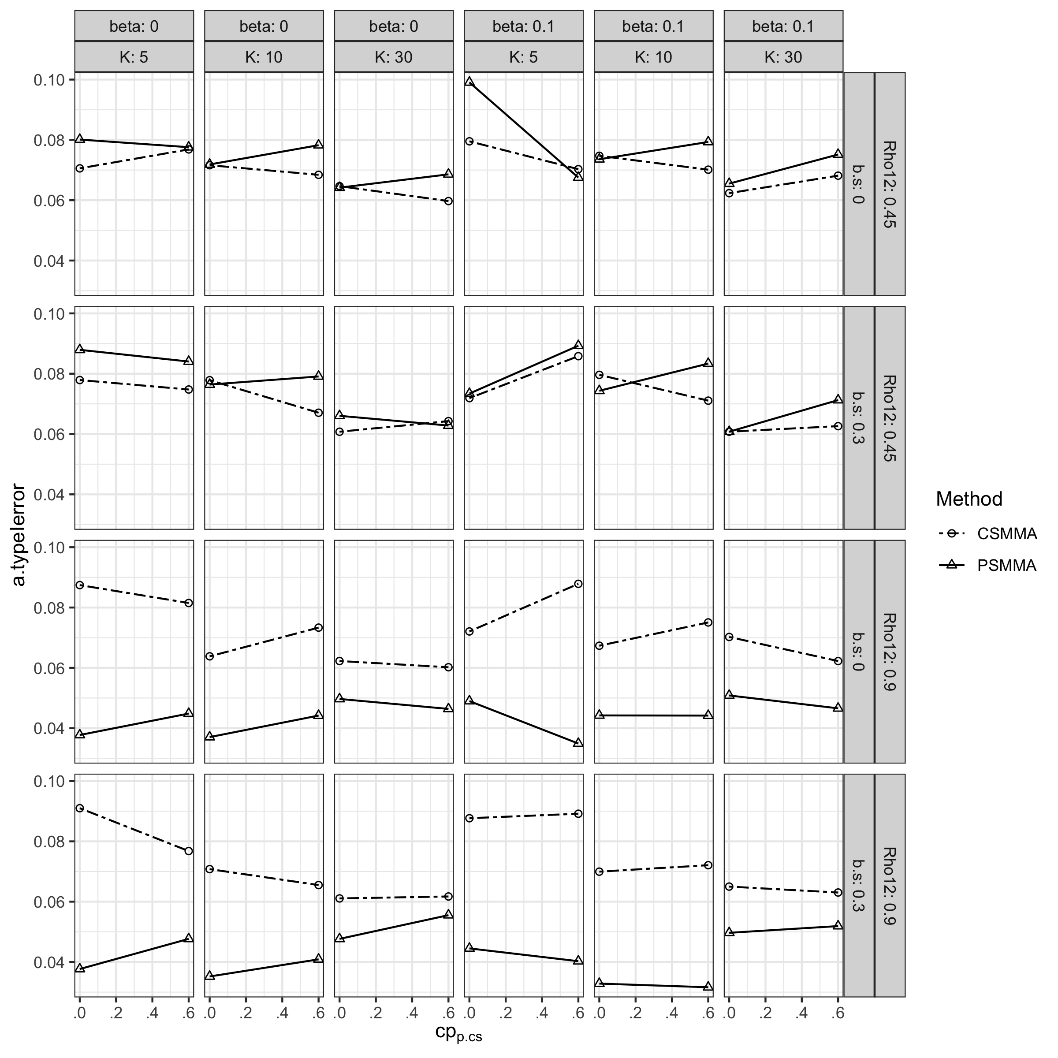

**Figure S16.**

*Statistical Power of the a Path under All Conditions in Study 1*

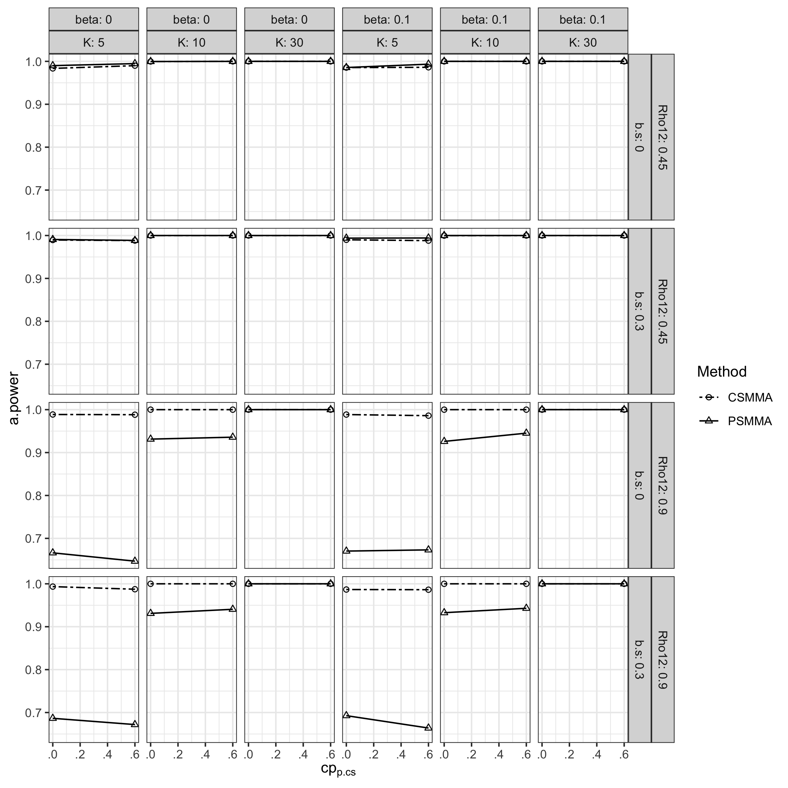

When estimating the $b$ path, both CSMMA and PSMMA had small bias (Figure S17). The CR of both CSMMA and PSMMA remained above $0.9$ (Figure S18). The type I error rates of CSMMA and PSMMA fluctuated from $0.02$ to $0.1$ (Figure S19). While the power of CSMMA remained above 0.9, that of PSMMA dropped with a smaller $K$ and a larger $ρ_{12}$ (Figure S20).

**Figure S17.**

*Bias of the b Path Coefficient under All Conditions in Study 1*

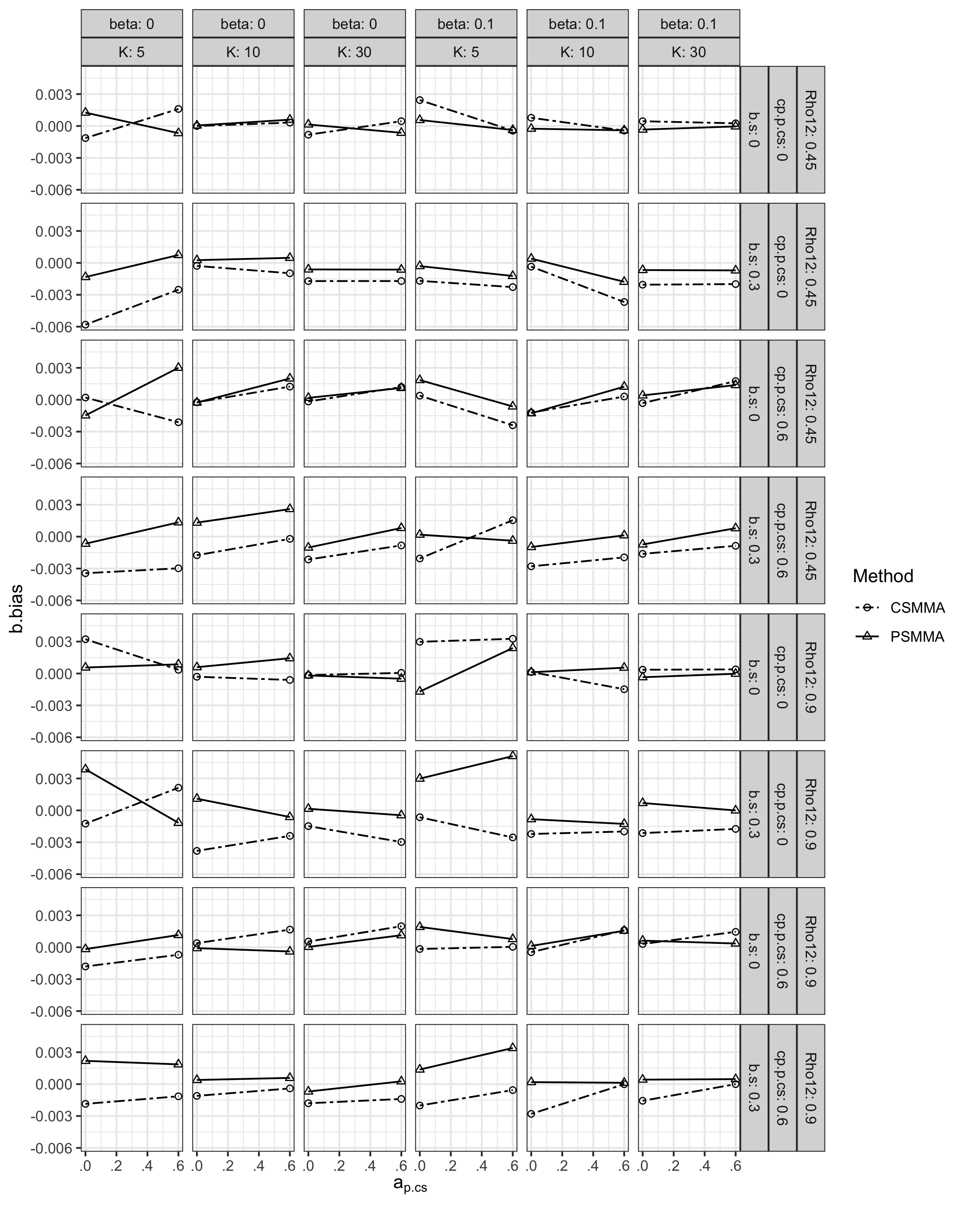

**Figure S18.**

*Coverage Rates of the b Path Coefficient under All Conditions in Study 1*

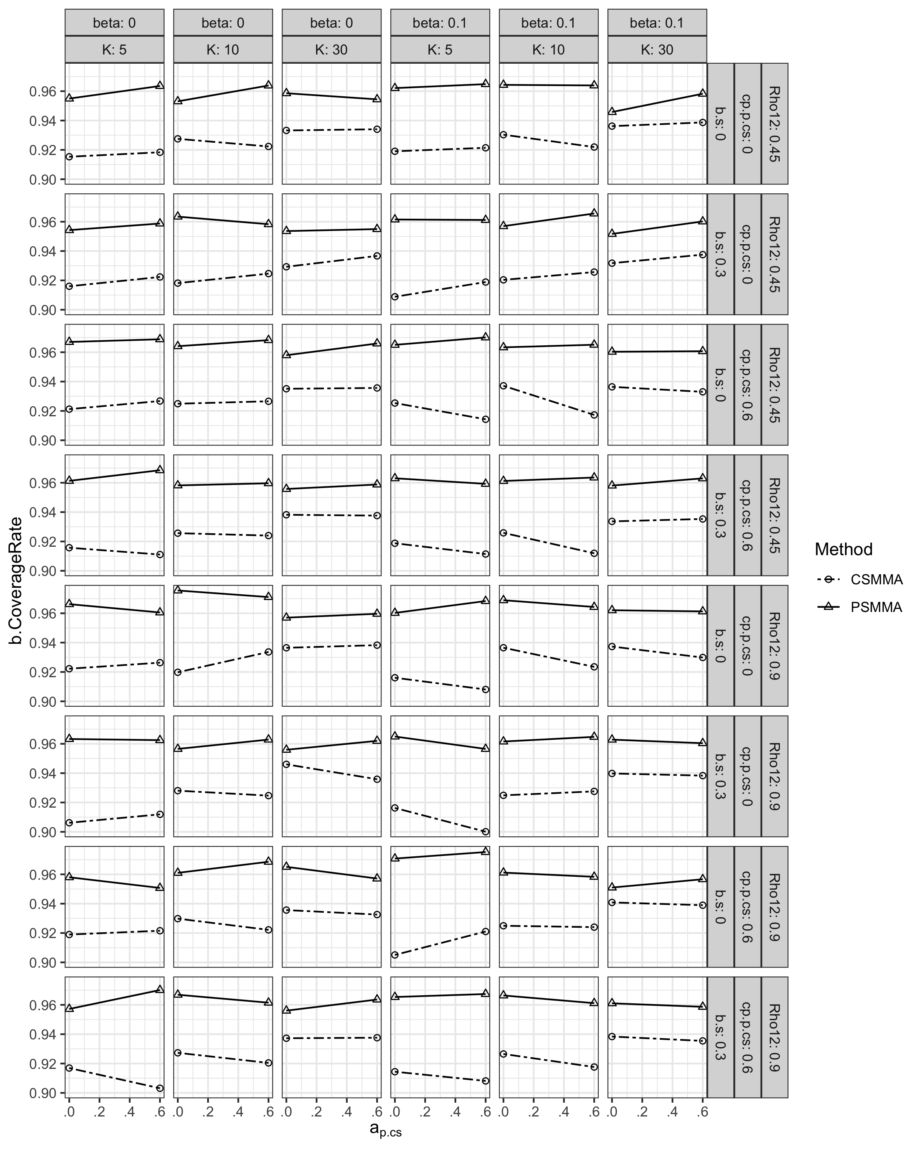

**Figure S19.**

*Type I Error Rates of the b Path Coefficient under All Conditions in Study 1*

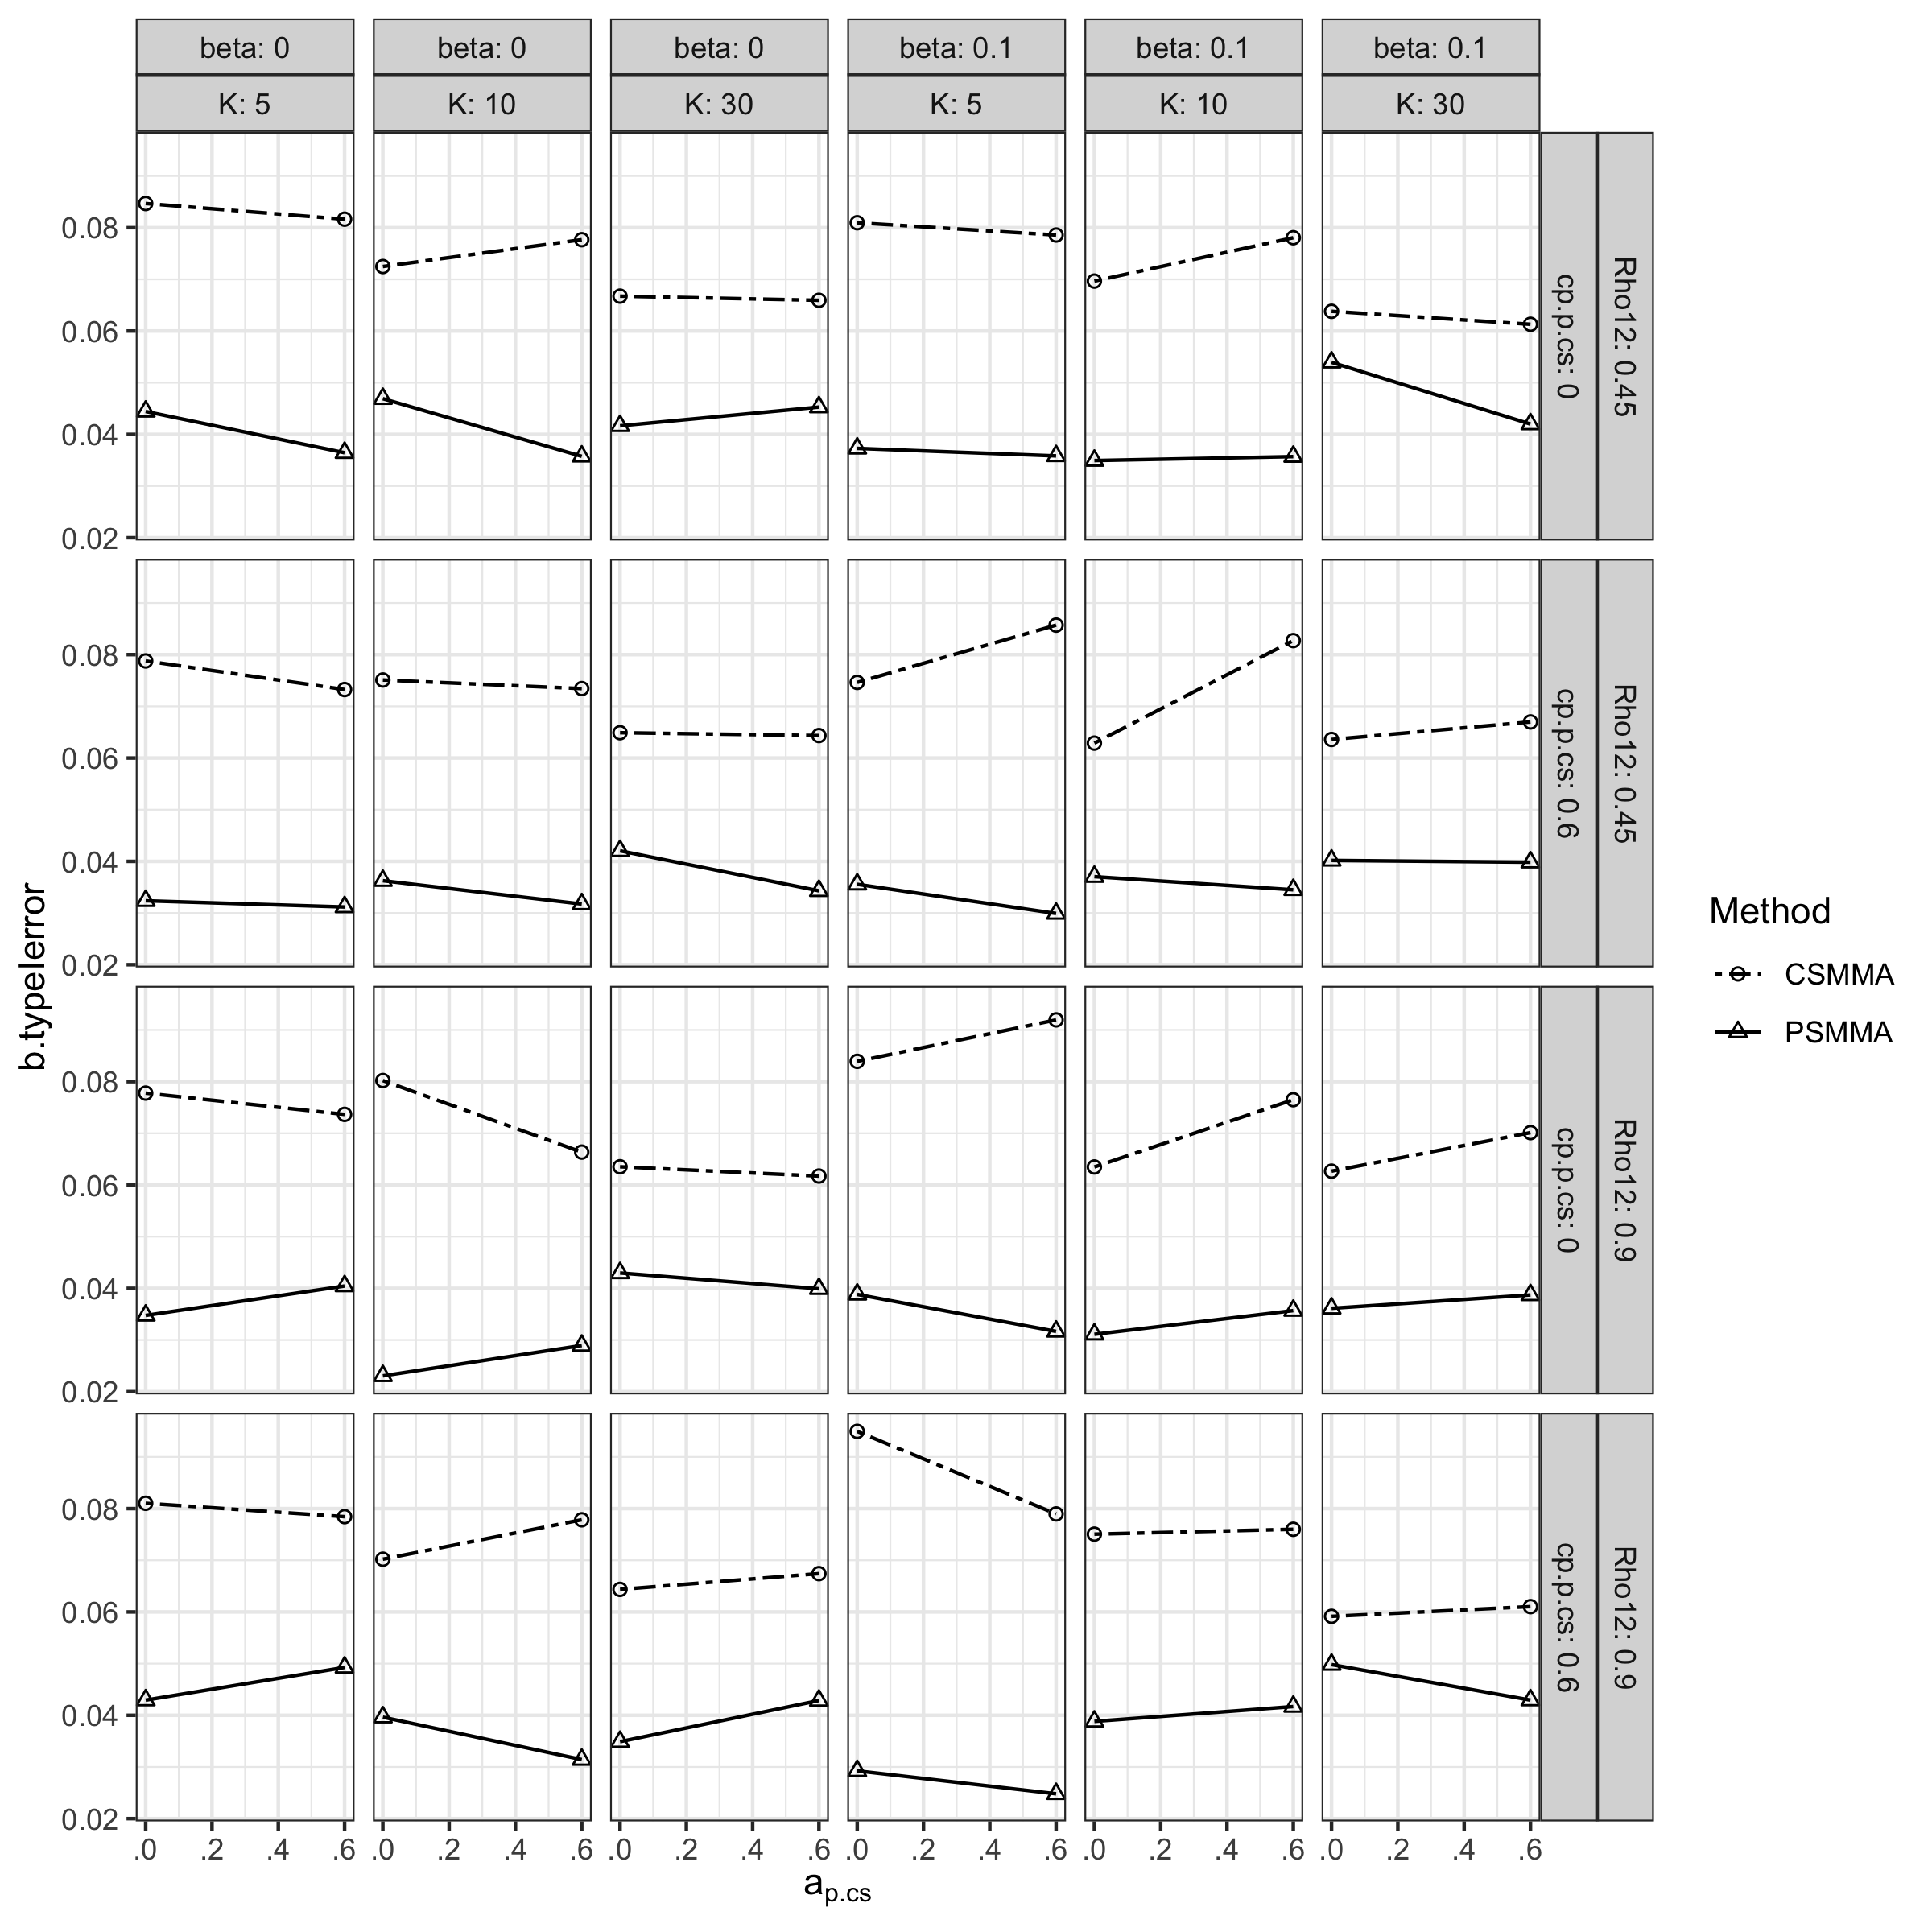

**Figure S20.**

*Statistical Power of the b Path Coefficient under All Conditions in Study 1*

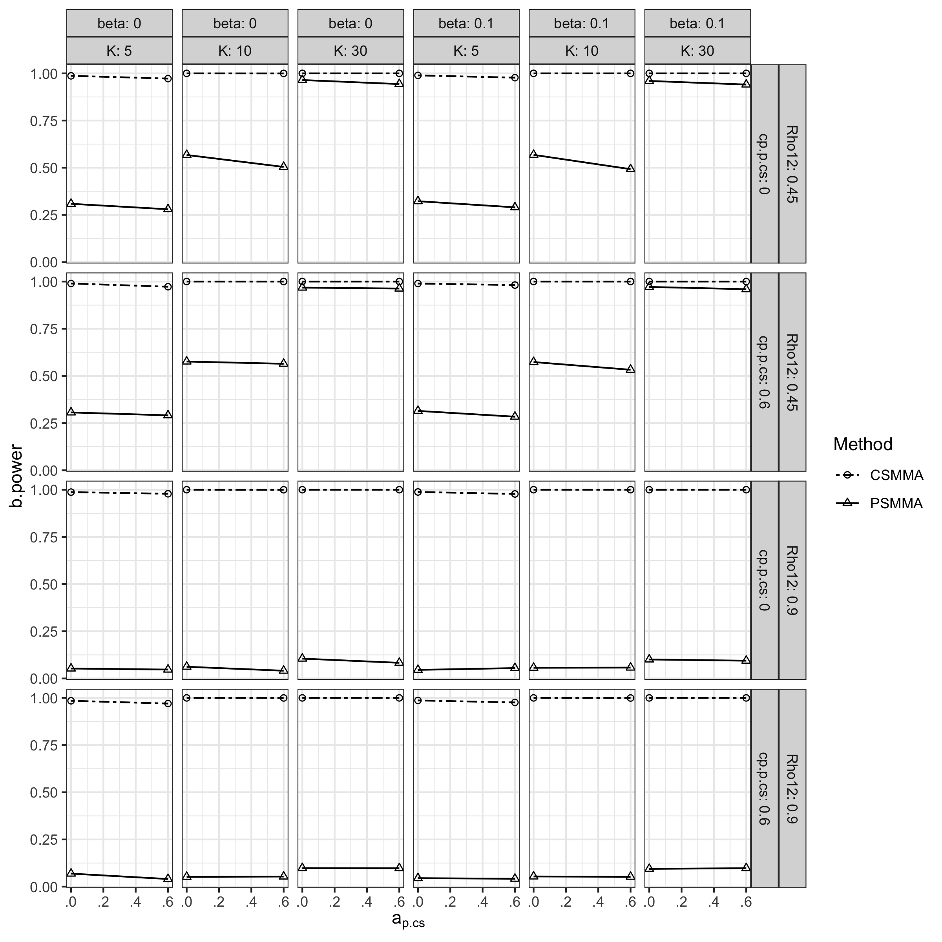

## S2.2 Study 2

### S2.2.1 Indirect Effect

As shown in Figure S21-23, the patterns of bias, CR, type I error rates and power of CSMMA and PSMMA in Study 2 were similar to Study 1. However, as illustrated in the main text, the inflation of posttest variances increased the power of PSMMA, and $β_{c_{s,cs}^{'}}$ and $c_{s,cs}^{'}$ had no apparent effect on this pattern (Figure S24).

**Figure S21.**

*Bias of the Indirect Effect under All Conditions in Study 2*

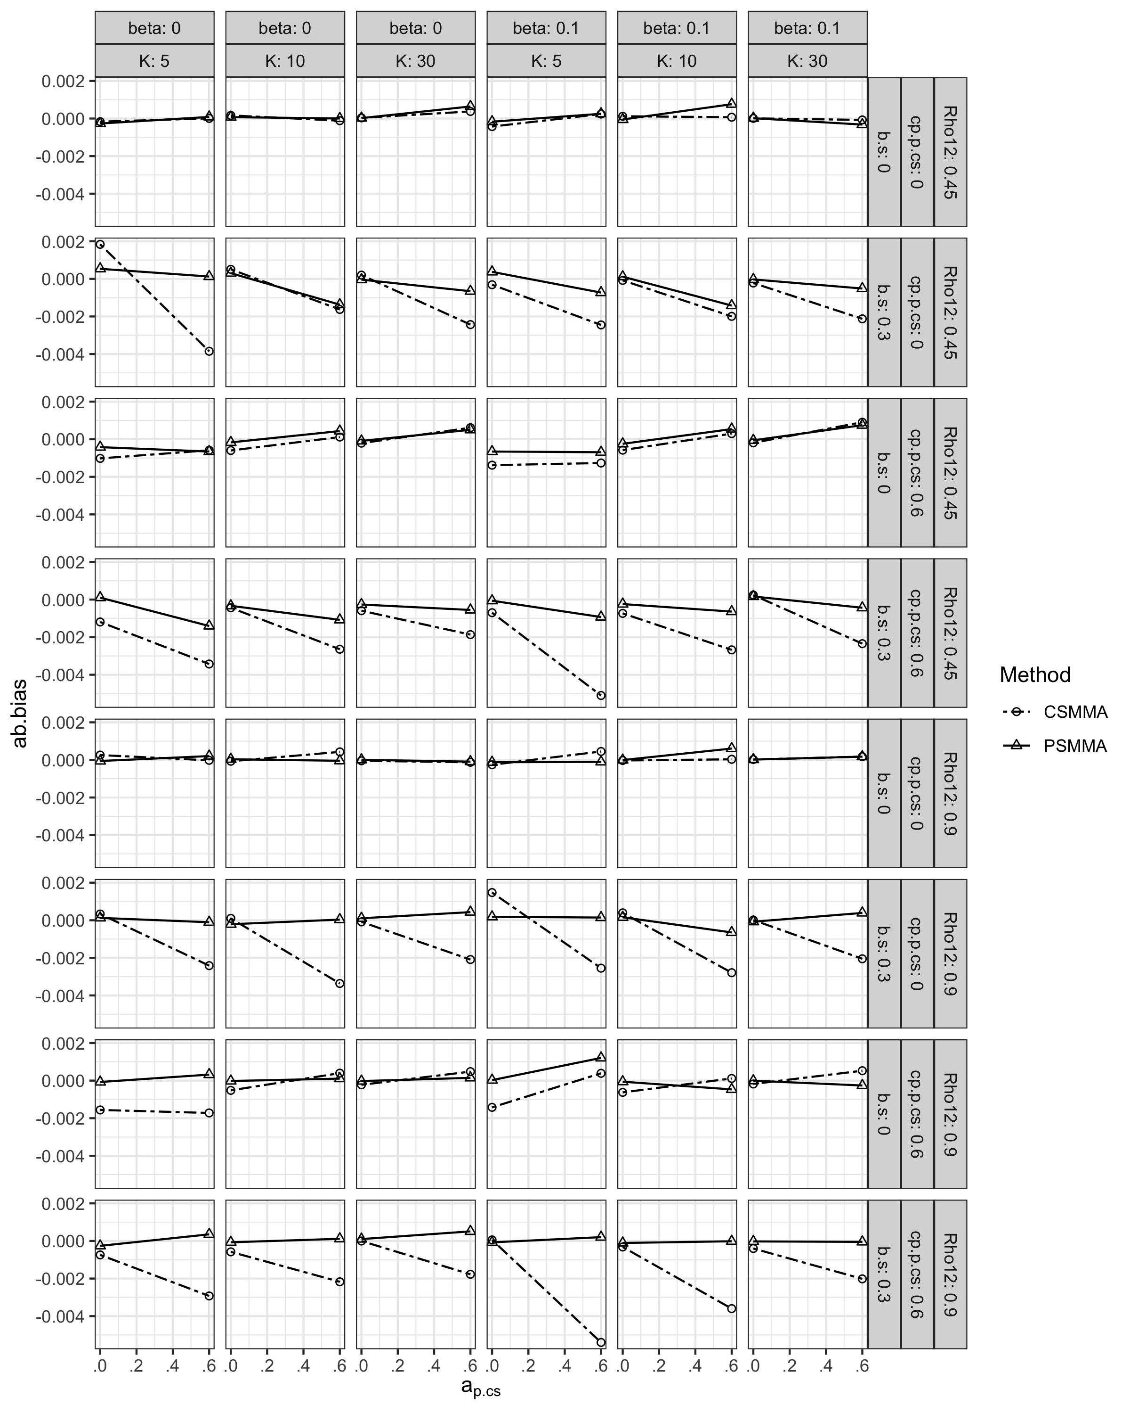

**Figure S22.**

*Coverage Rates of the Indirect Effect under All Conditions in Study 2*

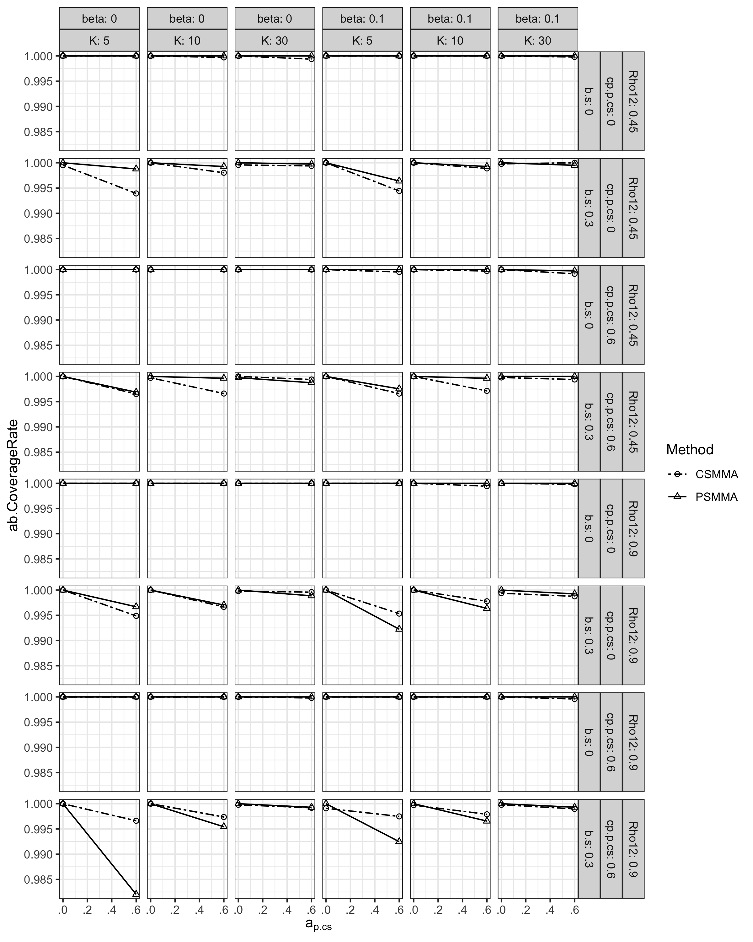

**Figure S23.**

*Type I Error Rates of the Indirect Effect under All Conditions in Study 2*

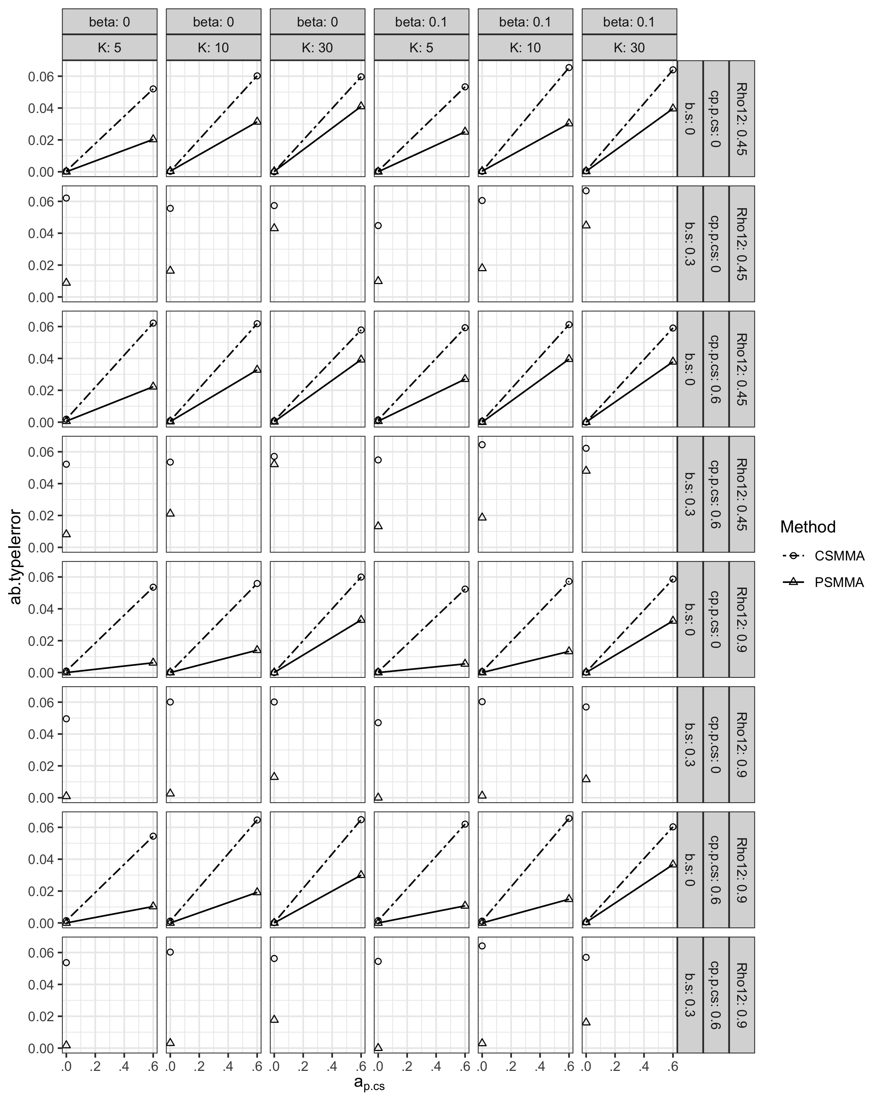

**Figure S24.**

*Statistical Power of the Indirect Effect under All Conditions in Study 2*

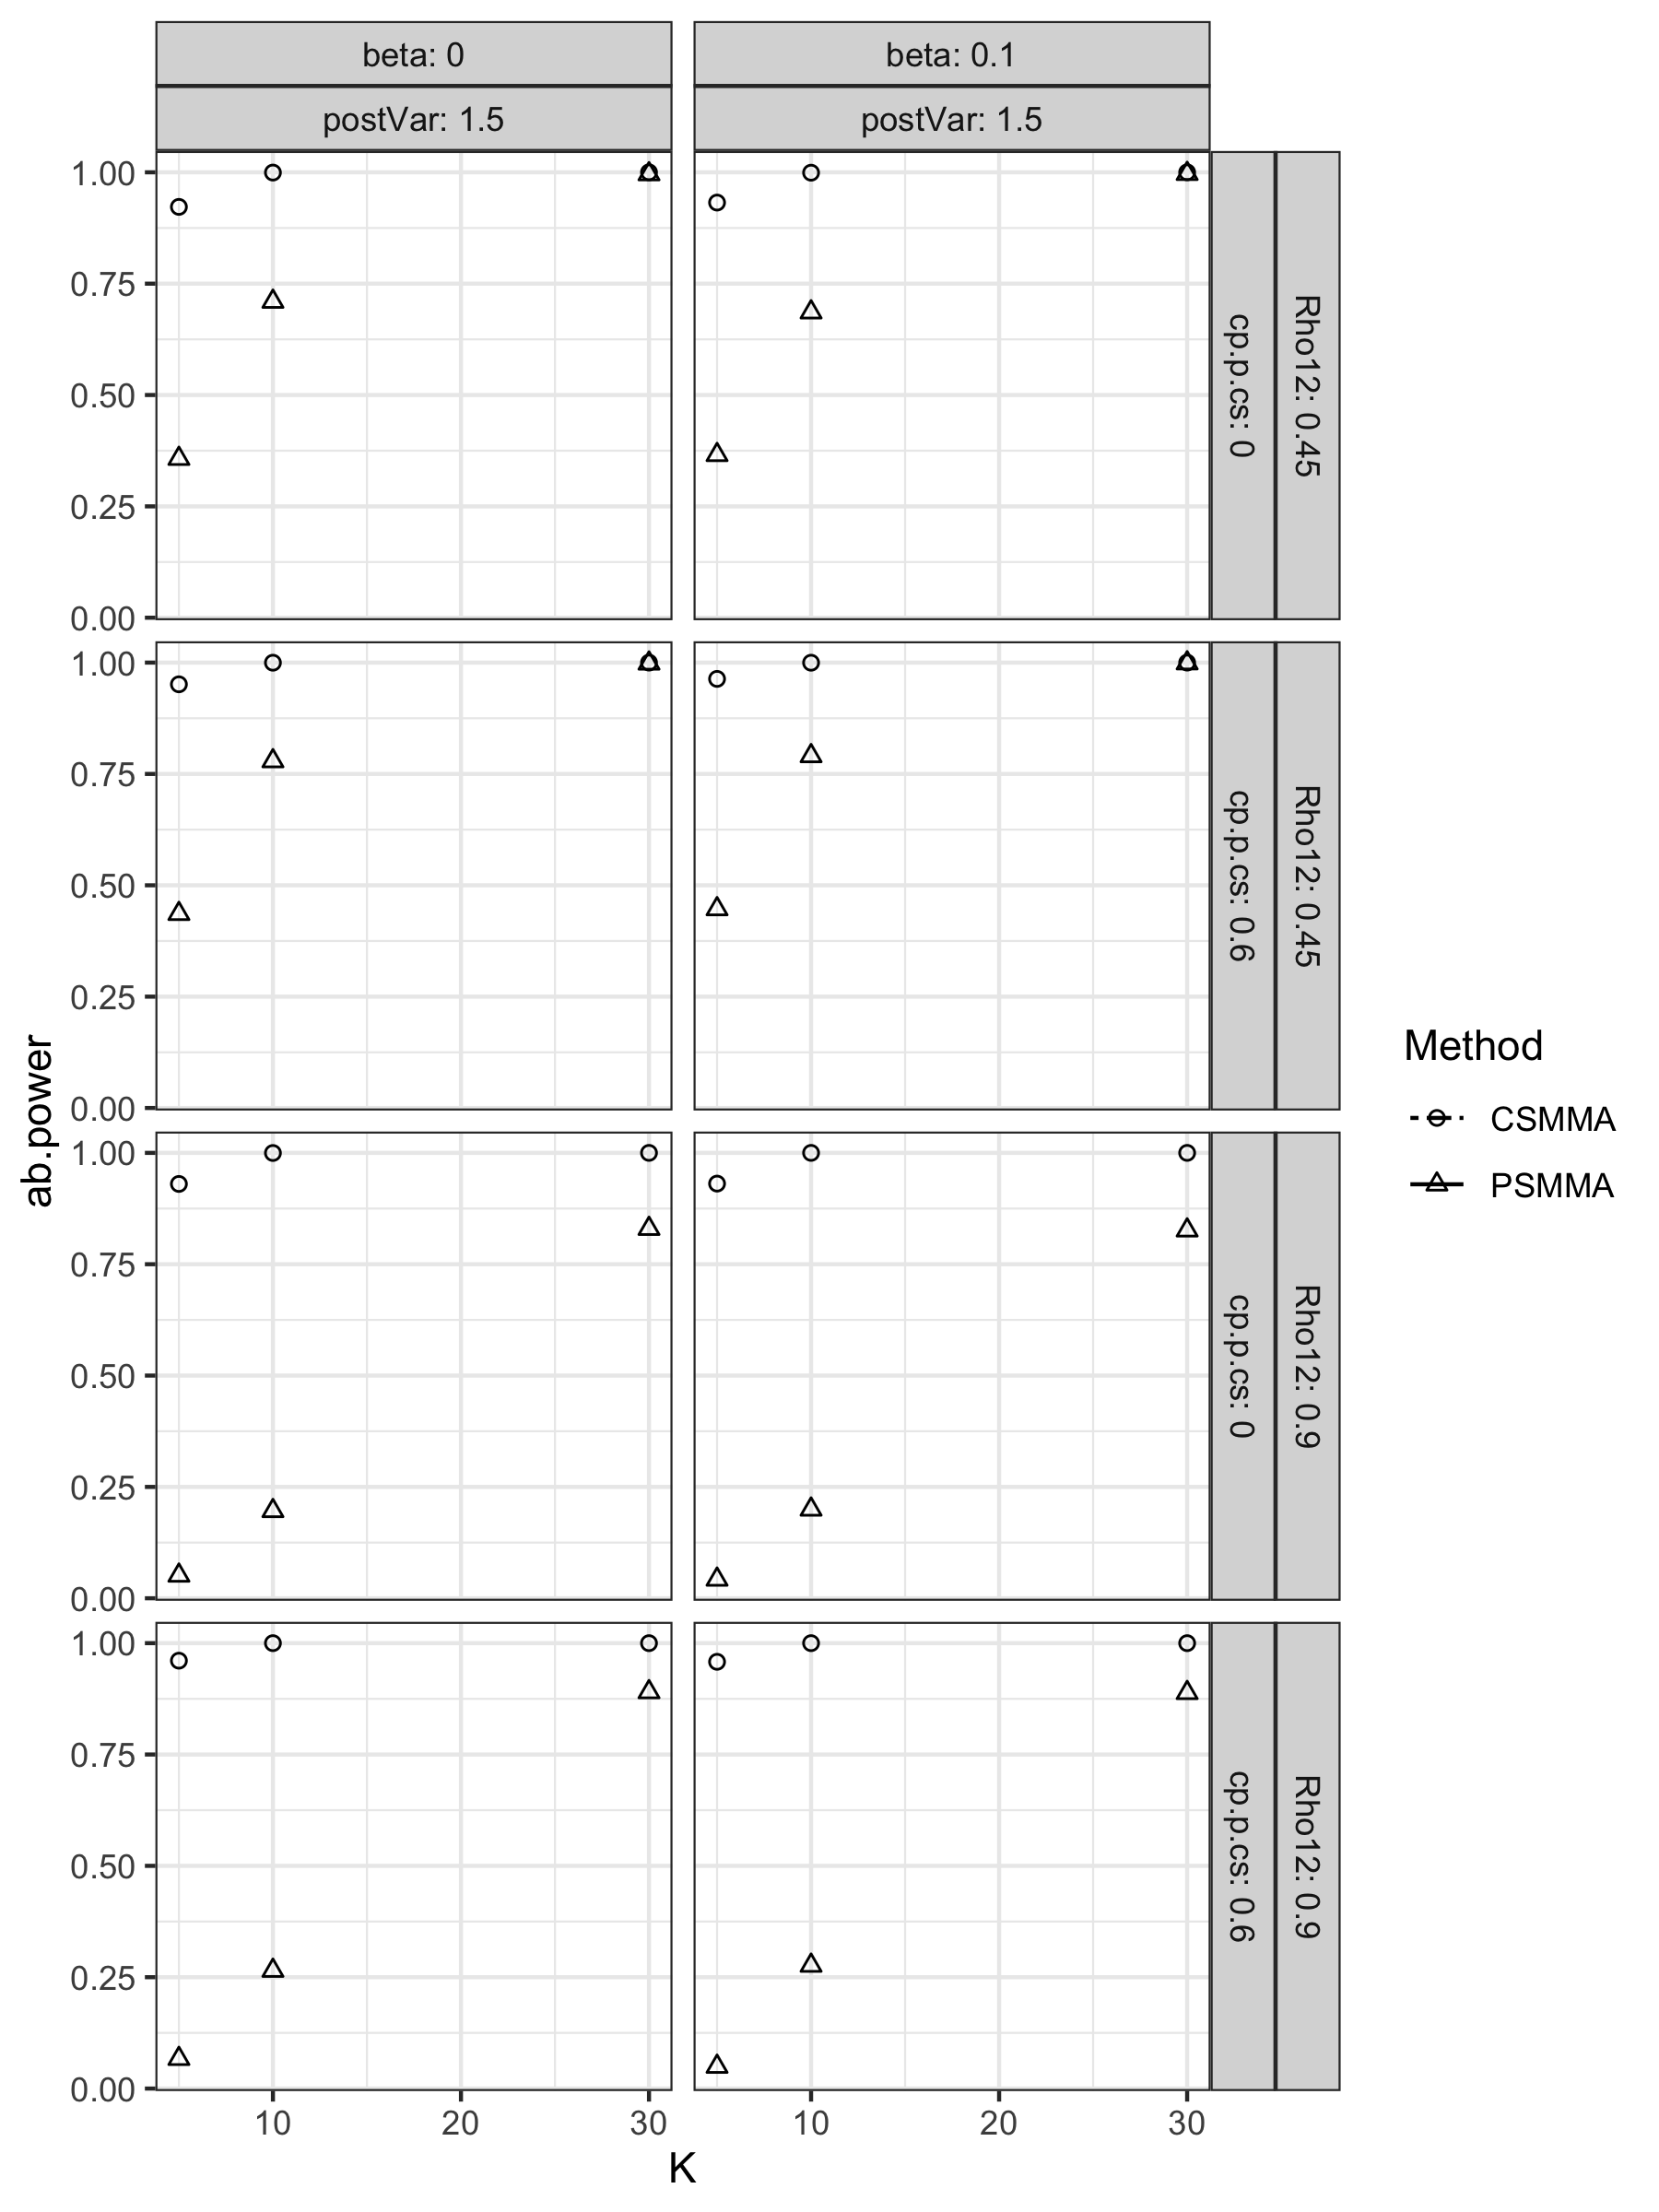

### S2.2.2 Direct Effect

Similarly, results regarding the direct effect had the same pattern as in Study 1 (Figure S25-28).

**Figure S25.**

*Bias of the Direct Effect under All Conditions in Study 2*

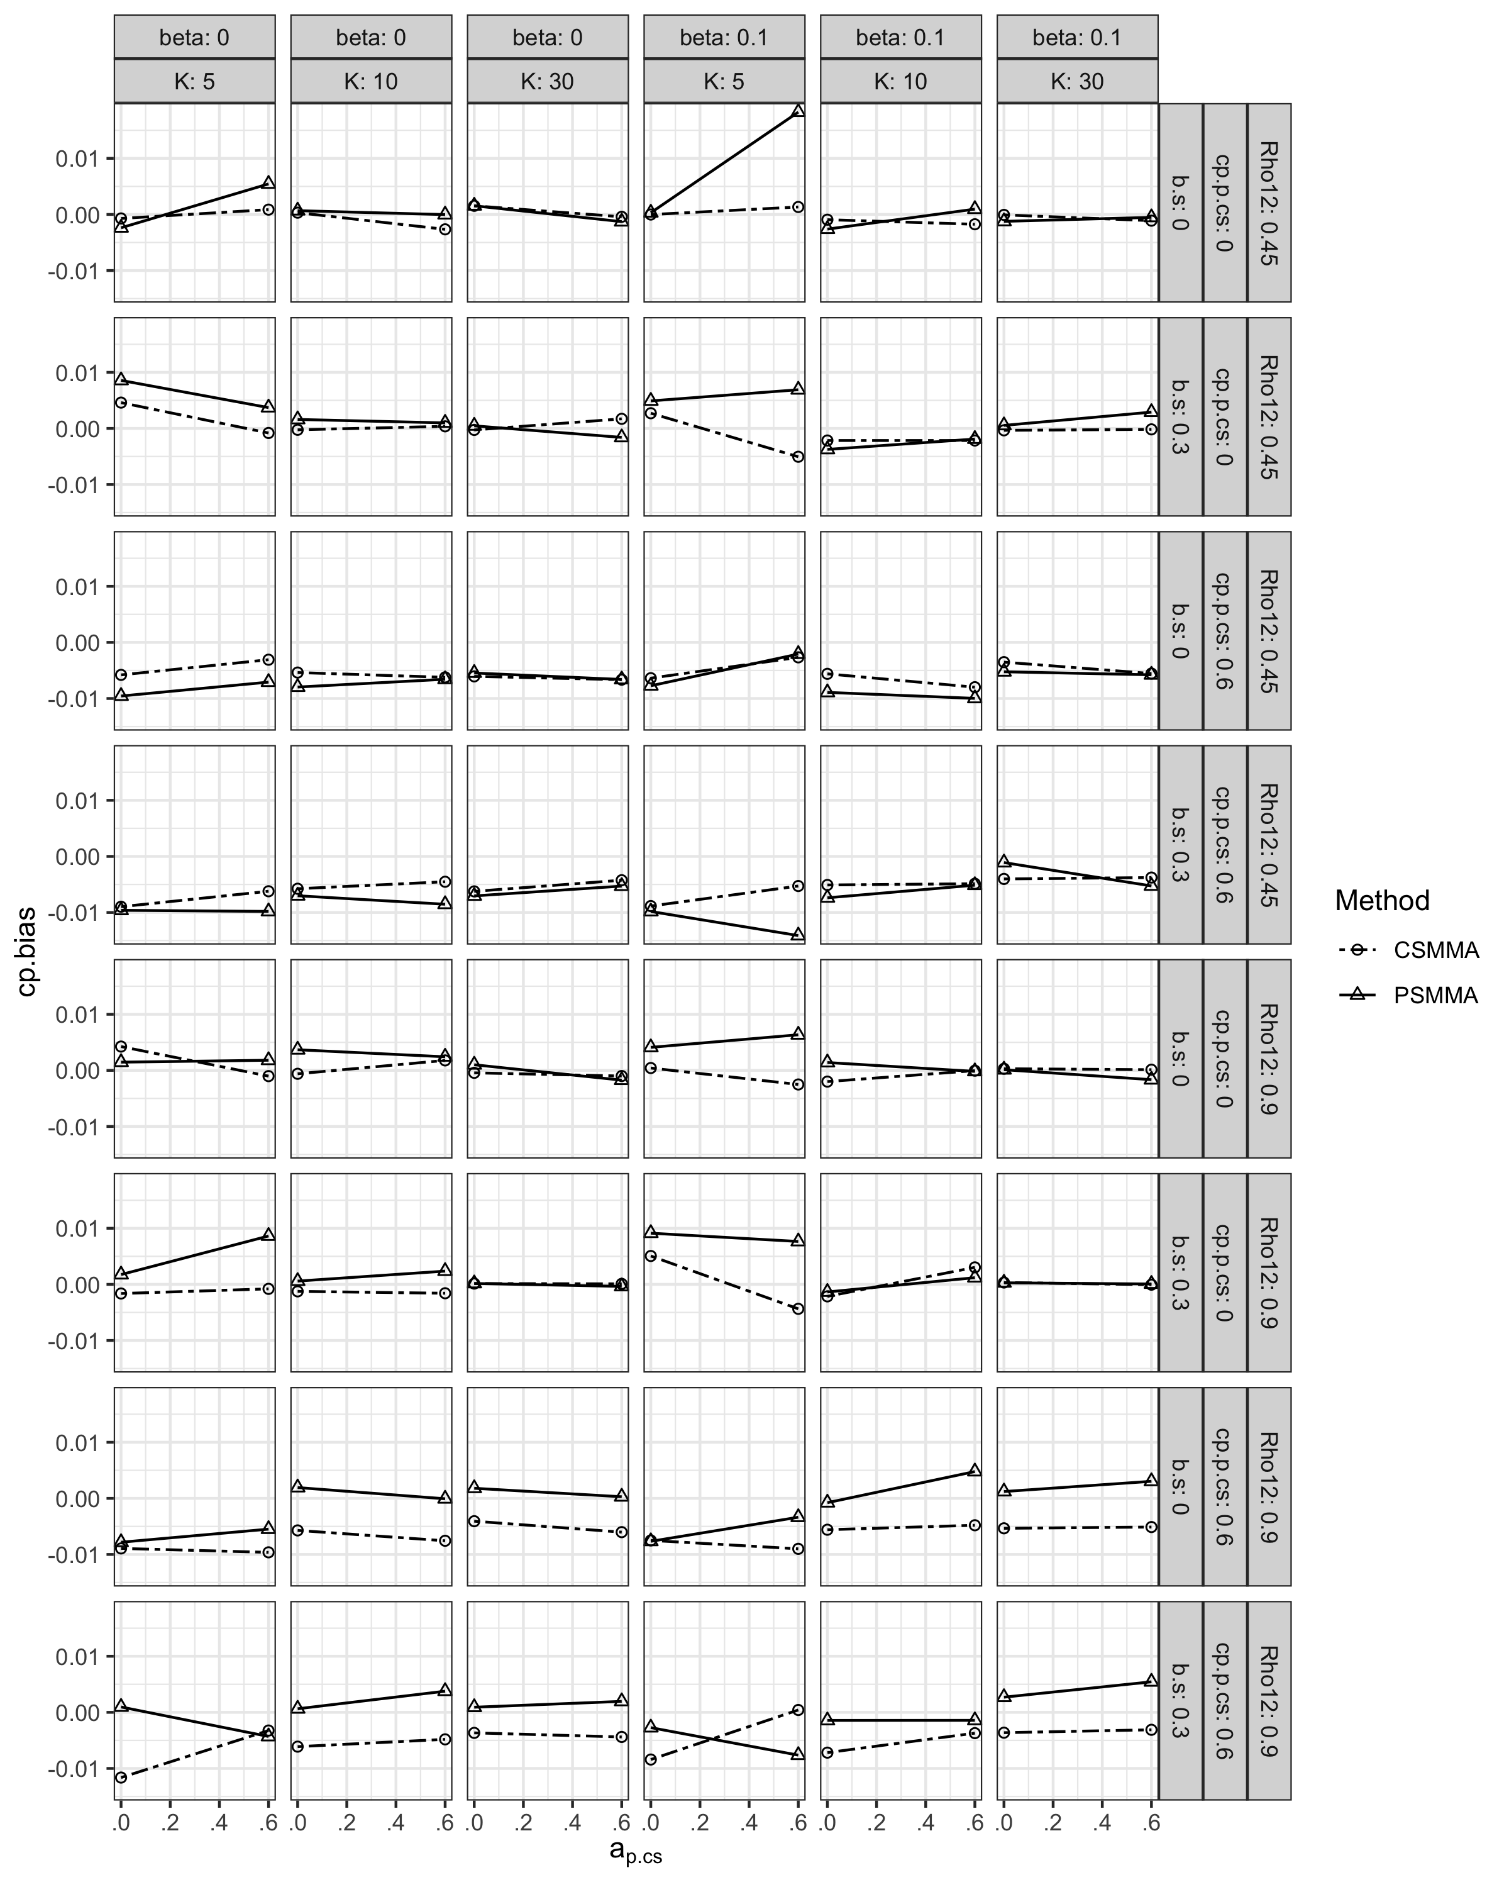

**Figure S26.**

*Coverage Rates of the Direct Effect under All Conditions in Study 2*

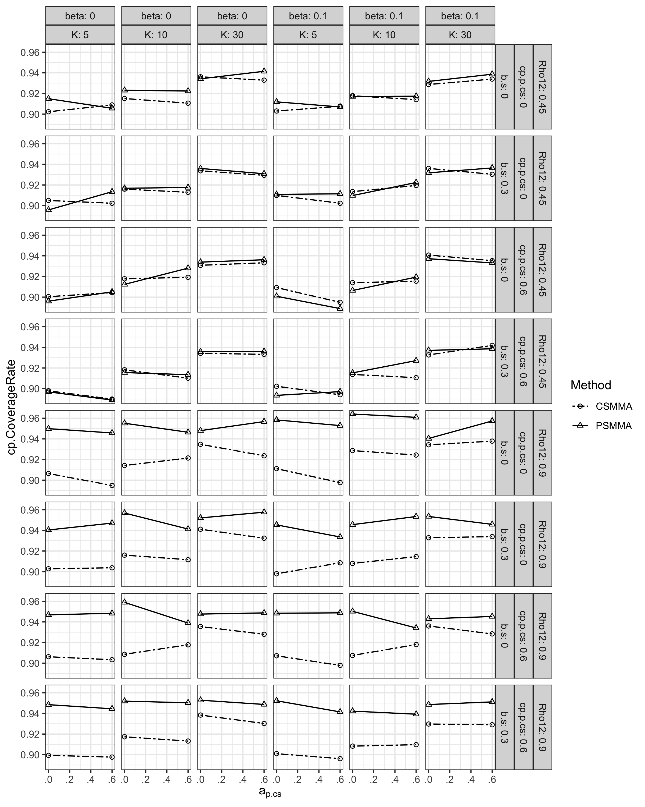

**Figure S27.**

*Type I Error Rates of the Direct Effect under All Conditions in Study 2*

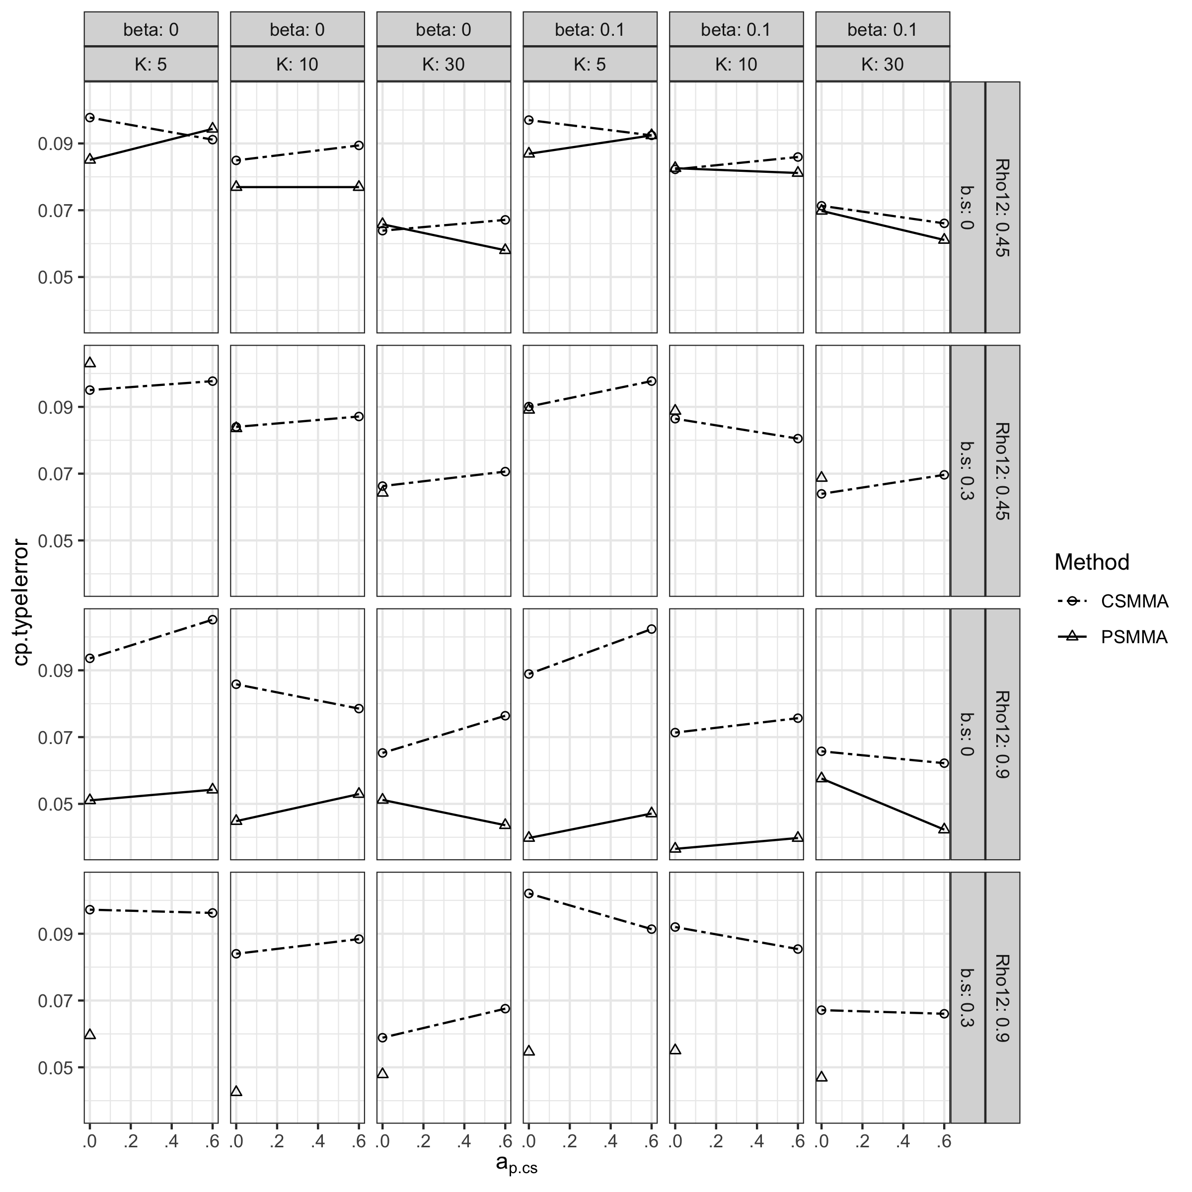

**Figure S28.**

*Statistical Power of the Direct Effect under All Conditions in Study 2*

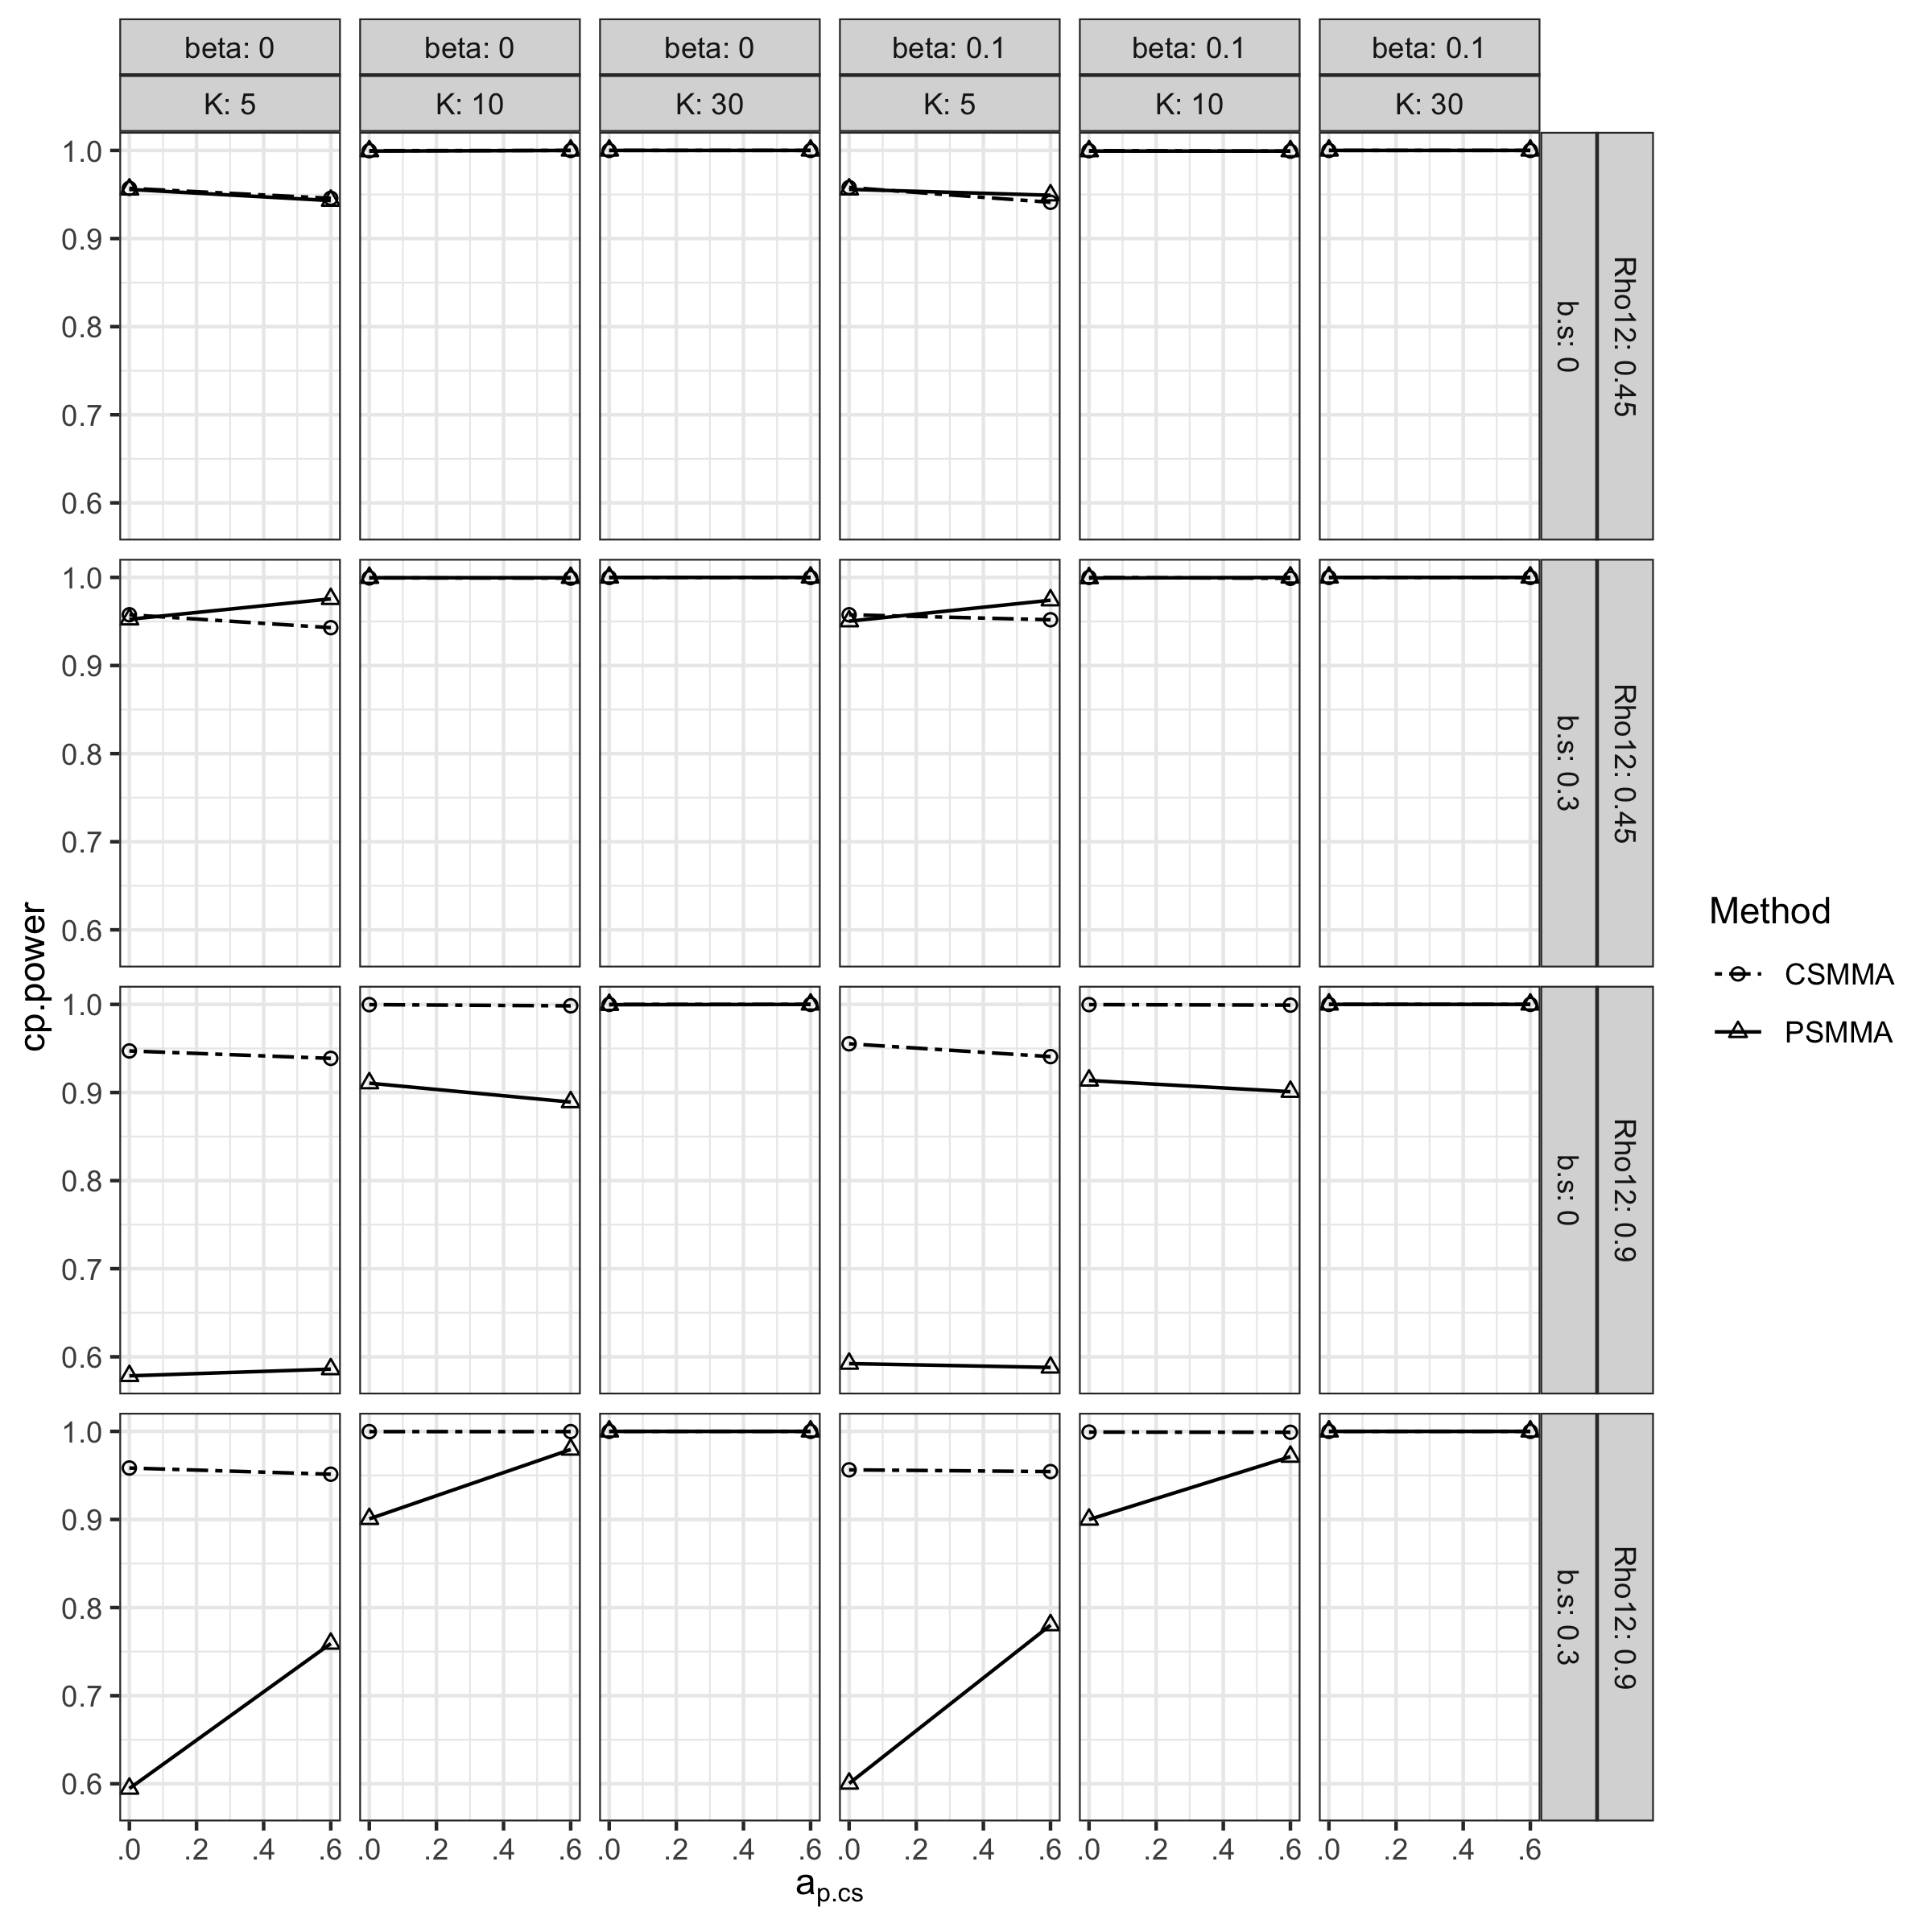

### S2.2.3 Moderating Effect

The bias, CR, type I error rates and statistical power regarding the moderating effect had similar patterns with Study 1 (Figure S29-32).

**Figure S29.**

*Bias of the Moderating Effect under All Conditions in Study 2*

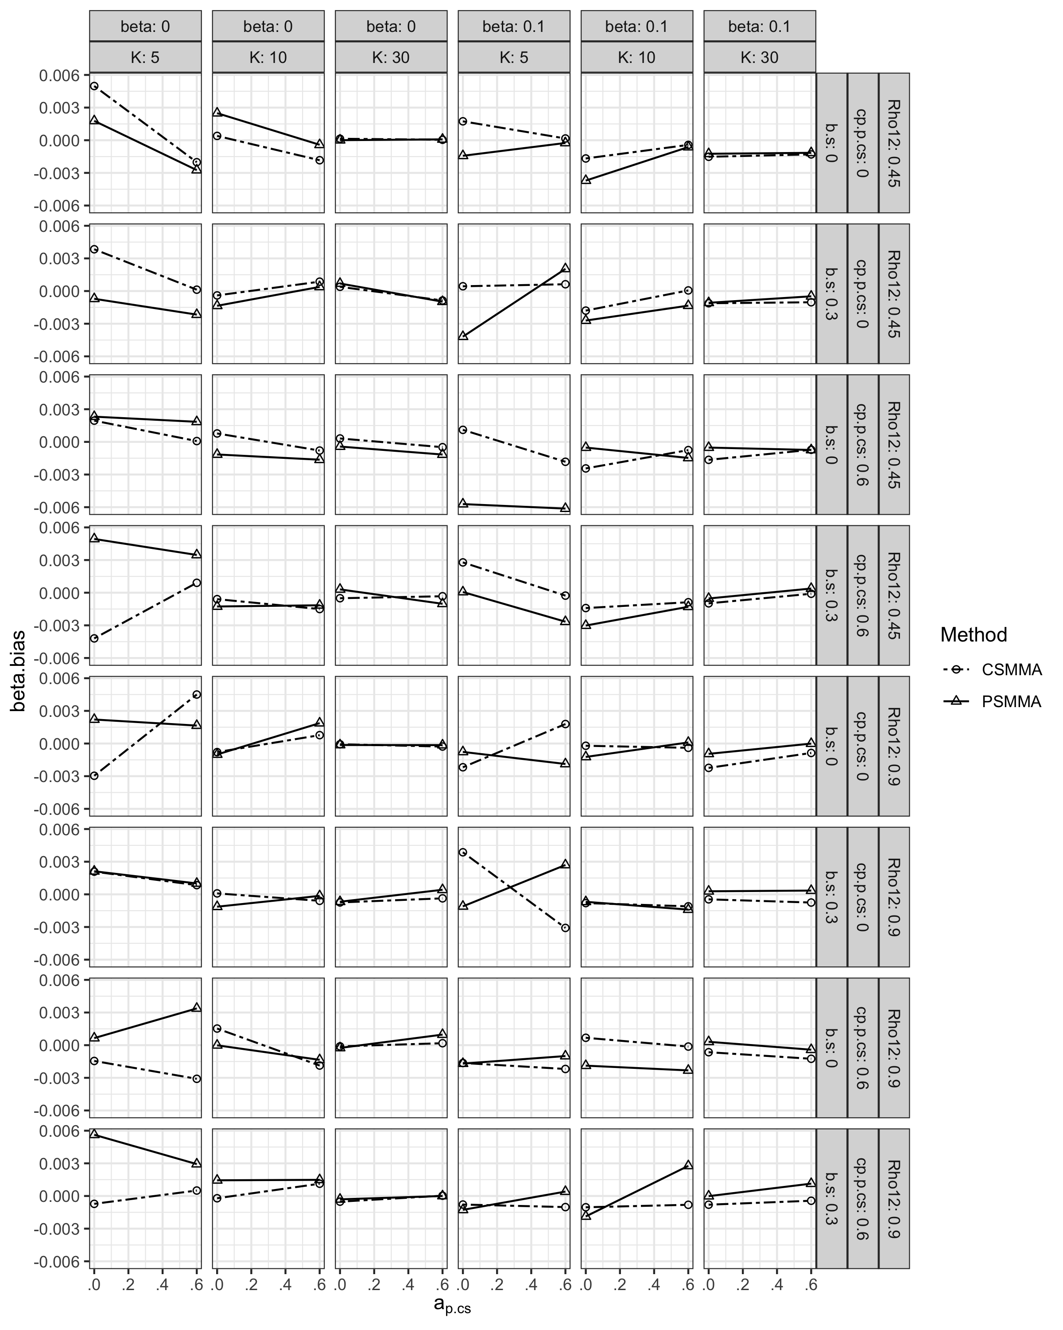

**Figure S30.**

*Coverage Rates of the Moderating Effect under All Conditions in Study 2*

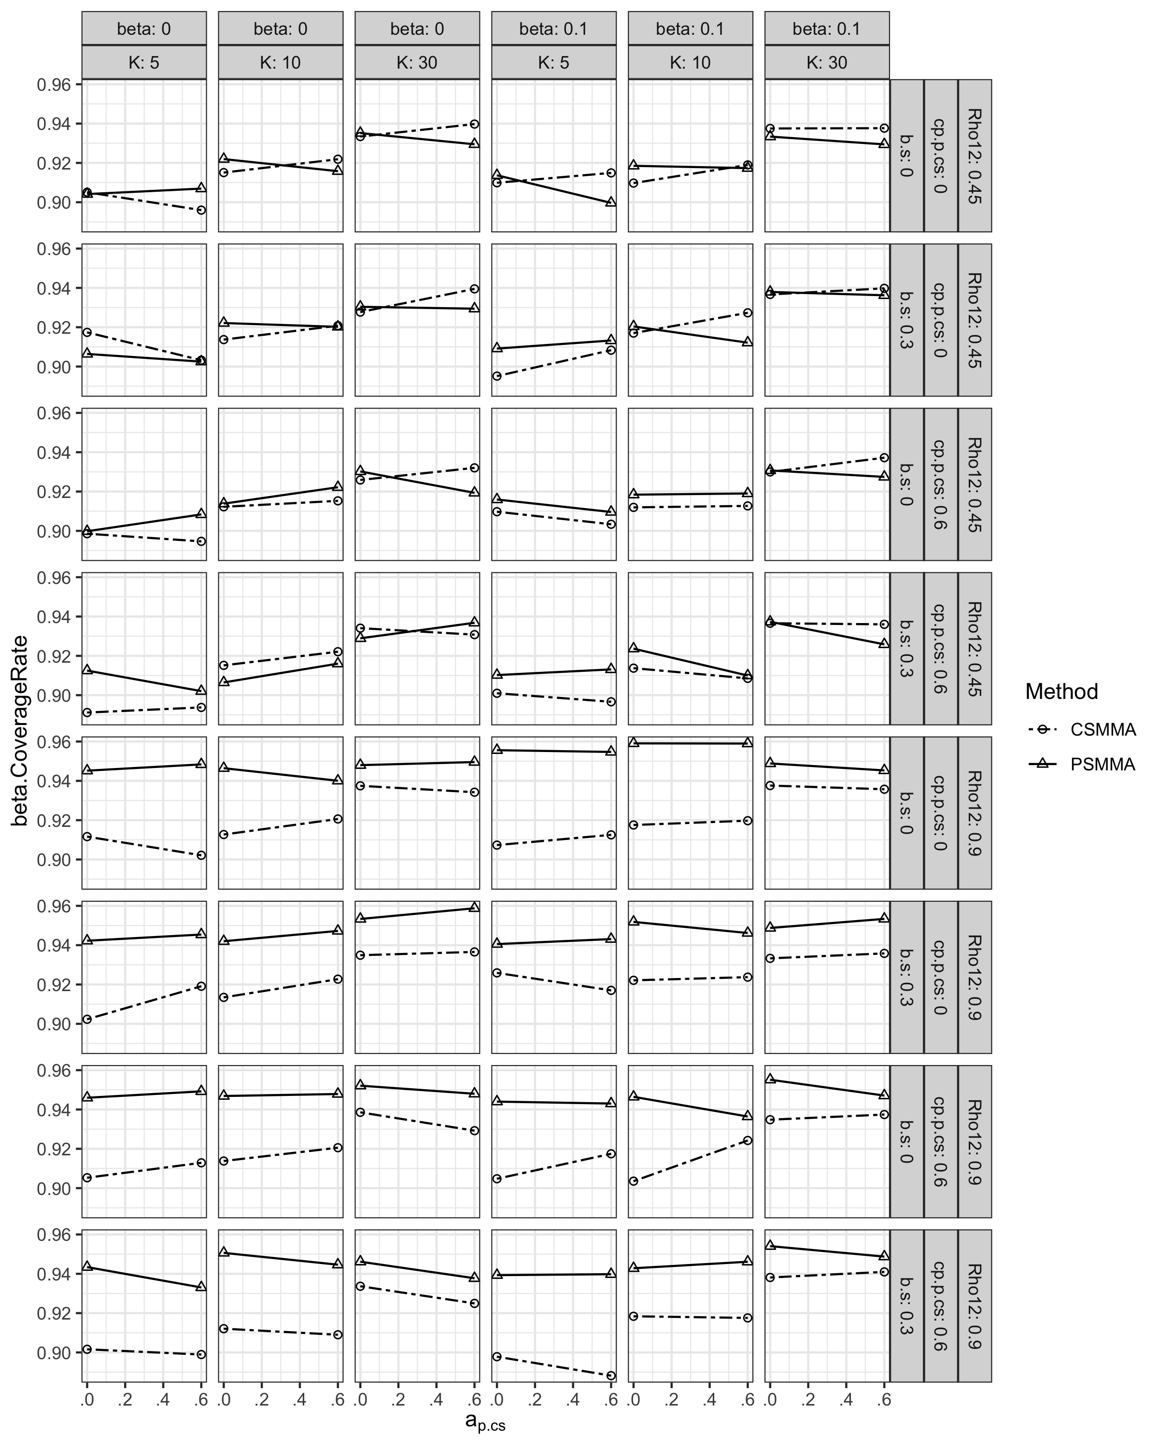

**Figure S31.**

*Type I Error Rates of the Moderating Effect under All Conditions in Study 2*

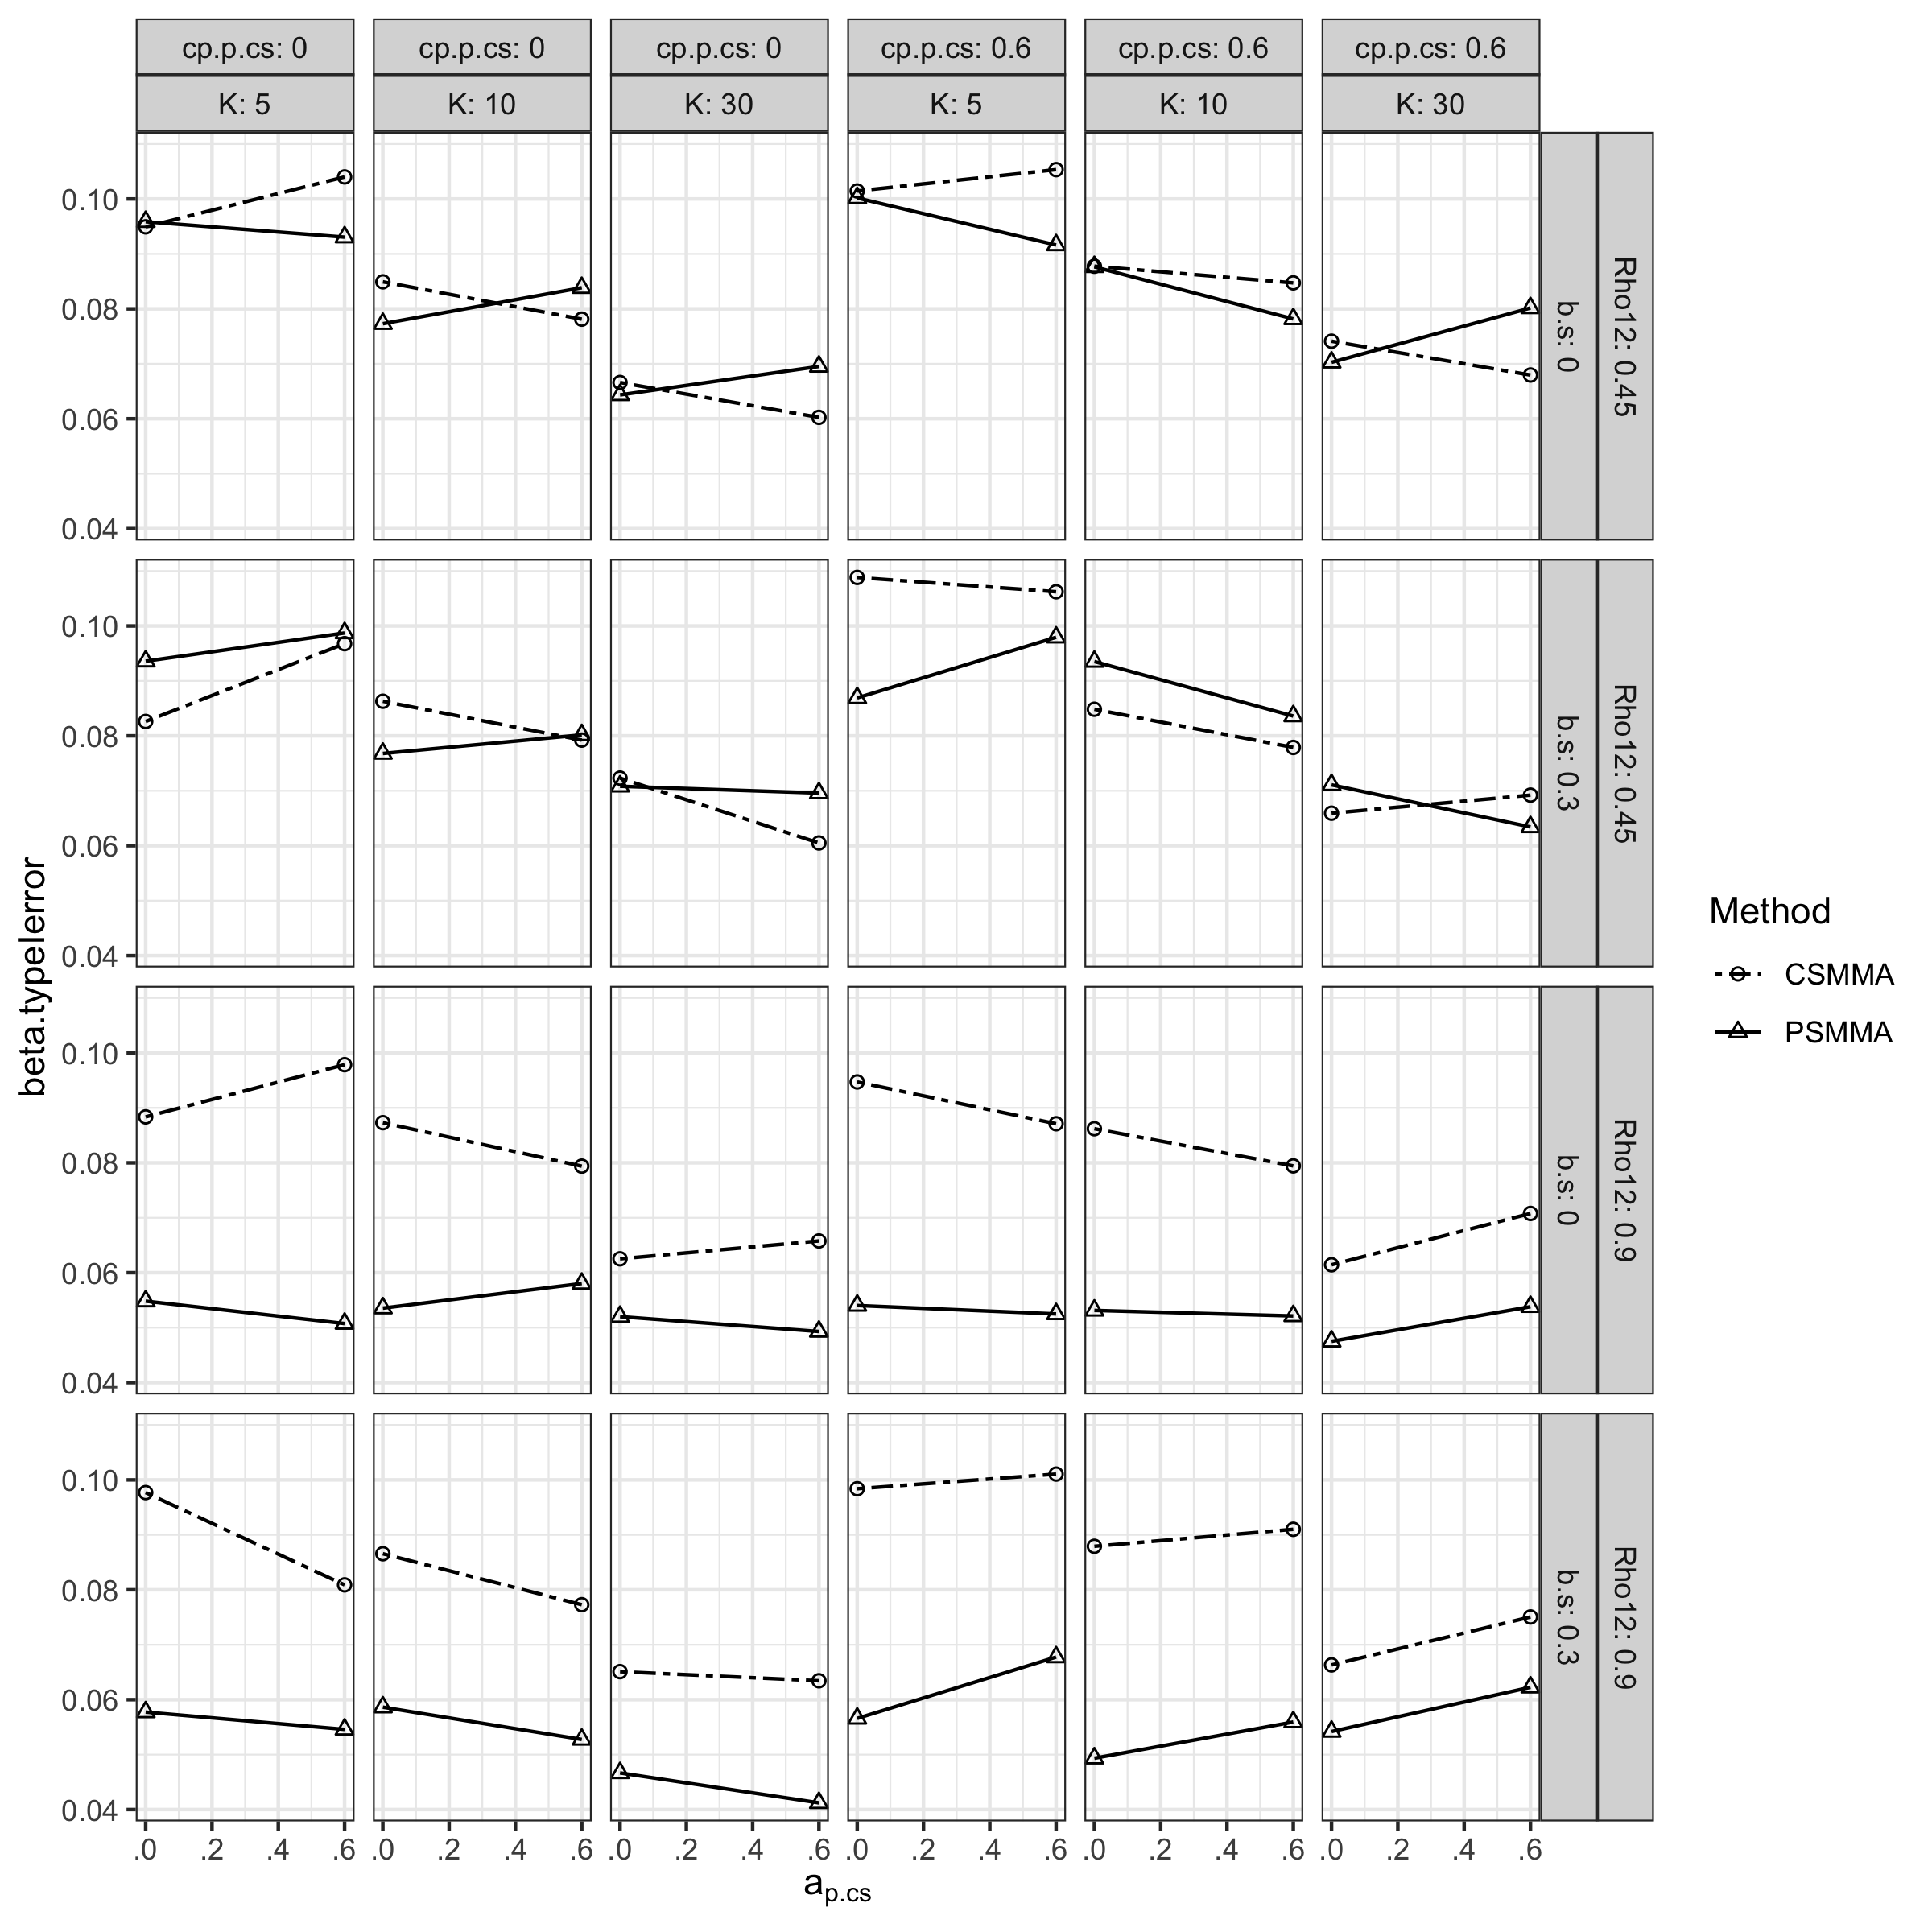

**Figure S32.**

*Statistical Power of the Moderating Effect under All Conditions in Study 2*

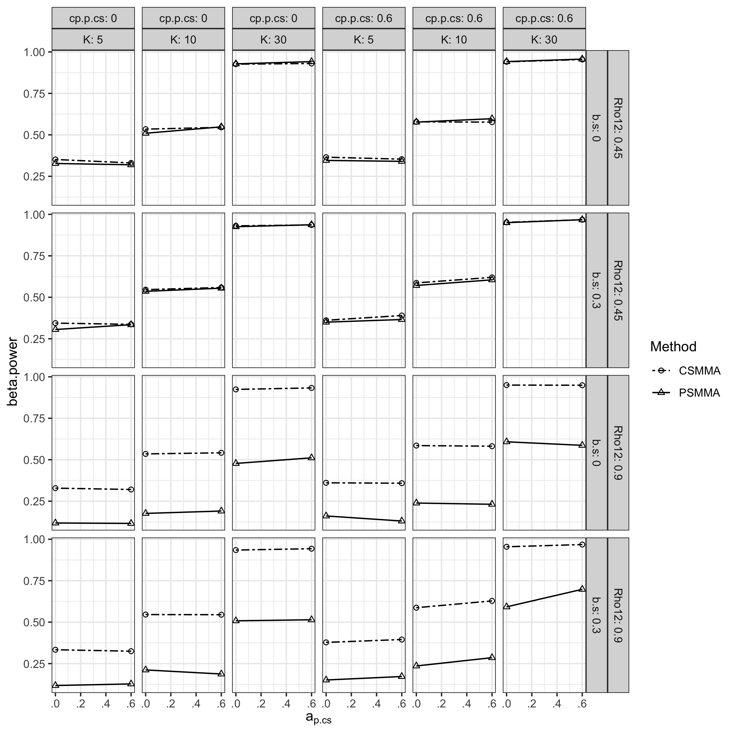

### S2.2.4 Coefficients of the a path and the b path

As shown in Figure S33-35 and in Figure S37-39, the patterns of bias, CR, and type I error rates of CSMMA and PSMMA when estimating the $a$ and $b$ paths were similar as in Study 1. However, the statistical power of PSMMA when estimating the $a$ and $b$ paths increased in the presence of the inflation of posttest variances (Figure S36 and S40).

**Figure S33.**

*Bias of the a path Coefficient under All Conditions in Study 2*

**

**Figure S34.**

*Coverage Rates of the a path Coefficient under All Conditions in Study 2*

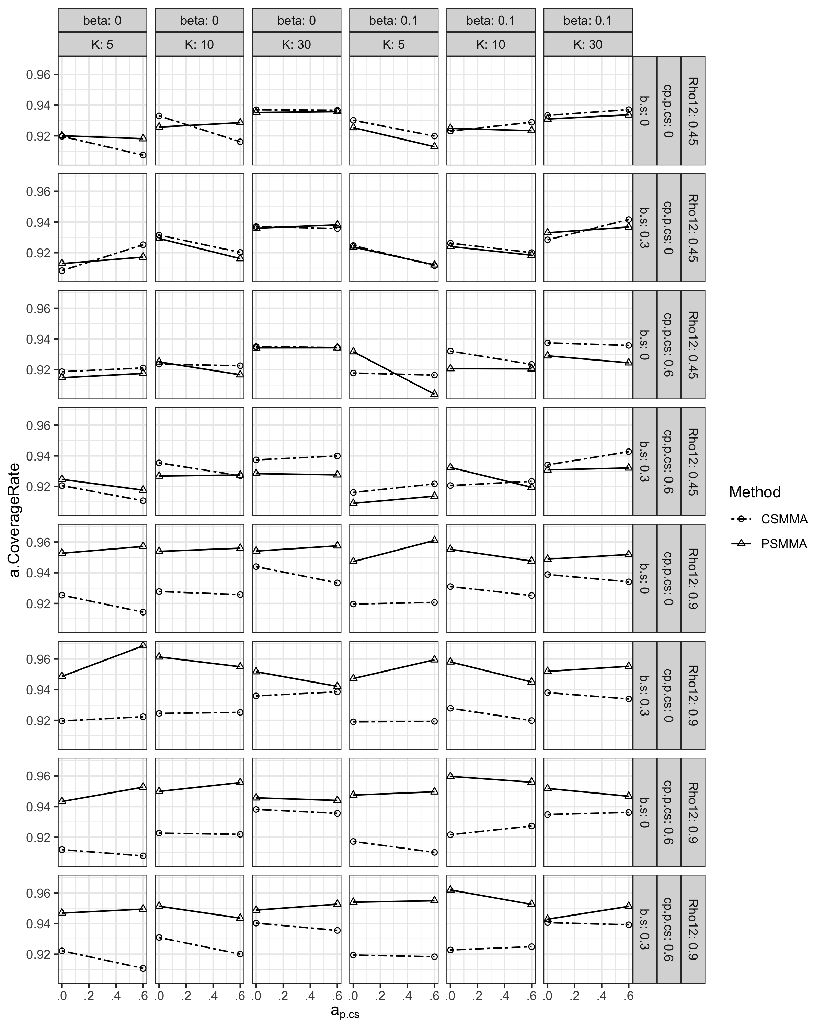

**Figure S35.**

*Type I Error Rates of the a path Coefficient under All Conditions in Study 2*

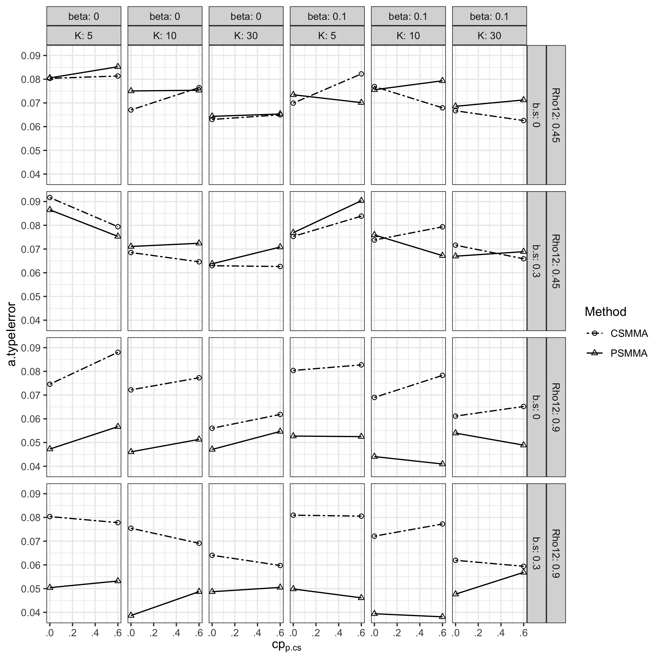

**Figure S36.**

*Statistical Power of the a path Coefficient under All Conditions in Study 2*

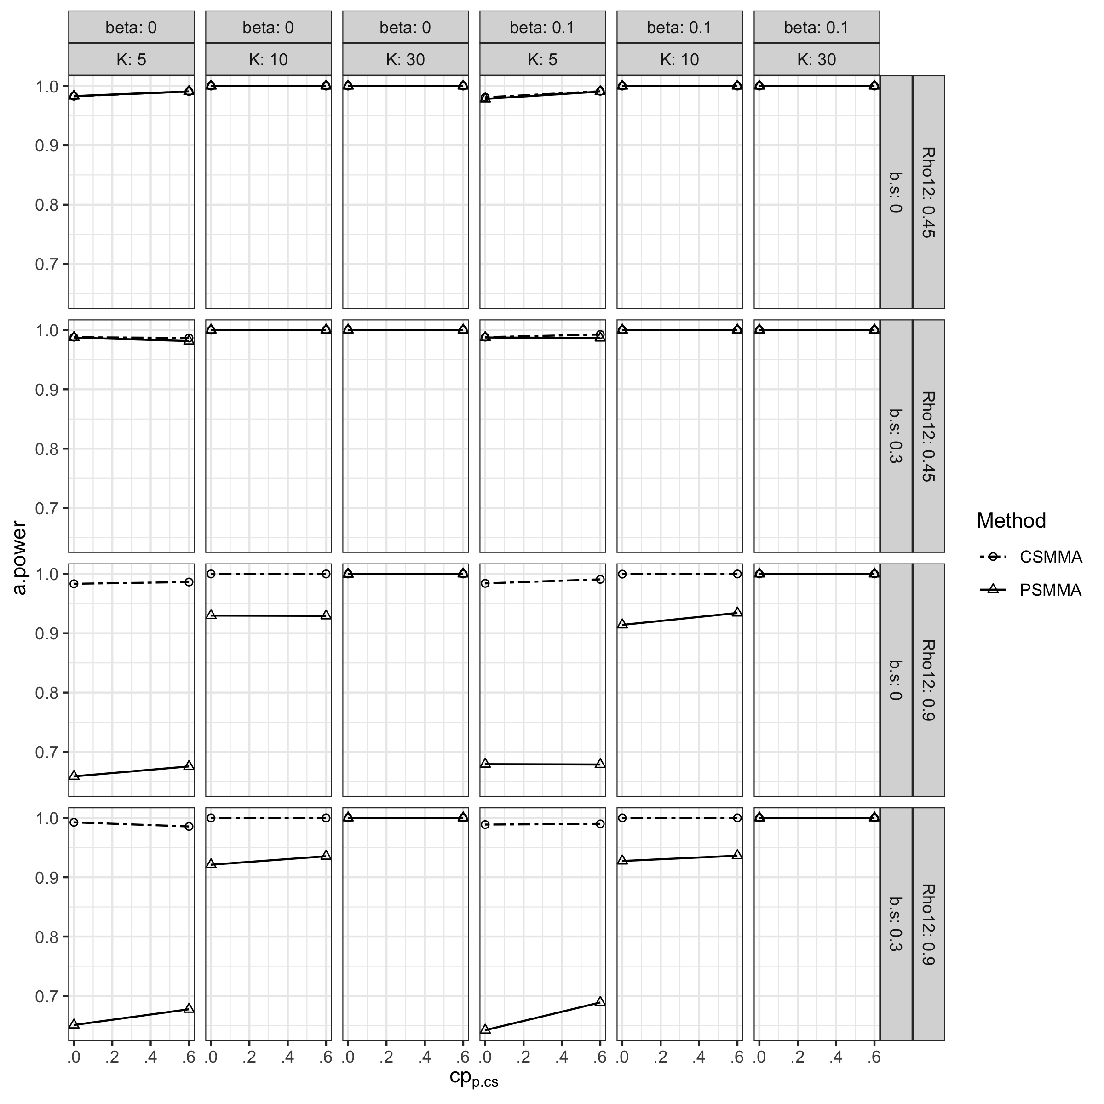

**Figure S37.**

*Bias of the b path Coefficient under All Conditions in Study 2*

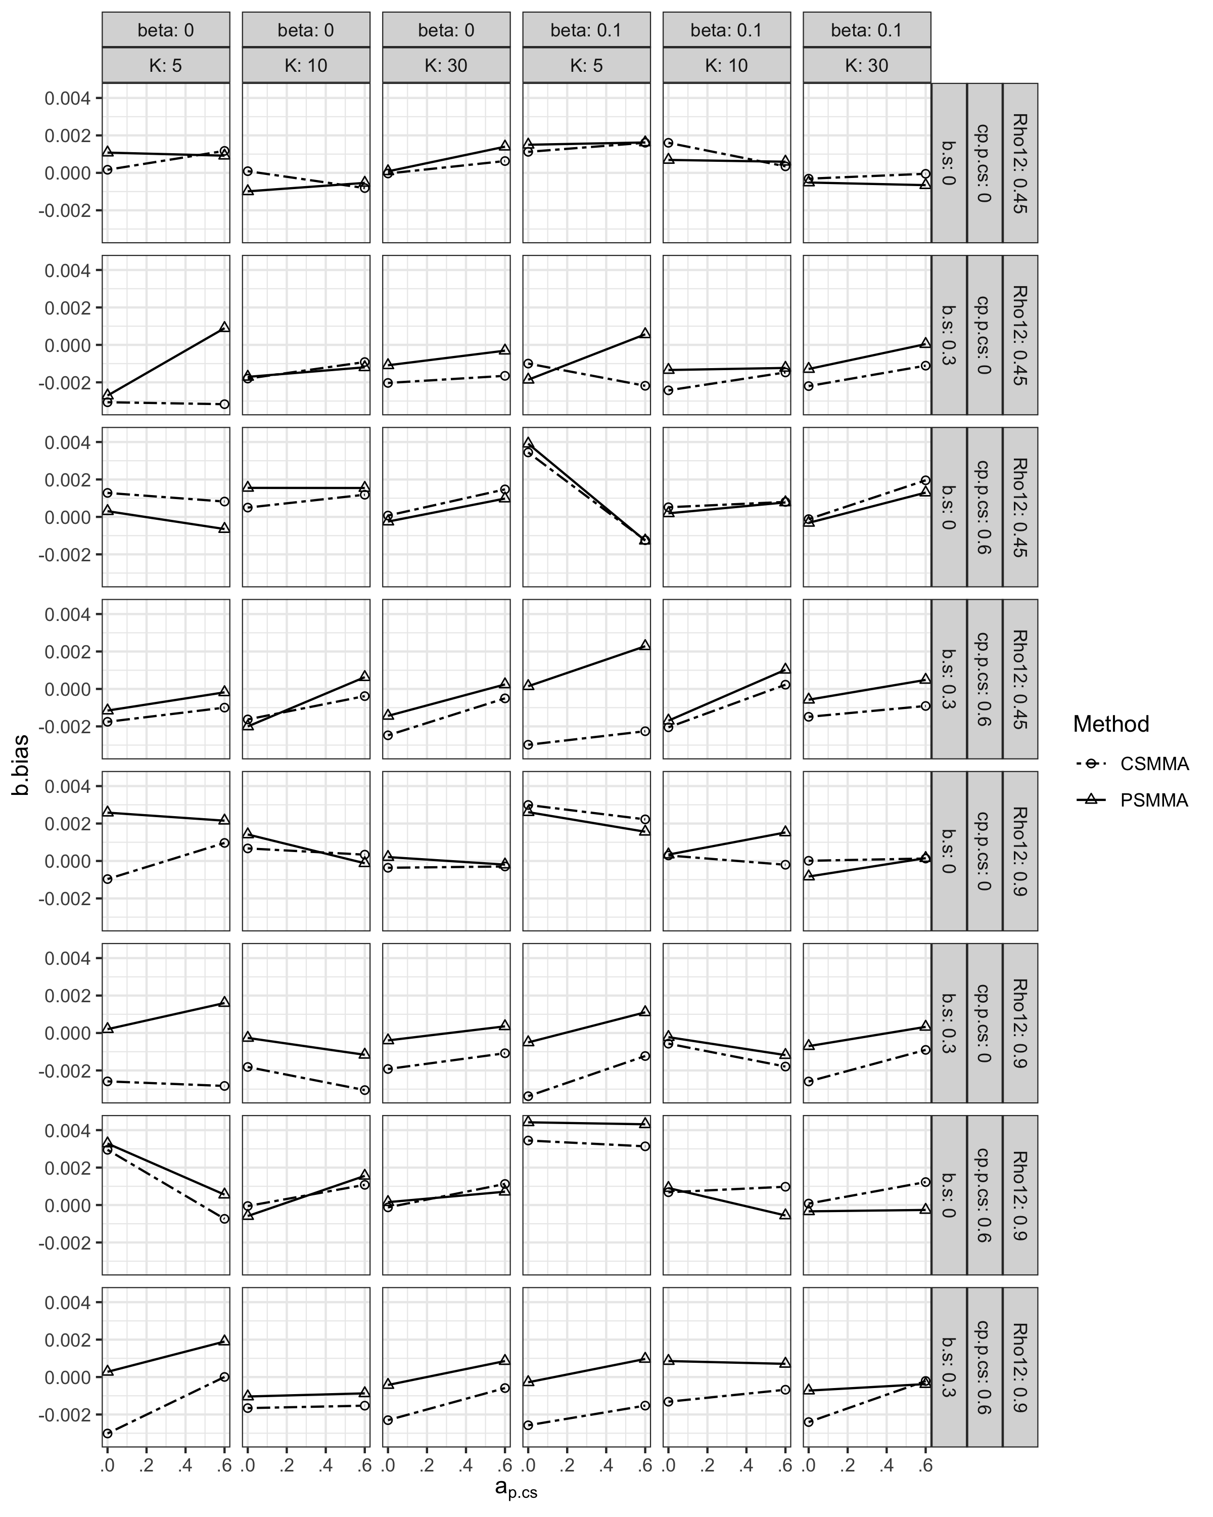

**Figure S38.**

*Coverage Rates of the b path Coefficient under All Conditions in Study 2*

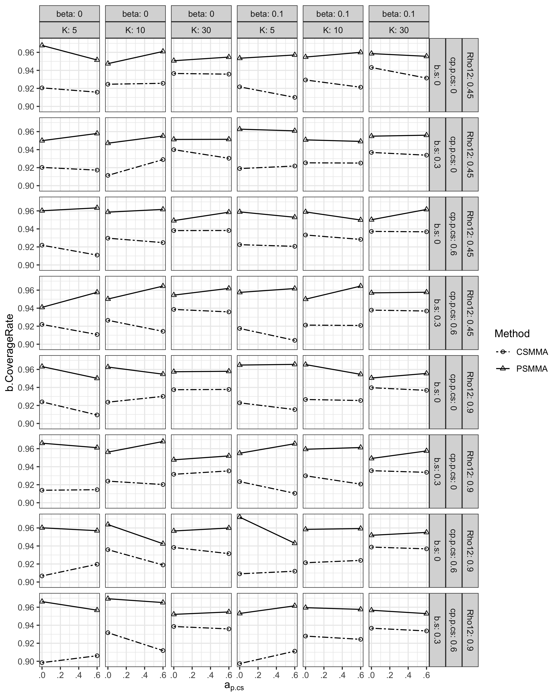

**Figure S39.**

*Type I Error Rates of the b path Coefficient under All Conditions in Study 2*

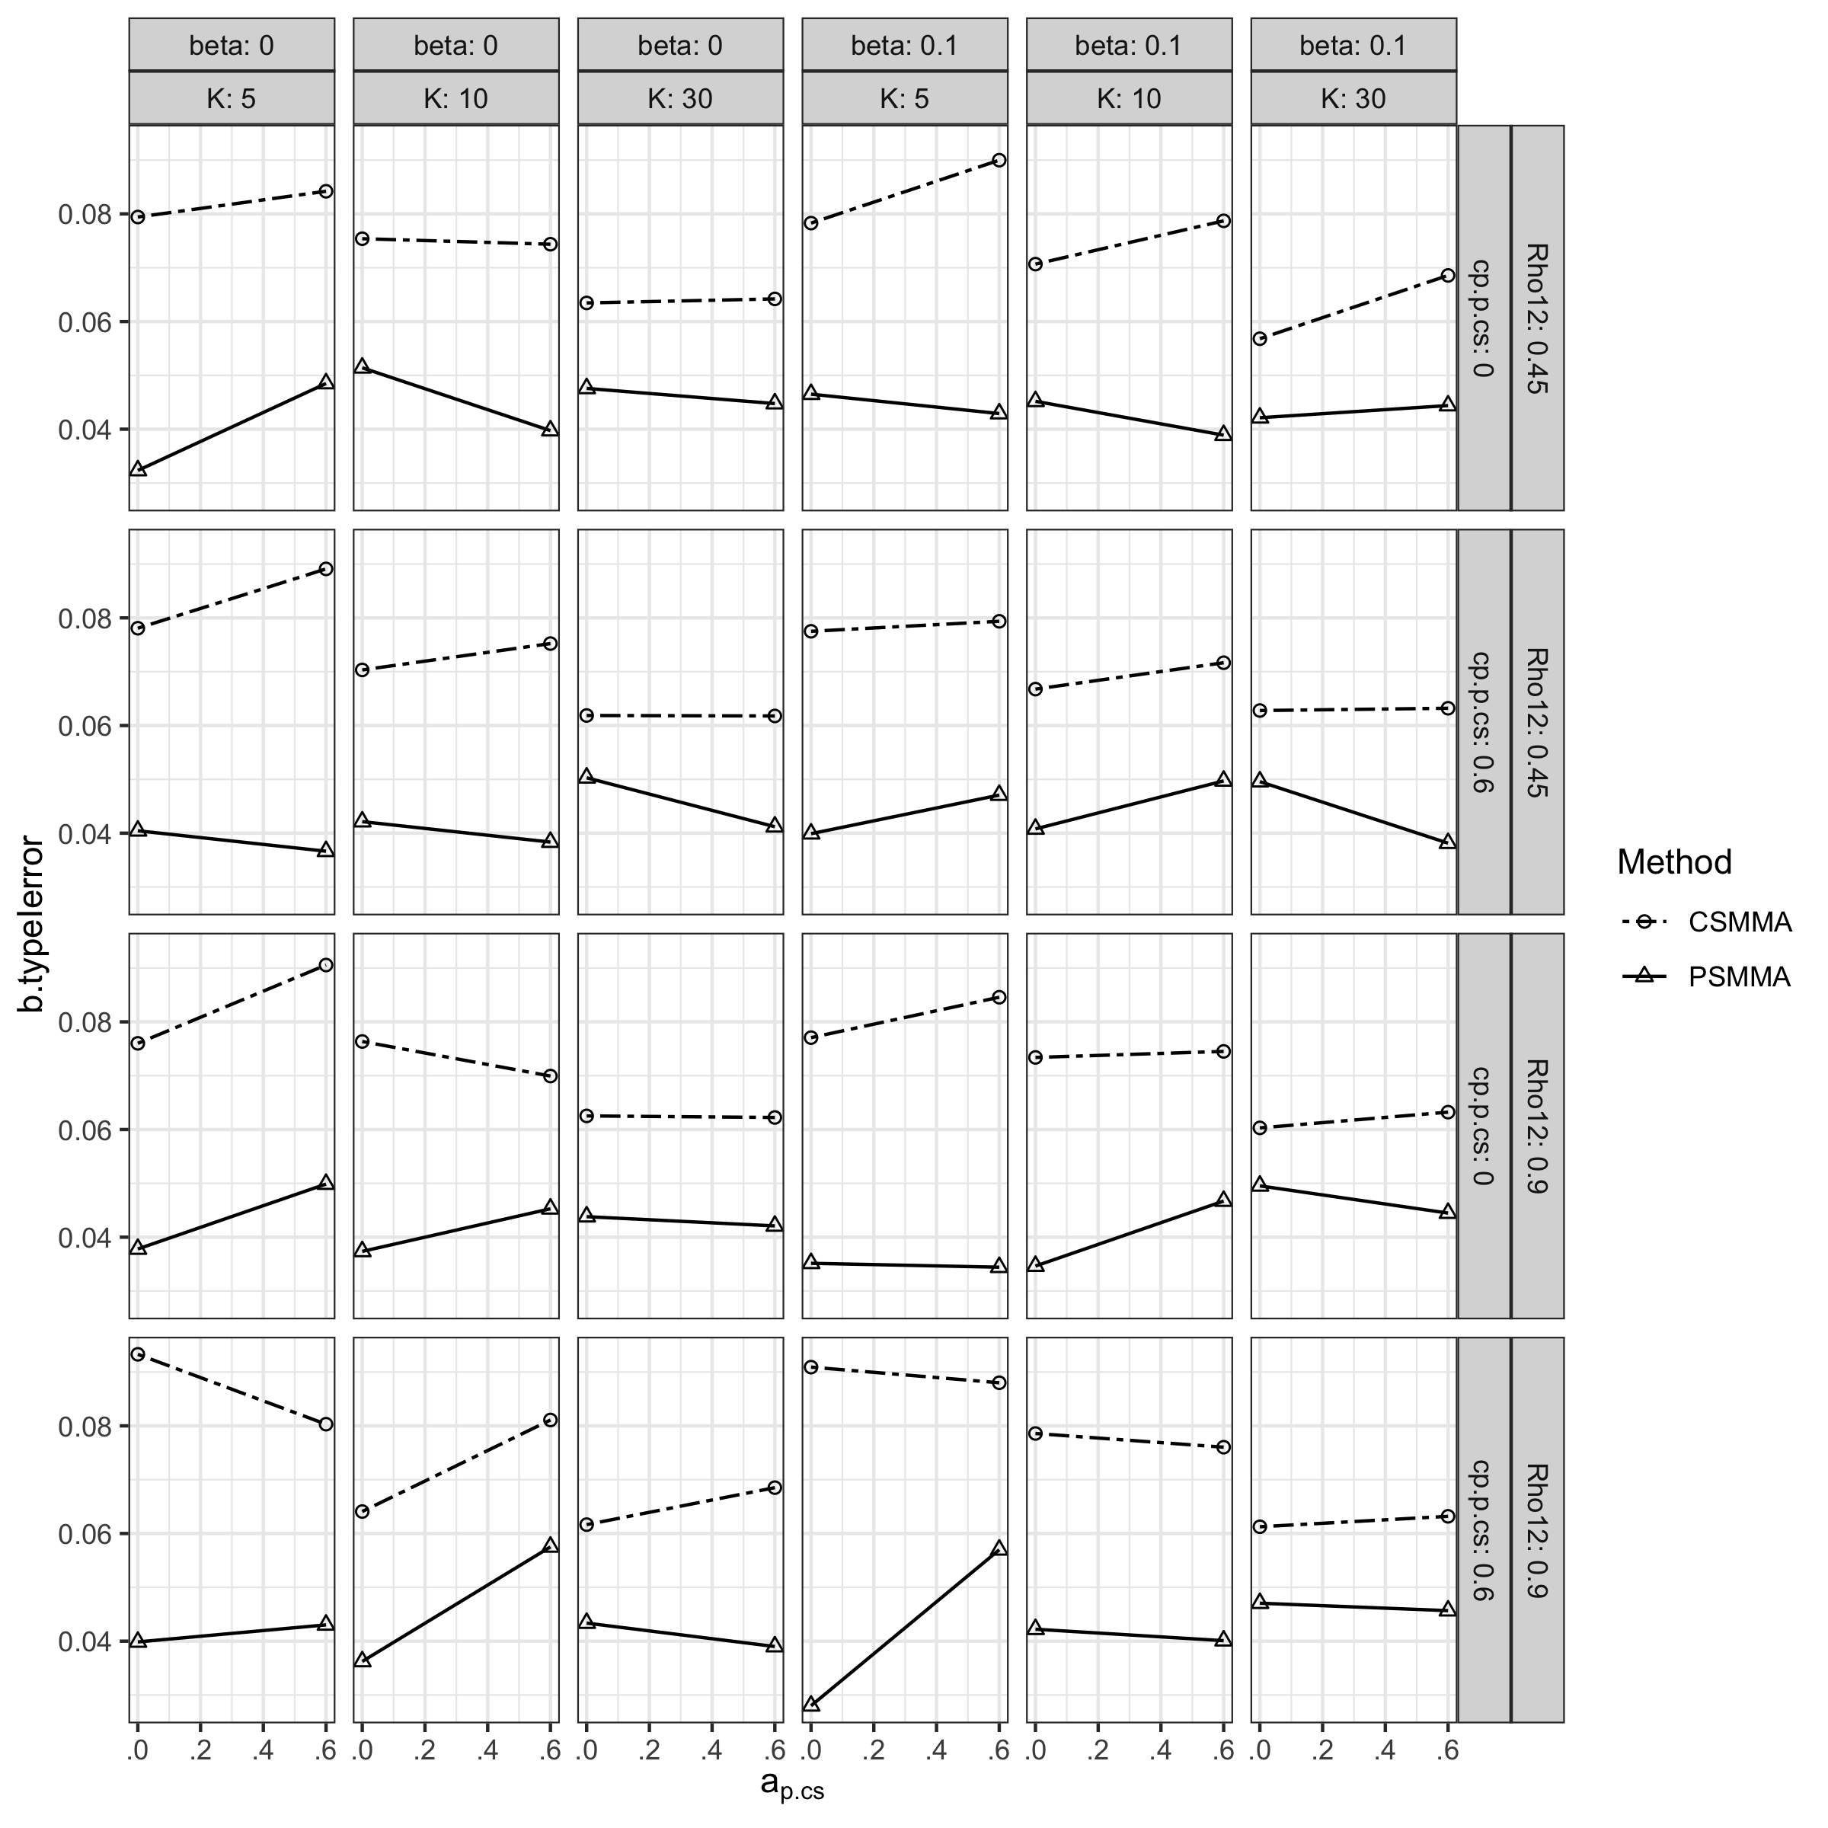

**Figure S40.**

*Statistical Power of the b path Coefficient under All Conditions in Study 2* 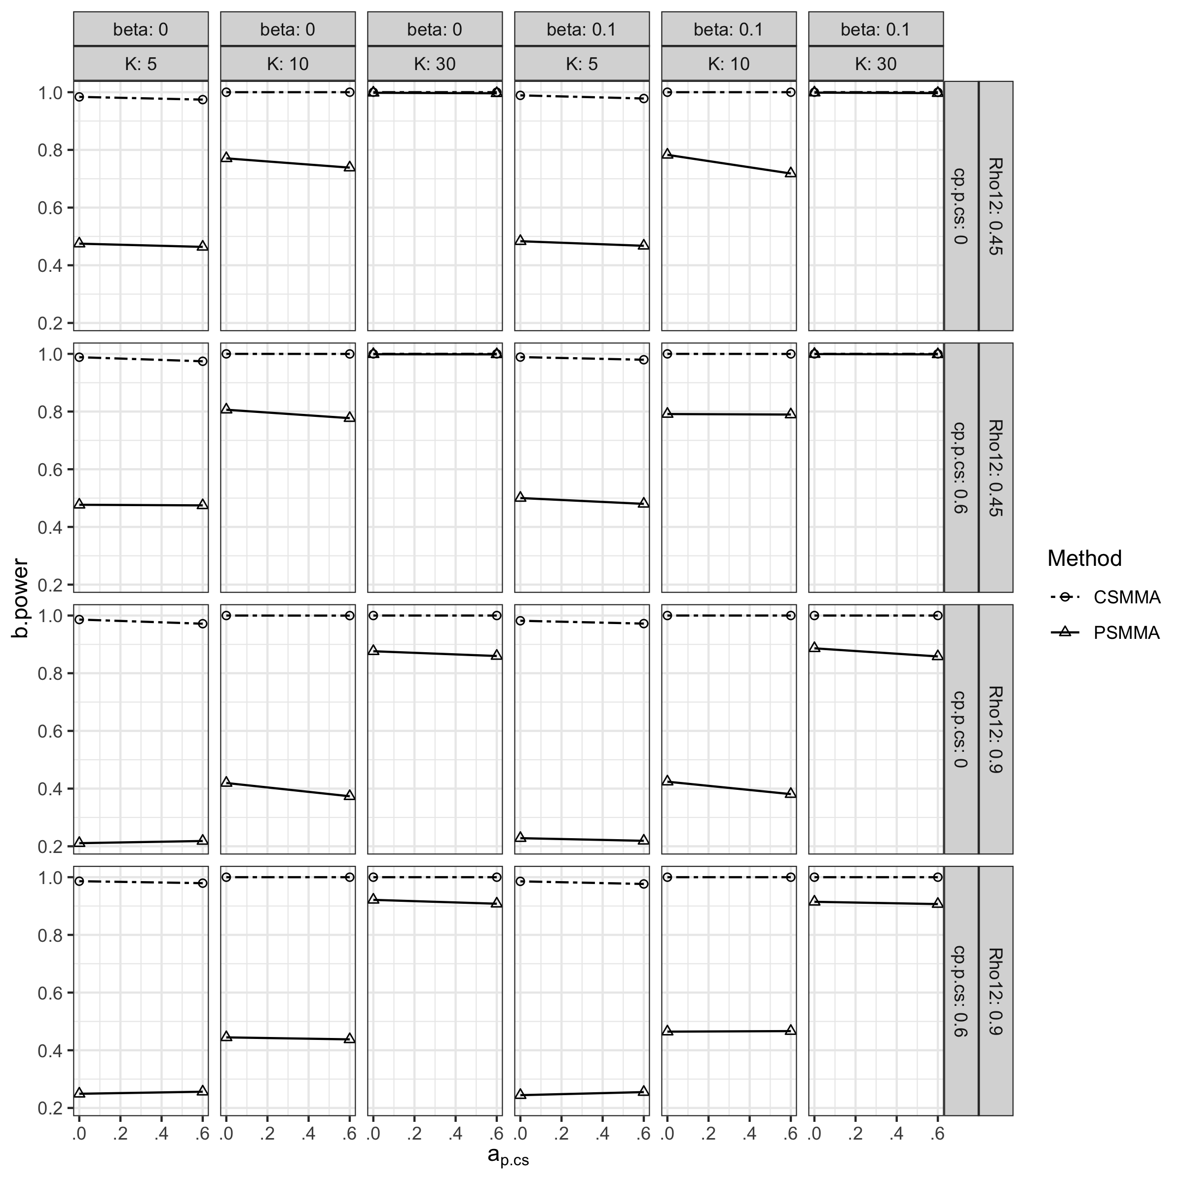

## S2.3 Positive Definite Rates in Study 1 & 2

As shown in Figure S41, the positive definite rate of CSMMA and PSMMA in Study 1 decreased with a smaller $K$. Similar patterns were observed in Study 2 (Figure S42).

**Figure S41.**

*Positive Definite Rates in Study 1 as Reported by OSMASEM*

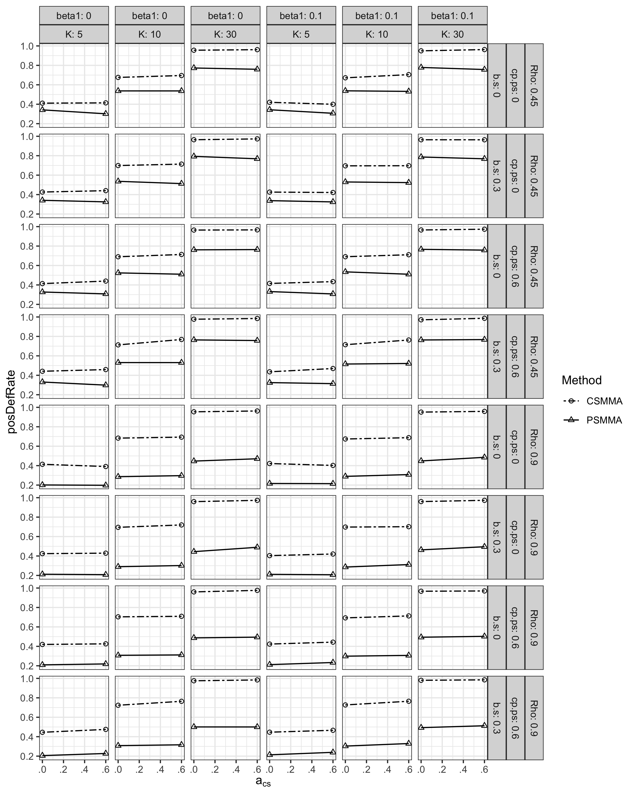

**Figure S42.**

*Positive Definite Rates in Study 2 as Reported by OSMASEM*

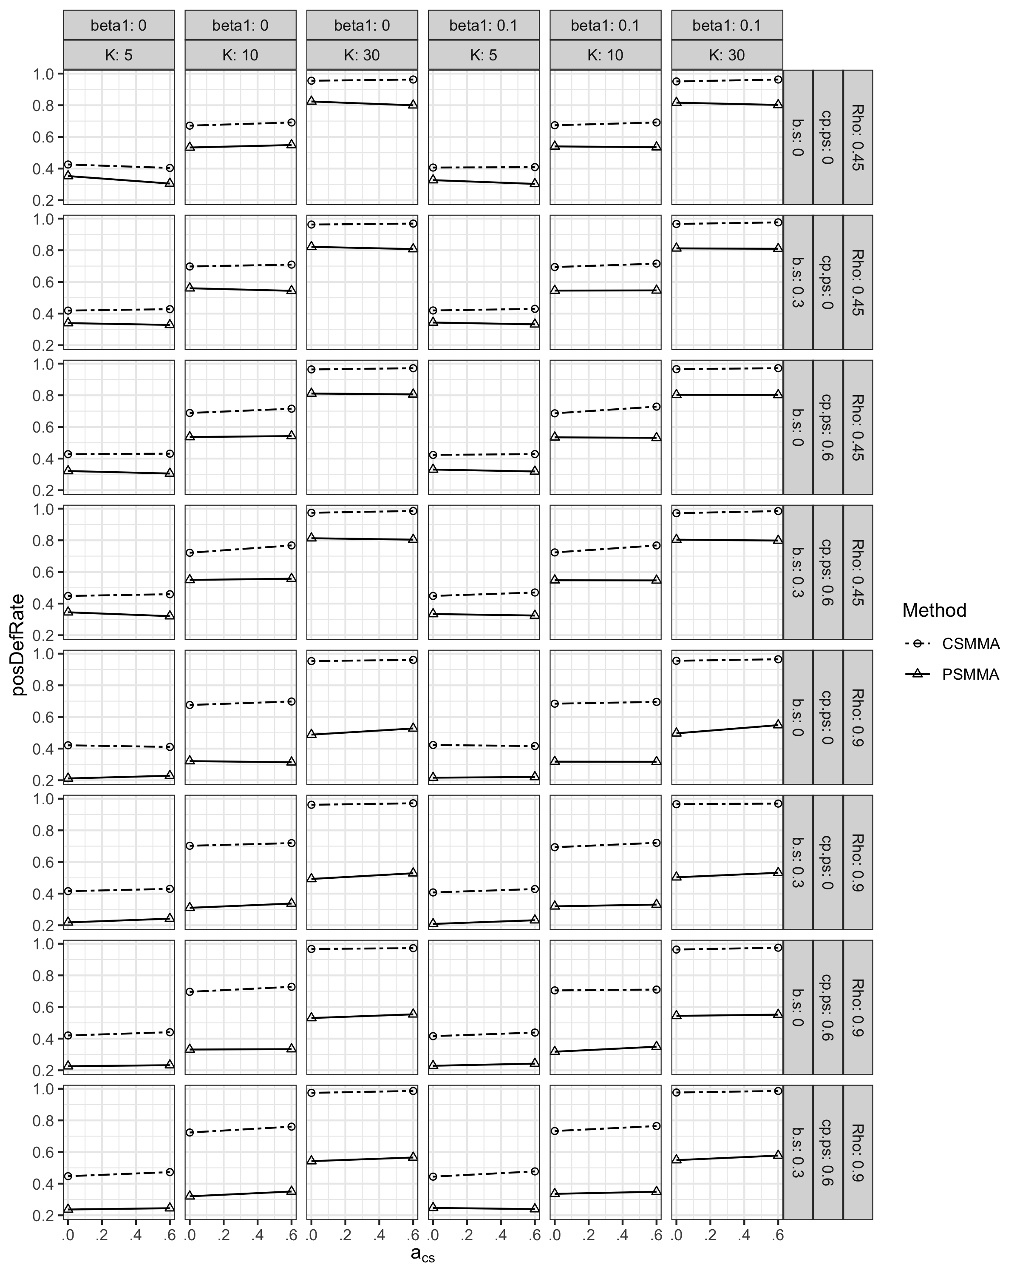

# S3 The Relationship between Parameters in PSMMA and CSMMA

## S3.1 Parameters in PSMMA with Nonzero Counterparts in CSMMA

As shown in Figure S43, when $a_{s.cs}=0.3$, $a_{s.ps}$ decreased with a larger pretest-posttest correlation (Rho12) and posttest variance inflation. The size of $b_{s.cs}, {cp}_{s.cs}$, and $β_{c_{s.cs}^{'}}$ did not have apparent effect here.

**Figure S43.**

*Posttest-score Parameter of the $a$ path ($a_{s.cs}=0.3$)*

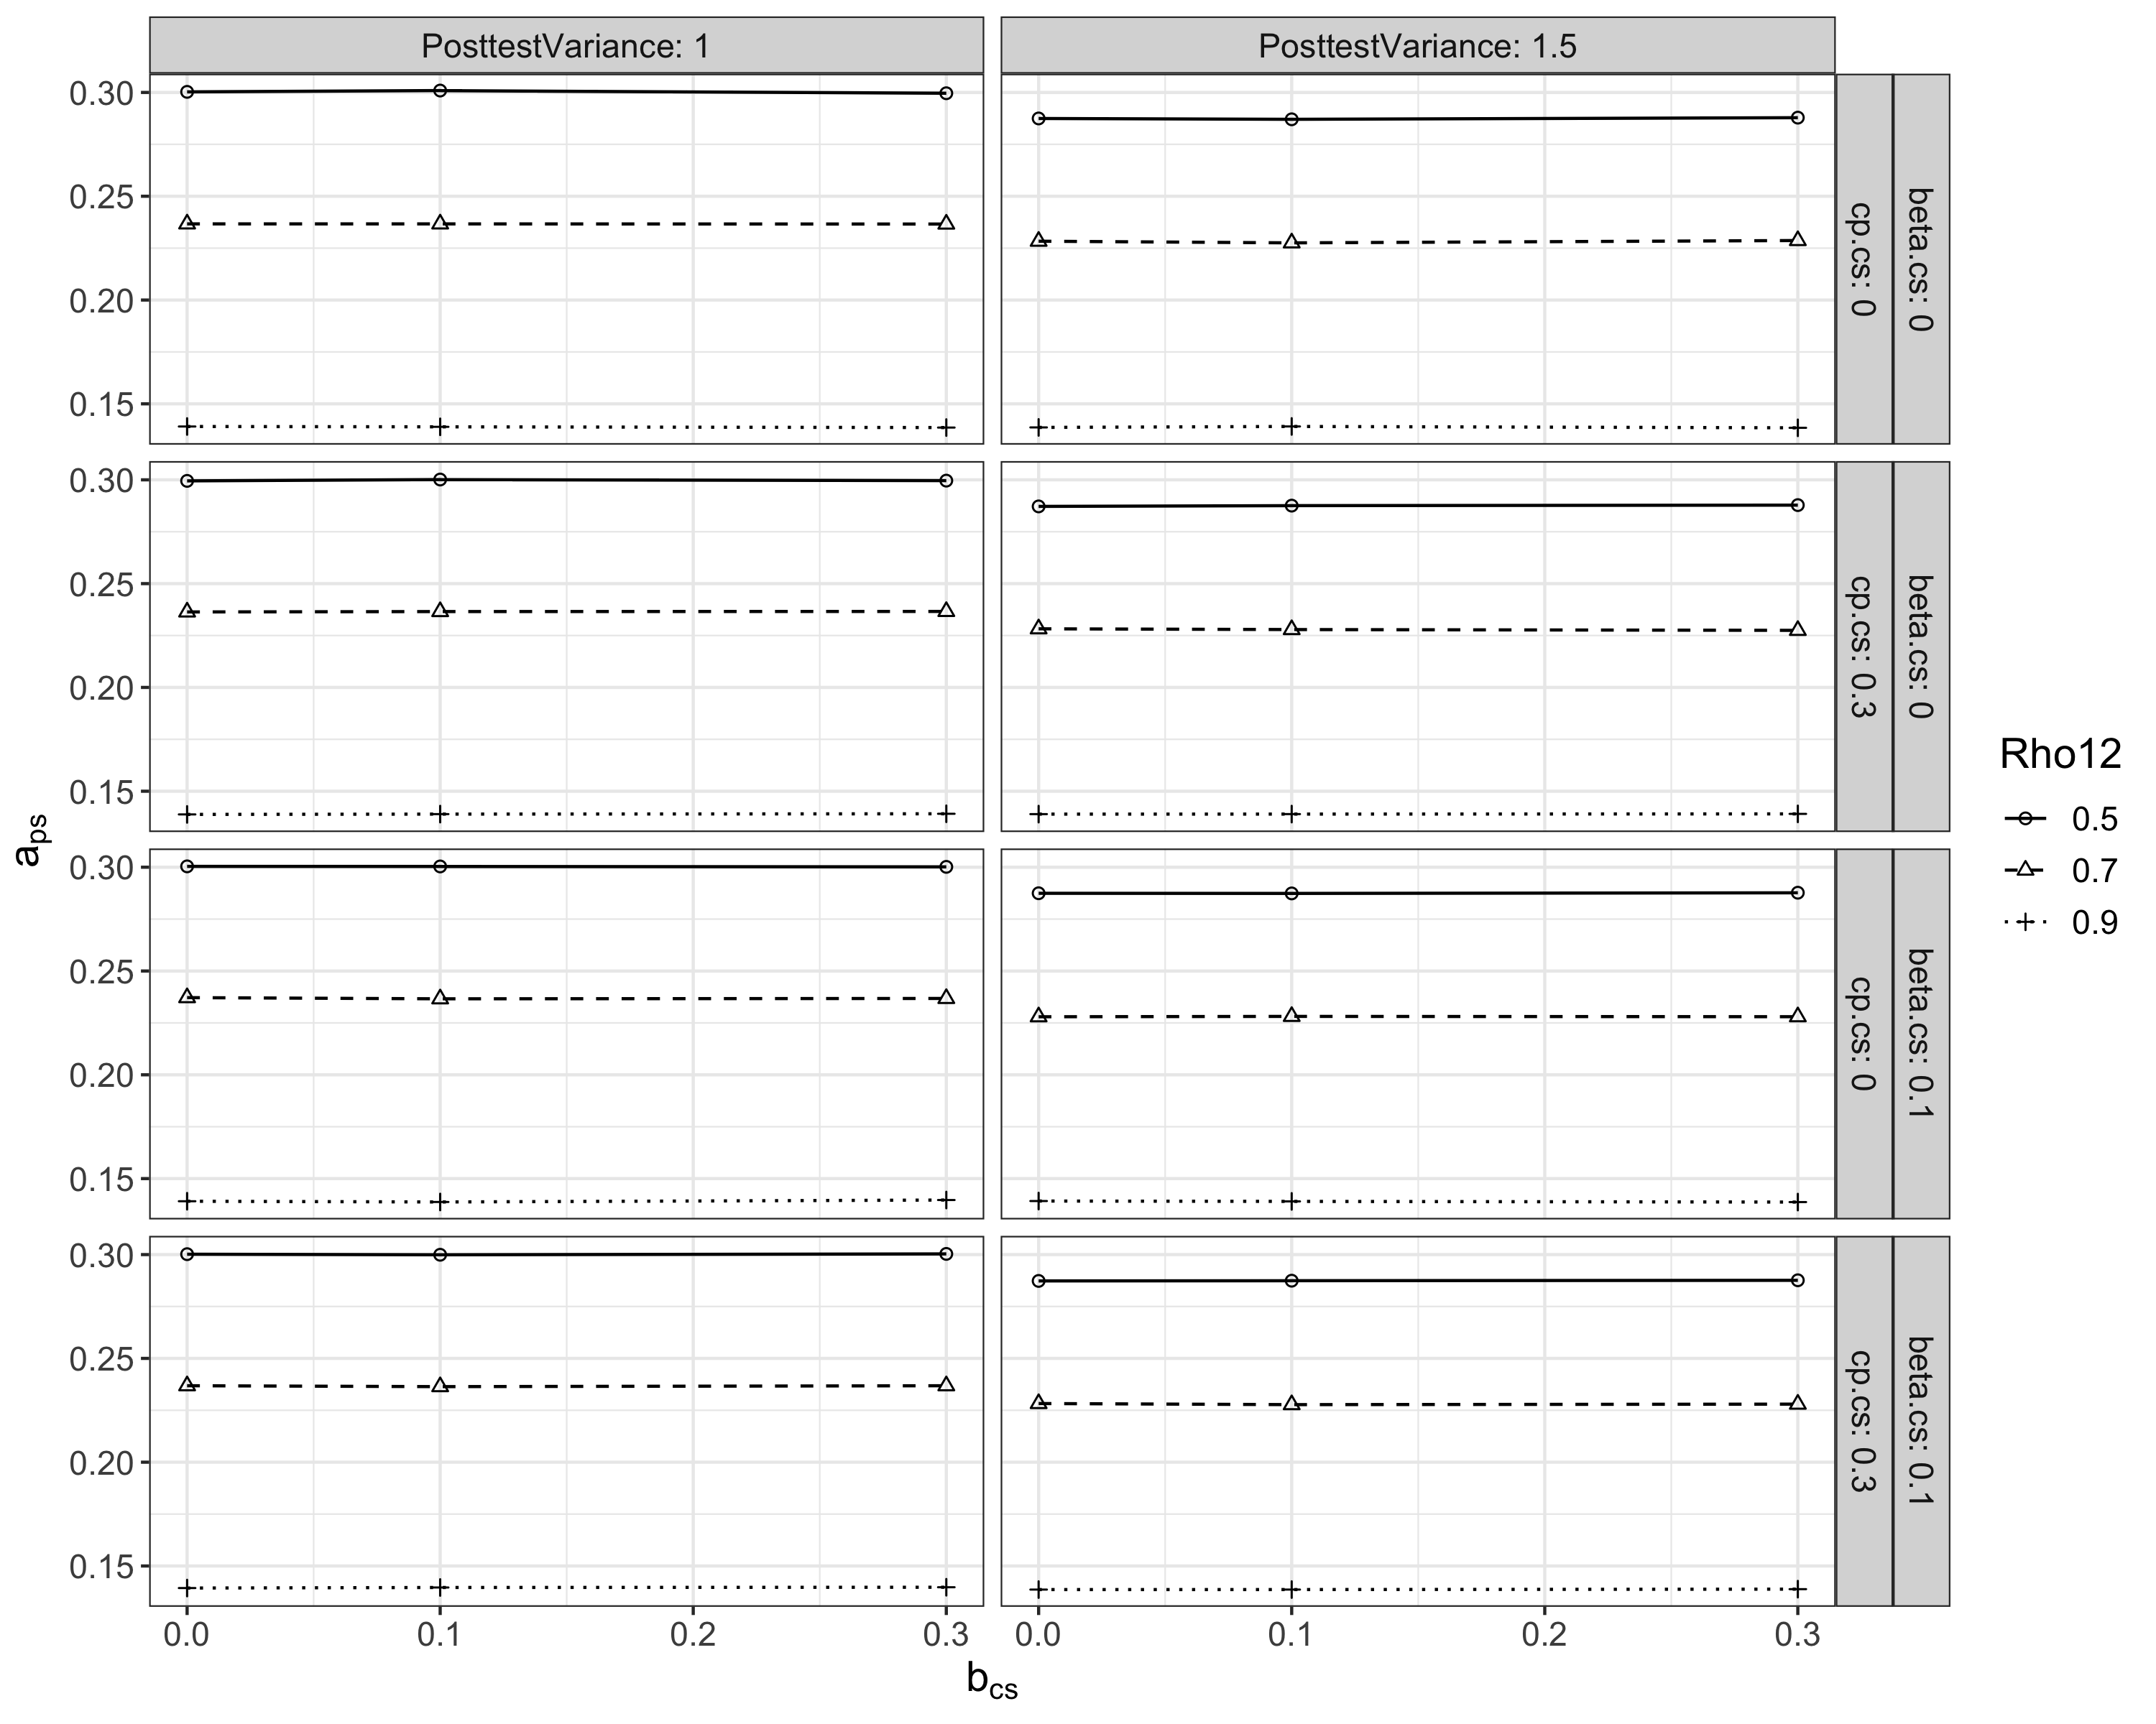

Similar patterns have been observed in the $c'$ and $β_{c_{s.cs}^{'}}$ paths too (Figure S44 and S45).

**Figure S44.**

*Posttest-score Parameter of the $c'$ path (${c'}_{s.cs}=0.3$)*

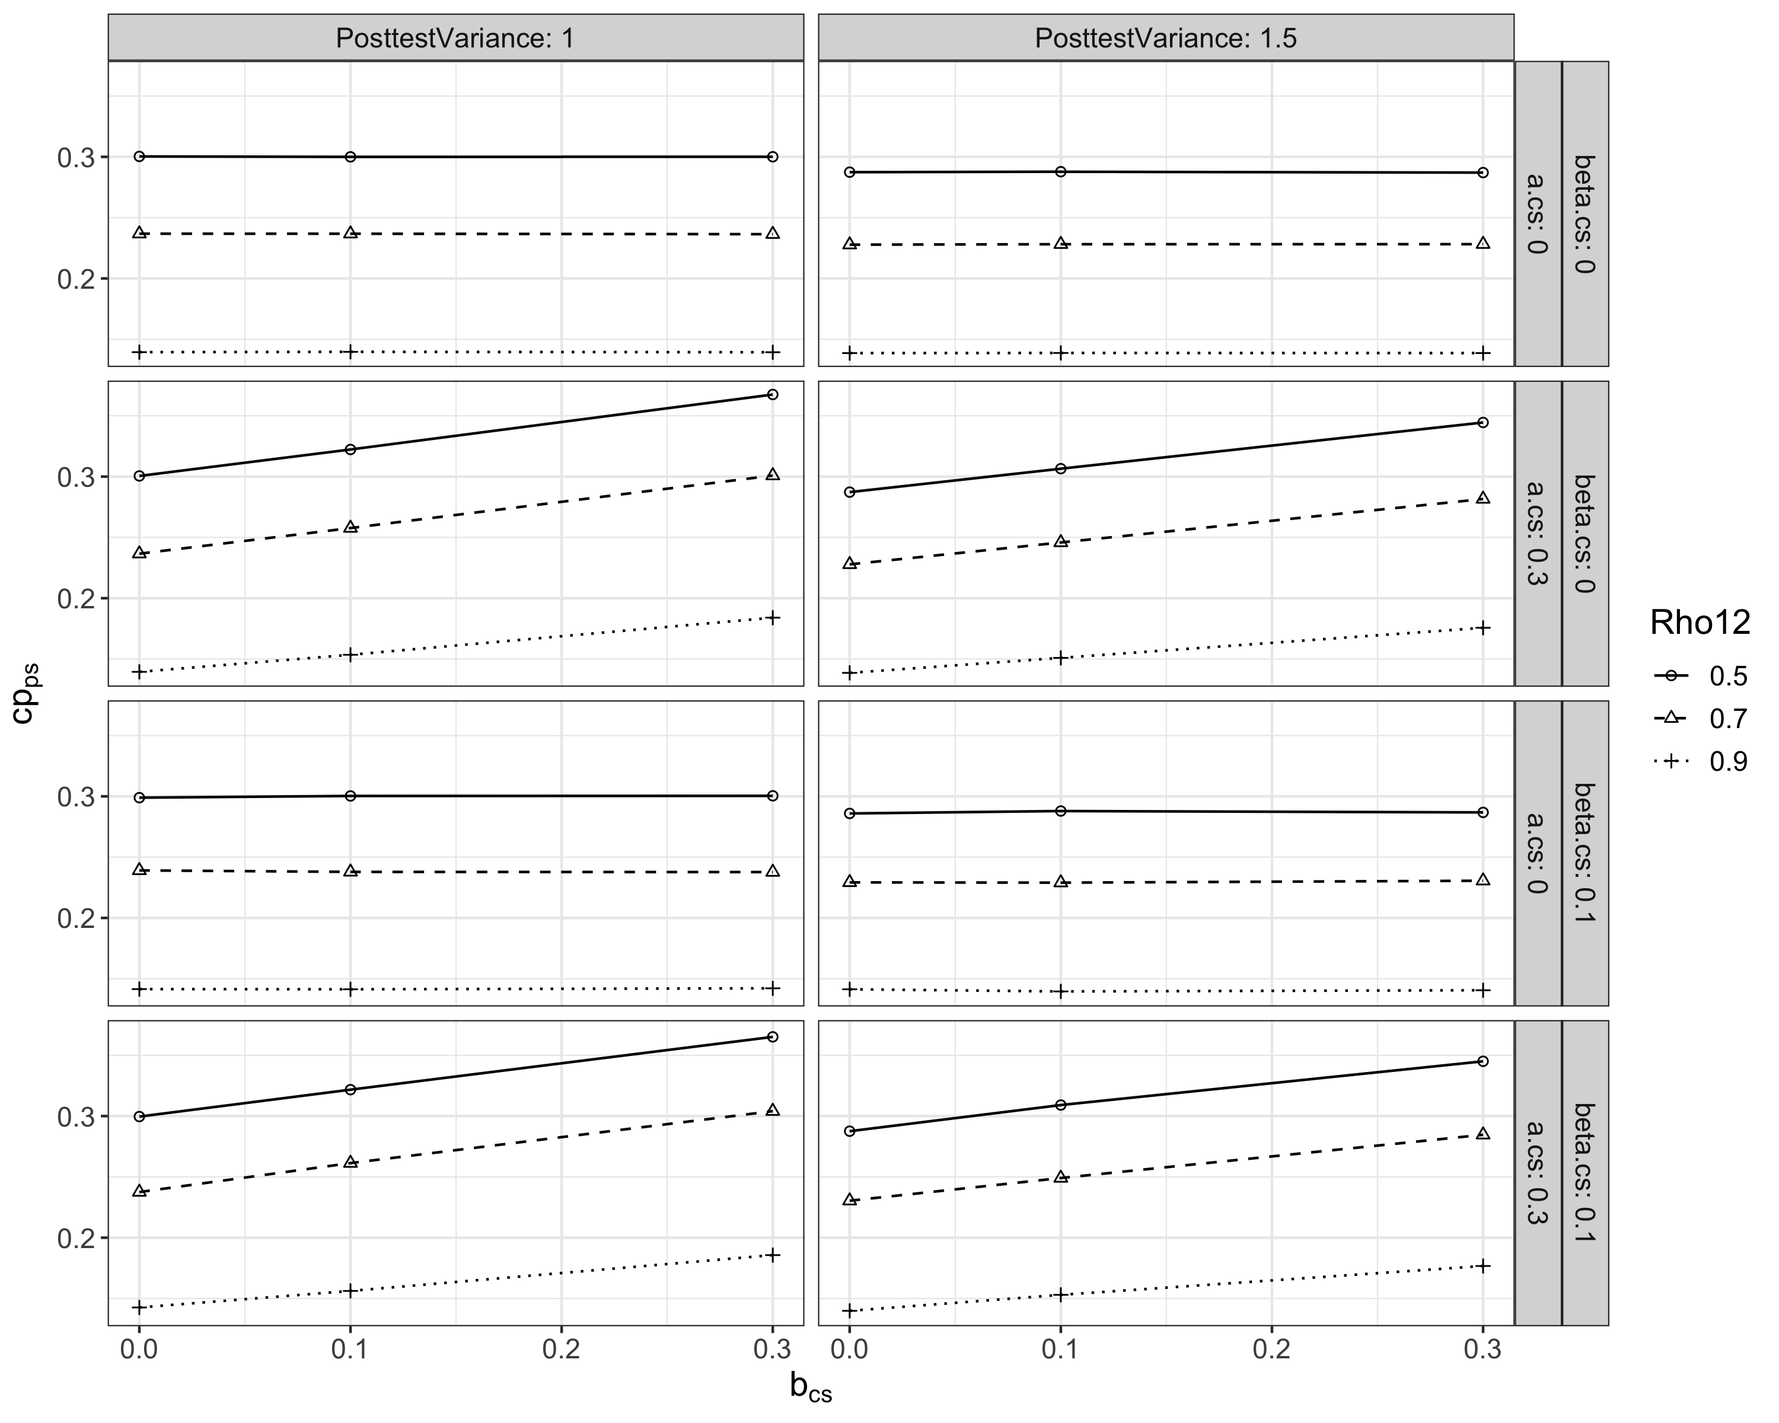

**Figure S45.**

*Posttest-score Parameter of the $β_{c'}$ path ($β_{c_{s.cs}^{'}}=0.1$)*

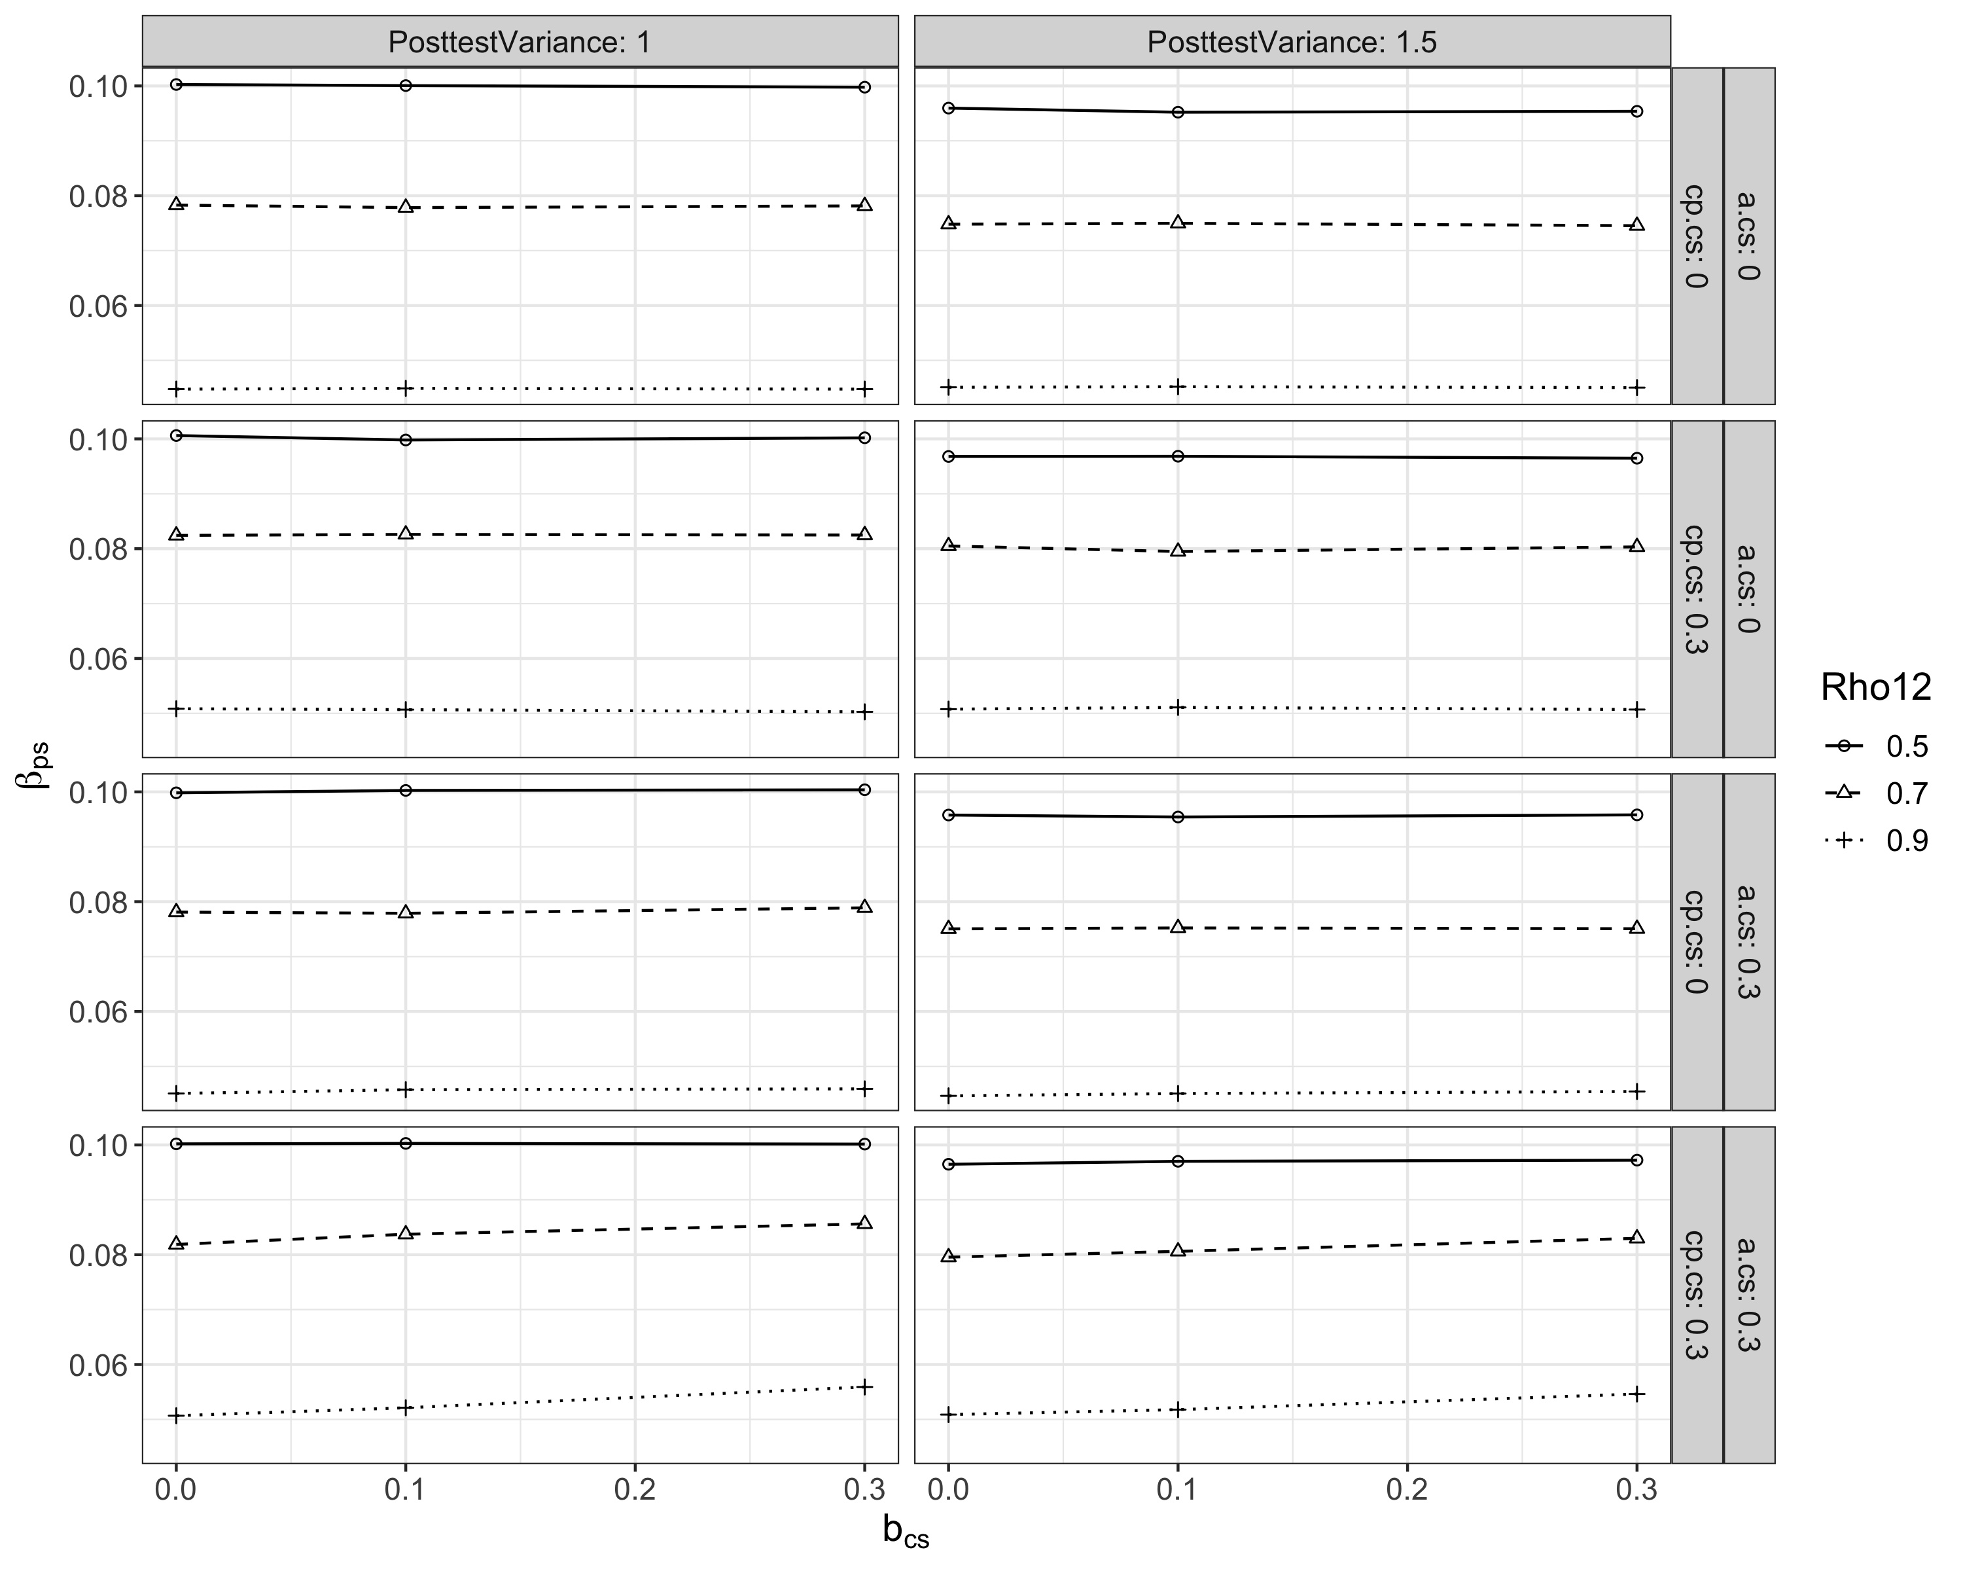

## S3.2 Asynchrony in Taking a Value of Zero

As shown in Figure S46, the posttest-score parameters on $a$, $b,$ and $β_{c'}$ paths were consistently zero when the counterparts in CSMMA were zero.

**Figure S46.**

*Posttest-score Parameter of the $a$* , $b$, and $β_{c'}$*paths ($a_{s.cs}=0$; $b_{s.cs}=0$; $β_{c_{s.cs}^{'}}=0$)*

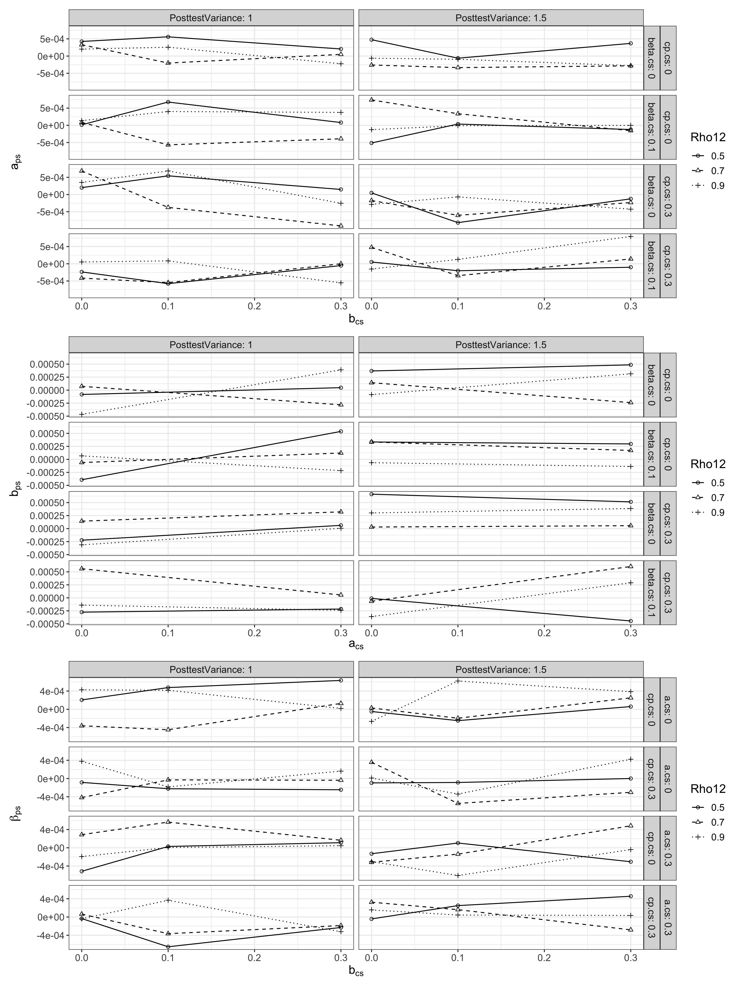

For a zero change-score $c'$, the corresponding posttest-score $c'$ was also zero when one of the change-score $a$ and $b$ paths was zero (the top two rows in Figure S47). However, when the change-score $c'$ equaled zero but the change-score $a$ and $b$ paths were simutaneously nonzero, the mean c' path in PSMMA took a nonzero value (the bottom two rows in Figure S47).

**Figure S47.**

*Posttest-score Parameter of the $c'$* *path ($c'=0$)*

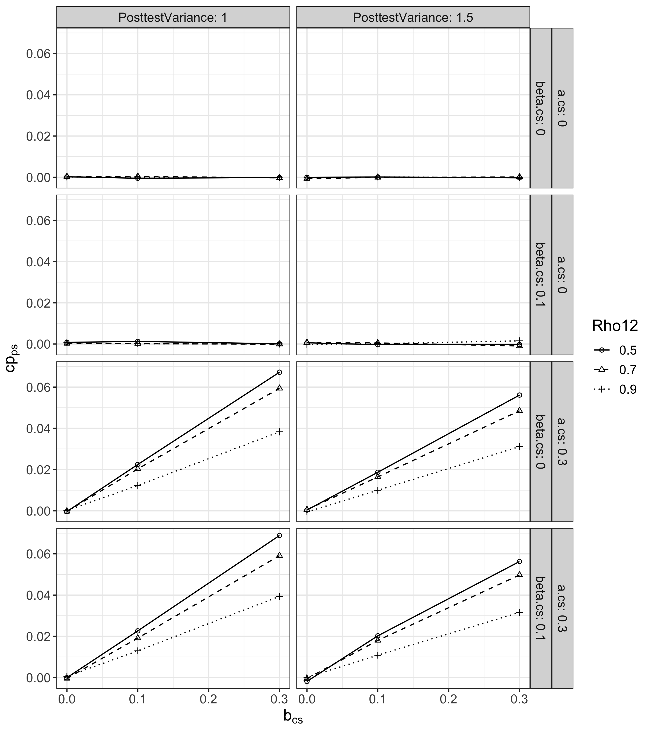

# S4 Simulations on MMA with Missing Correlations

Given that missing data are not uncommon in meta-analysis, we conducted simulation studies (Studies 3 and 4) with missing correlations considered (missing completely at random). The data-generating procedure in Studies 3 and 4 was the same as in Studies 1 and 2, except that a proportion of correlations were replaced with “NA”. Similar to Studies 1 and 2, Study 3 assessed MMA with equal variances in M and Y over time and between groups, whereas Study 4 examined MMA with unequal variances. The magnitude of variance inflation was identical as in Studies 1 and 2. In addition, the implementation of CSMMA and PSMMA, true path coefficients of PSMMA, and performance measures were the same as in Study 1 and 2. Both simulations were implemented using R Version 4.2.2 (R code team, 2022), with 5,000 repetitions for each condition.

## S4.1 Manipulated Factors and Fixed Parameters

In both studies, we investigated the impact of several factors on the performance of CSMMA and PSMMA, including the proportion of missing correlations, standardized change-score (denoted by the subscript cs) path parameters ( $a_{s,cs}$ and $b_{s,cs}$), pretest-posttest correlation ($ρ_{12}$), and the number of primary studies ($K$). A $2$ ($a_{s,cs}$) $×2$ ($b_{s,cs}$) $×2$ ($ρ_{12}$) $×3$ ($K$) $×$ 2 (missing rate) design was used. The settings for $a_{s,cs}$, $b_{s,cs}$, $ρ_{12}$, and $K$ were identical as in Studies 1 and 2. Two values of proportion of missing correlations are used (40% and 60%), following the simulation conducted in Jak & Cheung (2020). To simulate situations in reality, we considered relatively high missing rates for the $M$- $Y$ correlations as opposed to the other two correlations. Specifically, under the conditions where the missing rate equaled 40% (of all bivariate correlations, $r_{XM}$, $r_{XY}$, and $r_{MY}$), 40% of $r_{XM}$ and 80% of $r_{MY}$ were set as missing. On the other hand, under the conditions where the missing rate equaled 60%, 90% of $r_{XM}$ and 90% of $r_{MY}$ were set as missing. The fixed sample size and model parameters were identical as in Studies 1 and 2, except that we additionally fixed $c_{s,cs}^{'}$ at $0.3$ and $β_{c_{s,cs}^{'}}$ at $0.1$ because $c_{s,cs}^{'}$ and $β_{c_{s,cs}^{'}}$ had no apparent effect on the performance of CSMMA and PSMMA.

## S4.2 Simulation Results

### S4.2.1 Convergence Rates in Studies 3 and 4

Convergence rate of Study 3 is shown in Figure S48, whereas that of Study 4 followed had the same patterns.

**Figure S48. Convergence rate in Study 3**

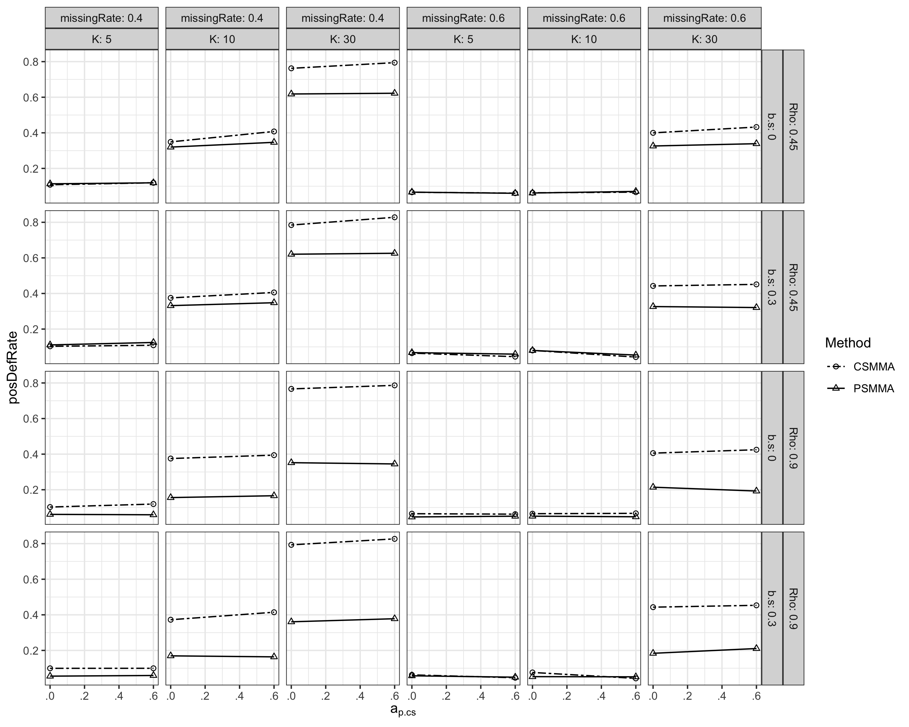

### S4.2.2 Study 3

**Indirect Effect.** Regarding the point and interval estimation of the indirect effect, CSMMA and PSMMA had comparable bias (around 0) and good coverage rate (>0.9). When the missing rate equaled 0.6, both CSMMA and PSMMA hard larger bias (Figure S49). Regarding the testing of the indirect effect, while CSMMA and PSMMA both had well-controlled type I error rates (0~0.1), the statistical power of CSMMA was higher than that of PSMMA (Figure S50).

**Figure S49. Bias of the Indirect Effect in Study 3**

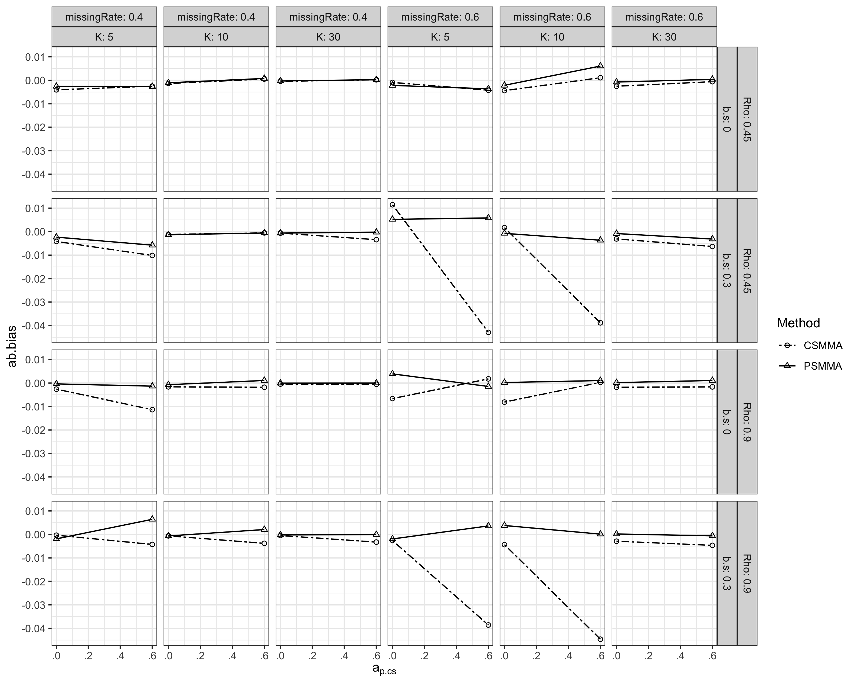

**Figure S50. Statistical power of the indirect effect in Study 3**

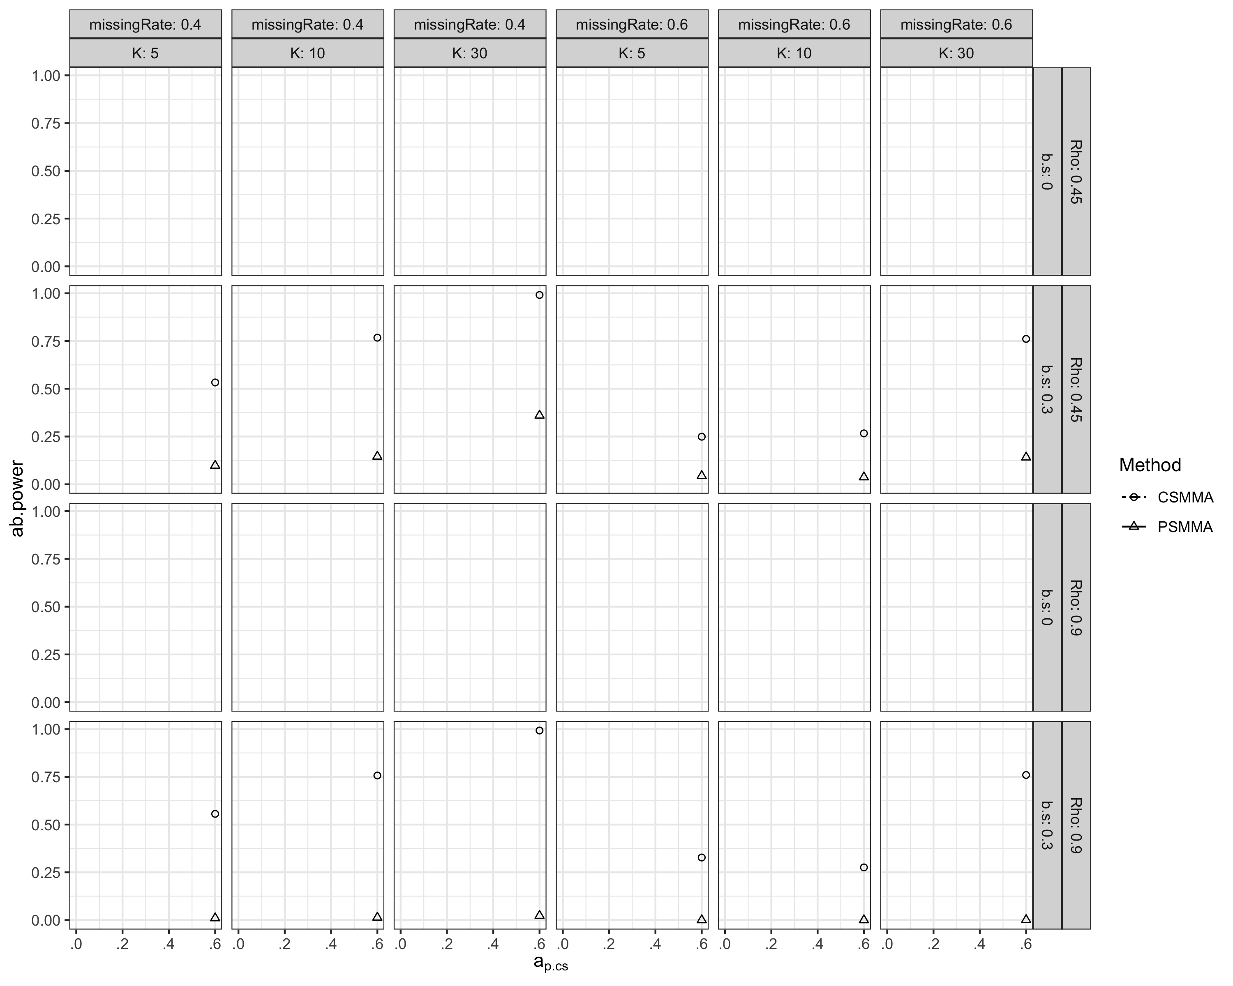

**Direct and Moderating Effects.** Regarding inferences of the direct and moderating effects, resultswith missing correlations were similar to Study 1, except that the statistical power was smaller than that in Study 1 (Figures S51 and S52).

**Figure S51. Statistical Power of the Direct Effect in Study 3**

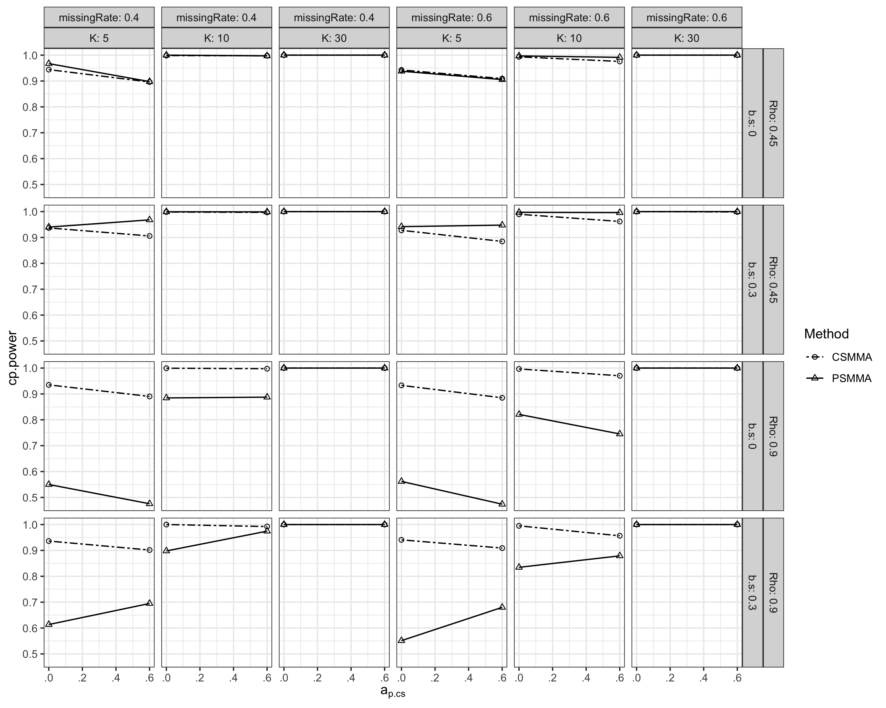

**Figure S52. Statistical Power of the Moderating Effect in Study 3**

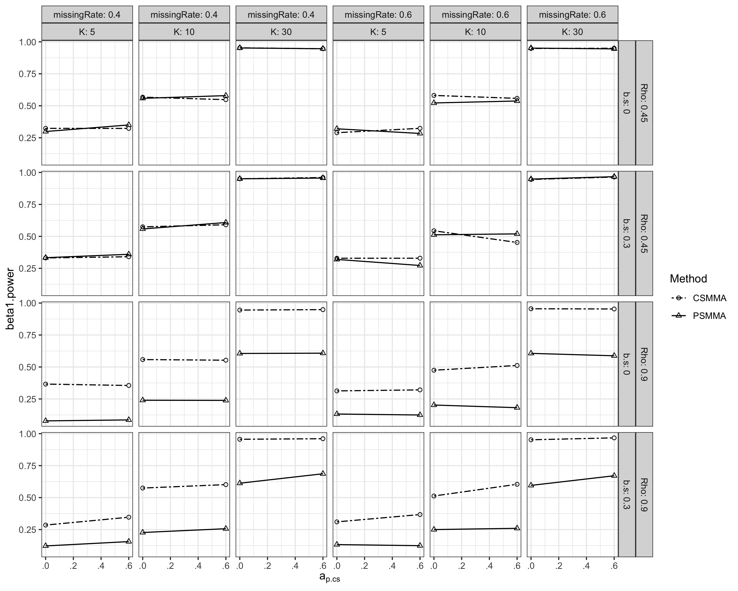

### S4.2.3 Study 4

Regarding inferences of the indirect, direct, and moderating effects, results of Study 4 were similar to Study 3 with one exception about statistical power of PSMMS. The power of PSMMA was slightly higher than that in Study 3 but was still much smaller than CSMMA, a patter similar to that in Studies 1 and 2.